Requirements for

Health to go

nutrition CARE system

**Group Members**

Marufa Chowdhury

Rachel Bautista

Mamadou Diallo

Tuan Truong

Rodney Vencio

**Client**

Amina Ashraf

**Instructors**

John O’Loughlin

Dave Watson

**2017**

Contents

Document Revision History 6

Preface 7

Purpose of the Document 7

Documentation Standards 7

User Requirements 8

Business Overview and Objectives 8

Project Overview 8

I. Statement of the Problem 8

II. Project Scope 8

III. System Environment 9

IV. Current System 10

System Requirements 11

I. Fact-Finding Methodology 11

II. Non-Functional Requirements 11

III. System Interface Requirements 12

IV. Usability Requirements 12

REQUIREMENTS MODELS 14

USE CASE DIAGRAM 14

USE CASE DESCRIPTIONS AND SCENARIOS 14

PROBLEM DOMAIN CLASS DIAGRAM 63

STATE MACHINE DIAGRAMS 64

ACTIVITY DIAGRAMS 69

system design 71

layered architecture 71

hardware architecture 72

hardware platform 72

software platform 73

interaction model 73

persistence model 116

class diagrams 124

INTERACTION SEQUENCE DIAGRAMS 127

DATA DICTIONARY 157

Testing 158

SYSTEM DEPLOYMENT 159

DATA CONVERSION 159

CHANGEOVER STRATEGY 159

SYSTEM ADMINISTRATION AND MAINTENANCE 160

SYSTEM MAINTENANCE 160

DEFICIENCY LIST 161

REQUIREMENTS NOT MET 161

NON-FUNCTIONING COMPONENTS 161

Project Management 162

Schedule 162

gantt chart 163

Team Configuration 171

Project Standards and PROCEDURES 171

Glossary 177

INDEX 179

BIBLIOGRAPHY 180

Appendices 181

PROGRAM LISTINGS 182

Appendix A: ENROLLMENT CHART 183

APPENDIX B: CLIENT CHART 184

APPENDIX C: WEIGHT MAP 185

APPENDIX D: BIGGER VERSION OF CLASS DIAGRAM 186

APPENDIX E: bigger version of persistence model 188

APPENDIX F: BIGGER VERSION OF GUI AND CONTROLLERS DIAGRAM 190

FIGURES

Figure 1: HTG Nutrition Care Use Case Diagram 14

Figure 2: Problem Domain Class Diagram 63

Figure 3 System manager - reset password 64

Figure 4 System manager - modify security 64

Figure 5 System manager - staff account management 65

Figure 6 Report manager - patient report 65

Figure 7 Report manager - business report 66

Figure 8 Advertisement 66

Figure 9 FAQ 67

Figure 10 Tip 67

Figure 11 Nutrition library 68

Figure 12 Staff manager – appointment 68

Figure 13 Staff manager - patient account 69

Figure 14 Staff manager patient invoice 69

Figure 15 Manage report 70

Figure 16 Package Diagram 71

Figure 17 Hardware requirements 72

Figure 18: HTG home screen 76

Figure 19: Services page 77

Figure 20: About page 78

Figure 21: Contact us popup link on navigation bar 79

Figure 22: Food calorie table 80

Figure 23: Nutition tips table 81

Figure 24: Nutrition tip 82

Figure 25: Frequently asked questions 83

Figure 26: Login 84

Figure 27: Sign up (part 1) 85

Figure 28: Sign up (part 2) 86

Figure 29: Edit account 87

Figure 30: Add patient record (part 2) 88

Figure 31: Patient Record (part 2) 89

Figure 32: Add new journal (part 1) 90

Figure 33: Journals table (part 2) 91

Figure 34: Send messages to nutritionist 92

Figure 35: Payment plans 93

Figure 36: My invoice and payment 94

Figure 37: Create staff account by admin 95

Figure 38: Create patient account by admin 96

Figure 39: Reset login by admin 96

Figure 40: Manage Invoice and Payments by staff 97

Figure 41: Manage calorie table 98

Figure 42: Add calorie 99

Figure 43: Modify calorie 100

Figure 44: Manage nutrition tips 101

Figure 45: Edit tips 102

Figure 46: Add nutrition tips 103

Figure 47: Add FAQ 104

Figure 48: Manage news 105

Figure 49: Add news 106

Figure 50: Manage promotions 107

Figure 51: Add promotion 108

Figure 52: Career section 109

Figure 53: Career applications 110

Figure 54: Manage careers 111

Figure 55: Add career 112

Figure 56: Edit career 113

Figure 57: Manage Internship 114

Figure 58: Manage volunteers 115

Figure 59 ERD Diagram 117

Figure 60 Brokers Diagram 125

Figure 61 Gui and Controllers 126

Figure 62 Login 127

Figure 63 Logout 128

Figure 64 Manage Staff 128

Figure 65 Create Staff Account 129

Figure 66 Update Staff Account 129

Figure 67 Deactivate Staff Account 130

Figure 68 Reactivate Staff Account 130

Figure 69 Delete Staff Account 131

Figure 70 Modify Security 132

Figure 71 Create and manage patient account 133

Figure 72 Create and manage patient account – UPDATE 134

Figure 73 Create and manage patient account – DEACTIVATE 135

Figure 74 Manage Patient Account 136

Figure 75 Manage patient account – CREATE 137

Figure 76 Manage patient account – UPDATE 138

Figure 77 Manage patient account – DEACTIVATE 139

Figure 78 Manage patient account – REACTIVATE 139

Figure 79 Payment Plan 140

Figure 80 Manage invoice and payments 140

Figure 81 Manage invoice and payments – INVOICE 141

Figure 82 Manage invoice and payments – MONITOR 142

Figure 83 Generate business report 143

Figure 84 Pay for service 144

Figure 85 Answer messages from patients 145

Figure 86 Answer messages from patients – CHAT 146

Figure 87 Answer messages from patients – EMAIL 147

Figure 88 Send message to nutritionist – EMAIL 148

Figure 89 Patient journal 149

Figure 90 Monitor patient progress 150

Figure 91 Manage patient journal 151

Figure 92 Generate patient progress report – NUTRITIONIST 152

Figure 93 Manage FAQ, Tips of the day, Nutrition library 153

Figure 94 Access and search nutrition library 154

Figure 95 Manage appointments 154

Figure 96 Manage adverts 155

Figure 97 Subscribe and use adverts 155

Figure 98 Manage activity logs 156

Figure 99 Manage logins 156

Figure 100 Book appointment 157

# Document Revision History

|  |  |  |  |
| --- | --- | --- | --- |
| Version | Date | Authors | Revision Notes |
| Requirements document | October 3, 2016 | Marufa Chowdhury  Rachel Bautista  Mamadou Diallo  Tuan Truong  Rodney Vencio | Initial draft for review |
| Requirements Analysis document | October 31, 2016 | Marufa Chowdhury  Rachel Bautista  Mamadou Diallo  Tuan Truong  Rodney Vencio | Second draft for review |
| Design document | December 9, 2016 | Marufa Chowdhury  Rachel Bautista  Mamadou Diallo  Tuan Truong  Rodney Vencio | Third draft for review |
| Resubmission: updated design document | January 23, 2017 | Marufa Chowdhury  Rachel Bautista  Mamadou Diallo  Tuan Truong  Rodney Vencio | Fourth draft for review |
| Final system document | April 13, 2017 | Marufa Chowdhury  Rachel Bautista  Mamadou Diallo  Tuan Truong  Rodney Vencio | Final version |

# Preface

## Purpose of the Document

The purpose of this document is to communicate the process of operating a nutritionist consultancy business by a self-practicing nutritionist for proper study and development of a suitable software ***system***. The requirements themselves will also be within the document for review and final sign-off by the single client contact, nutritionist Amina Ashraf. In addition, this document will be used for grading and consulting done by Southern Alberta Institute of Technology (Sait) and Jon O’Loughlin and David Watson (PROJ354).

It is understood that the requirements, requirement documents, requirement materials and design documents will be utilized and held in other locations, i.e., share drives, cloud services, etc., but this document will be known as the 'source of truth' against all such documents and materials.

## Documentation Standards

In documenting the coding process, we have employed the Javadoc documentation generator on Eclipse (Neon version) and Netbeans (version 8.2).

For all our diagrams, we have so far used the tools Software Ideas Modeler (version 10.42) and Microsoft Visio 2016.

For formatting this document, we have used Microsoft Word 2013-2016 and OneNote 2013-2016. All Heading 1 are shaded in dark blue while Heading 2 in light gray with the Heading 3 being prefixed by uppercase roman numeral characters. After Heading 3, the prefix on the rest of the subtitles and subheadings use following format sequence: Capital letter, number, lowercase letter, lowercase roman numerals. Except the front page, the font size is a standard 12 points from Heading 1 down to the regular paragraphs. Likewise, the font type is a standard ‘Tw Cen MT’ font from top to bottom excluding the front page.

The terms with corresponding definitions in the Glossary are shown in **bold***italics*. Use Case names and actors list are shown in bold when used with corresponding descriptions and scenarios (not necessarily within the Use Case Diagrams).

# User Requirements

## Business Overview and Objectives

The client and main stakeholder is Amina Ashraf, who is a nutritionist working at the company Jenny Craig in Calgary, AB. She has her own business called Health To Go, which monitors and tracks her clients weight and calorie count, as well creates meal plans for them. She helps her clients to maintain a healthy lifestyle without having to pay extensive amounts of money. The goal of her program is to help her patients achieve the lifestyle they want.

## Project Overview

1. Statement of the Problem

The client has been receiving more patients lately and is having trouble keeping her records of each client, and keeping them organized. Since her current system is paper-based, she would prefer a system that would provide less physical data and more efficiency. As well she would like a visual representation of her clients' progress, so they can see the comparisons of their before and after weights.

1. Project Scope

In meeting the business requirements of the client, the team has itemized the following list of key system functionalities that consist and define its project scope:

1. **Patient**
   1. Self-register and login to the system
   2. Subscribe to a payment plan and directly pay through the system via Paypal or an integrated secure payment service tool
   3. Manage his/her own account
   4. Reset own login
   5. Use the journal planner tool
   6. Use the messenger tool to drop and/or receive messages, questions and complaints for the nutritionist, office assistant or administrator (hereafter, as admin).
   7. Pay for the service using the website built-in functionality
   8. Generate printable copies of his/her statement of account or invoice
   9. Book appointments
   10. Subscribe to email list for notification of offers and updates
   11. Receive, access or activate free trial offers
   12. Access and search nutrition library
   13. Access FAQ and Tip of the Day
2. **Nutritionist**
   1. Login to and logout from the system as nutritionist, admin or office assistant
   2. Reset her own password
   3. Use the messenger tool for managing questions, messages, complaints and other requests for assistance
   4. Monitor patient progress
   5. Manage the FAQ, Tips of the Day and Nutrition Library
   6. Edit/Set system settings, options or preferences for the messenger tool, calorie tracker tool, journal planner tool, progress animator, report generation, notifications, FAQ and Tip of the Day
   7. Perform admin functionalities
   8. Perform office assistant functionalities
3. ***Admin*** 
   1. Manage system permissions, restrictions, logins, account maintenance and resources
   2. Manage staff account(s)
   3. Act on requests for password reset
   4. Manage system security
   5. Manage activity log
   6. Manage system notifications
   7. Manage garbage collector
4. **Office Assistant**
   1. Login to and logout from the system
   2. Manage nutrition library, FAQ and Tips of the Day as per nutritionist
   3. Manage patients’ journals
   4. Manage appointments
   5. Manage patient accounts
   6. Manage advertisements
   7. Manage invoices and payments
   8. Generate business reports
5. System Environment

The system environment is the online interface for the interaction between the nutritionist and the patient, and the back-end interface for the interaction between the server and the people maintaining it. The system requirements include the hardware and software. For the hardware requirements, there must be a capable computer, cell phone or tablet that connects to the internet, enough system memory to load the application resources, a capable browser, preferably Internet Explorer, and capable routers/modems that support fast internet access to handle the system processes. For the software implementation, we have a web application that uses a database built in MySql, a database server with all our data, procedures and functions, a web server with all of our business logic and core Java implementation, and a website with all of our HTML, CSS, Javascript, and other frameworks.

1. Current System

The current system the nutritionist is working with is mostly paper based. She records all the information, preps meal plans, and personal information of her patients on paper. She has forms to fill out when enrolling a new patient, and needs to look through piles of paper for details of a certain patient. She communicates with her patients through phone calls and sometimes email or text.

# System Requirements

1. Fact-Finding Methodology

For fact-finding methodology, the team employed the following techniques:

**Document Sampling.** On one of the documents that we have collected was an Enrollment form (Appendix ‘A’). It took all the personal and contact information of the client. That it includes, email, phone number, weight, program purchased, intro consultation and monthly measurements. The second form that we received was the Client Chart (Appendix ‘B’), it records weekly activities such as Support & Strategies, Menu, and Motivation. Also the form records the current weight and pounds lost during that week, and it records what food plan they have chosen for that week. The third form was the Weight M.A.P form (Appendix ‘C’), which keeps track of the clients’ consumption of food outside of the meal plan they have chosen. It records your current weight and how much you have gained, food habits that have prevented you from losing weight or contributed most to the weight gain. As well as restaurants you have eaten at, and your favorite foods.

1. Non-Functional Requirements

As non-functional requirements, the team reports the following capabilities of the application:

1. System response times:
   1. Loading the system takes about 30 seconds
   2. Logging in and out of the system takes about five seconds.
   3. Updating and retrieving data in the system takes about five seconds
   4. System expires after 30 seconds of no activity.
2. System Access
   * 1. The system is capable of accommodating simultaneous high-level access to at least 100 users
     2. The system downtime is dependent of the gravity of the action needed. In the event of a system crash, backup measures are not automatic but the system creates a corresponding alert flag so action can be done at the reasonable time.
3. System data
   1. The system and database should be capable of processing and storing at least 20 MB of data per transaction. This can cover patient's submitted x-rays and other medical or health-related documentation as well as the nutritionist's communication data and materials
   2. Closed patients' files should be stored for up to three years
   3. 100-word limit for each patient communication
   4. Questions are saved on nutritionist's end for three years
4. Security considerations
   1. This is a continuing research process, as any existing securities can easily be overturned by new developments in technology
   2. Some of the measures that are now implemented are as follows:
      * SSL access for the website
      * Password hash
      * Input validation on front-end and back-end
      * Encryption of transit data
      * URL encoding restraint
      * Extra key validation for forms
      * Anti-SQL injection measures
   3. The system is capable enough to withstand system attacks like ***SQL injection***, ***Cross-Site Scripting (XSS)***, ***inclusion vulnerabilities*** and ***brute force attack***.
5. System Interface Requirements

For the system interface, the team implemented the following:

A user-friendly website with helpful links and buttons that can accommodate a person with the least possible computer knowledge

A user-friendly back-end interface to help the people responsible for website maintenance to do their job

An interface payment remittance service using Paypal

1. Usability Requirements

To be usable, the team set out the following measures:

1. The system's interface design is as instinctual as possible. By mere initial glance, the actor should already know what to do
2. The system is equipped with buttons and links that perform enough functionalities that can do what otherwise will be a laborious process, i.e., processing a payment, creating/processing accounts, making emails, saving documents, creating reports
3. System is quick and responsive enough to aid in the nutritionist-patient interaction
4. Switching between different functionalities or sections by tabbing
5. Printability of reports, diet plans, statement of accounts, and interaction
6. Accessibility of system from anywhere
7. Availability of ready-made topics for patient's inquiries
8. Accessible and searchable library of nutritional data or links to websites with meaningful nutritional information
9. Availability of old data in the archive for a longer time
10. Nutritionist contact and address are easily obtainable from the website
11. Appointment booking is possible to make directly from the website without having to call or send an email

# REQUIREMENTS MODELS

## USE CASE DIAGRAM

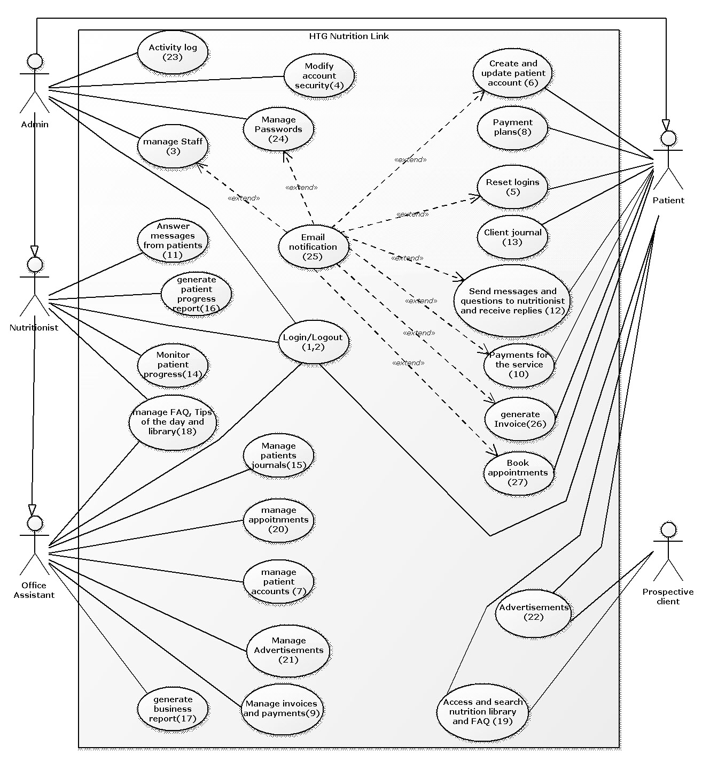

Figure 1: HTG Nutrition Care Use Case Diagram

## USE CASE DESCRIPTIONS AND SCENARIOS

1. Actors List

**Nutritionist**: A licensed nutritionist doing a self-practice in Calgary. She is responsible for all main work flows in the system such as communicating with the patient, creating client diet and meal plans, modifying the meal plan, and answering patient messages

**Patient**: A person looking for timely health-related information or assistance from a nutritionist

**Prospective client**: A person who is researching about the program and may be interested in signing up or referring it to a relative or client. They ask and look for questions regarding the program. And if interested they can sign-up for a Free Trial.

**Office Assistant**: A staffer that is responsible for all support or clerical activities the nutritionist requires

**Administrator**: A super user of the system, who is responsible for higher level functionalities of the system

1. Use Cases

|  |  |
| --- | --- |
| ID | Use Case – 1 (implemented) |
| Title | Login |
| Description | Actor enters proper login credentials and granted access. The account and time of access are recorded.  The login page has the following minimum set of functionalities:   1. Textboxes – for user and password 2. Buttons – for sign in and sign up 3. Forgot password link – for resetting login |
| Primary actor(s) | Patient, nutritionist, office assistant, admin |
| Precondition | User has valid credentials |
| Post-condition | User is logged in using own credentials |
| Limitation(s) | If the user failed to enter the correct credentials, the system redirects to the default system page with an error message. Likewise, the system redirects back to the default system page if the user cancels the login |

* 1. Action Flow

|  |  |
| --- | --- |
| Actions | System Response |
| * + 1. Actor enters website URL | * + 1. Website opens with section for logging in |
| * + 1. Actor clicks on sign in button | * + 1. Popups for username and password |
| * + 1. Actor enters username and password, then clicks login button | * + 1. Validates credentials. On error, see Error Flow |
|  | * + 1. Alternate Flows:  1. Alternate Flow 1: successful login 2. Alternate Flow 2: failed login but less than three attempts 3. Alternate Flow 3: forgot password 4. Alternate Flow 4: failed login |
|  | * + 1. Redirects to previous page |
|  | * + 1. Logs activity |

* 1. Alternate Flow 1: Successful login

|  |  |
| --- | --- |
| Actions | System Response |
|  | * + 1. Successful login: system redirects to the default website welcome page |

* 1. Alternate Flow 3: Forgot password (not yet implemented due to email requirement issues)

|  |  |
| --- | --- |
| Actions | System Response |
|  | * + 1. Failed validation: System popups an error message that username or password is incorrect |
| * + 1. Actor clicks on link “forgot password” | * + 1. Popups dialog box to get registered email address |
| * + 1. Actor enters email address, then clicks submit button | * + 1. Popups message that reset link sent to registered email |
| * + 1. Actor clicks the reset link from email | * + 1. Redirects to reset login page |
| * + 1. Actor enters new password and confirms it, then clicks on save button | * + 1. System persists new information into database |
|  | * + 1. Login screen pops up again |
|  | * + 1. Successful login: system redirects to the default website welcome page |

* 1. Alternate Flow 4: Failed login

|  |  |
| --- | --- |
| Actions | System Response |
|  | * + 1. Failed validation: System popups an error message that username or password is incorrect |
| * + 1. Actor enters a different username and password | * + 1. Validates credentials |
|  | * + 1. Failed validation: System popups an error message that username or password is incorrect |
| * + 1. Actor tries entering his/her credentials for a third time | * + 1. Revalidates credentials |
|  | * + 1. Failed validation again. System popups a third and final error message that “Account is temporarily locked. Please email admin at [<<Email>>](mailto:admin@yahoo.ca) to unlock account” |
|  | * + 1. system redirects to the default system page |

* 1. Error Flow: At any time that an invalid information is entered and the operation failed

|  |  |
| --- | --- |
| Action | System Response |
|  | * + 1. Display error message: “Error: <error message>” |

|  |  |
| --- | --- |
| ID | Use Case – 2 (implemented) |
| Title | Logout |
| Description | User logs out of system  On logging out, no additional content is necessary. The logout button is always located at the top right hand section of the navigation bar. On click of the button, the logout button will be replaced by login and the system reroutes to the home page. |
| Primary actor(s) | Patient, nutritionist, office assistant, admin |
| Precondition | User is logged in to own account |
| Post-condition | User logged out of own account |
| Limitation(s) | If user closes the browser, it will have the same of logging out the user from the system |

* 1. Action Flow

|  |  |
| --- | --- |
| Actions | System Response |
| * + 1. User clicks logout link | * + 1. System logs out user from system |
|  | * + 1. System refreshes and redirects to the default home screen |

* 1. Error Flow: When error occurs during logout

|  |  |
| --- | --- |
| Action | System Response |
|  | * + 1. Display error message |

|  |  |
| --- | --- |
| ID | Use Case - 3 (implemented) |
| Title | Manage Staff |
| Description | The admin or nutritionist is responsible for the creation, update, deactivation, reactivation and deletion of a staff account  The manage staff pages have the following content:   1. Form for adding a new account, updating and account, deactivating, reactivating, and saving an account; 2. The corresponding buttons |
| Primary actor(s) | Admin or Nutritionist |
| Precondition | Admin or Nutritionist has successfully logged in; Manage Staff screen is displayed. |
| Post-condition | Actor performs an operation on manage staff page |
| Limitation(s) | The admin or nutritionist can abort any operation and return to switchboard screen. When actor closes the page (i.e., when actor is done with the account creation, etc.), system defaults to home screen. |

* 1. Action Flow: New staff account creation

|  |  |
| --- | --- |
| Actor Action | System Response |
| * + 1. Admin or Nutritionist clicks on new account button | * + 1. Enables dialog box with empty fields |
|  | * + 1. Verifies using ID if record already exists. Error message (3.6. Error Flow) when it does. Else, proceeds on. |
|  | * + 1. Pops up form for entering new staff data |
| * + 1. Actor enters requested data (name, email, contact information, address, healthcare number, bank information for payroll, username, password and security question) and clicks submit | * + 1. The system processes the entered information and checks for validity pattern. |
|  | * + 1. Persist new staff data into database if all fields are validated |
|  | * + 1. If the process was successful, a message (new staff account successfully created is displayed on the screen). At any point if an error occurs (refer to error flow 3.6). |
|  | * + 1. Logs the activity |

* 1. Alternate Flow 1: Update staff account

|  |  |
| --- | --- |
| Actions | System Response |
| * + 1. Admin or nutritionist enters search value, then clicks on search | * + 1. Looks up account and populates the account textbox fields. Else, Error Flow if not counf. |
| * + 1. Admin or Nutritionist clicks on update account | * + 1. Textbox fields become editable |
| * + 1. Updates form, then clicks on save | * + 1. System validates data |
|  | * + 1. If account information is valid, account is saved in the database |
|  | * + 1. Pops message that staff data has been updated |
|  | * + 1. System sends email notification to the corresponding staffer. |
|  | * + 1. Logs activity |

* 1. Alternate Flow 2: Deactivate staff account

|  |  |
| --- | --- |
| Actions | System Response |
| * + 1. Admin or Nutritionist enters search value, then clicks on search | * + 1. Looks up the account and populates the textbox fields. If not found, Error Flow |
| * + 1. Admin or Nutritionist clicks on deactivate account | * + 1. Asks for confirmation |
| * + 1. User confirms | * + 1. Deactivates account |
|  | * + 1. The actor and time of deactivation is saved. |
|  | * + 1. Prompts that account deactivation is successful |
|  | * + 1. Logs activity |

* 1. Alternate Flow 3: Reactivate staff account

|  |  |
| --- | --- |
| Actions | System Response |
| * + 1. Admin or Nutritionist enters search value, then clicks on search | * + 1. Looks up the account and populates the textbox fields. If not found, Error Flow |
| * + 1. Admin or Nutritionist clicks on reactivate account | * + 1. Asks for confirmation |
| * + 1. User confirms | * + 1. Reactivates account |
|  | * + 1. The actor and time of reactivation is saved. |
|  | * + 1. Prompts that account reactivation is successful |
|  | * + 1. Logs activity |

* 1. Alternate Flow 4: Delete staff account:

|  |  |
| --- | --- |
| Actions | System Response |
| * + 1. Admin or Nutritionist enters search value, then clicks on search | * + 1. Looks up the account and populates the textbox fields. If not found, Error Flow |
| * + 1. Admin or Nutritionist clicks on delete account | * + 1. Asks for confirmation |
| * + 1. User confirms | * + 1. Deletes account. On error, Error Flow |
|  | * + 1. The actor and time of deletion is saved. |
|  | * + 1. Prompts that account deletion is successful |
|  | * + 1. Logs activity |

* 1. Error Flow: At any time that an invalid information is entered for the staff account or a database and operation failed

|  |  |
| --- | --- |
| Actor Action | System Response |
|  | * + 1. Display error message |

|  |  |
| --- | --- |
| ID | Use Case - 4 (not implemented) |
| Title | Modify Security |
| Description | Changes or updates system level security or account level security to no security, minimum, medium or maximum  For modify security, the page should have the following content:   1. Form for modifying the security on an account. The form should have the following elements: 2. Textboxes – for account ID, name and email 3. Radio buttons – for the levels of security (minimum, medium and maximum) 4. Button – to modify security 5. Form for modifying system security with the following content: 6. Radio buttons – showing the different levels (minimum, medium, maximum) 7. Button – to apply security |
| Primary Actor(s) | Administrator |
| Pre-condition | Logged in as admin with SYSDBA level clearance; system is operational; user account exists in the system |
| Post-condition | System level or account level security is changed |
| Limitations | Only an admin account has system privilege to modify security either for system or an account. Security here only applies to database security. Website security is not included |

* 1. Action Flow

|  |  |
| --- | --- |
| Actions | System Response |
| * + 1. Admin clicks on modify security link | * + 1. System management page opens |
| * + 1. Fills out form for modify account security, then clicks on apply | * + 1. Looks up account. On error, Error Flow |
|  | * + 1. Asks for confirmation |
| * + 1. Selects yes | * + 1. Applies the security |
| * + 1. Clicks on medium for system security, then clicks on apply | * + 1. Asks for confirmation |
| * + 1. Selects yes | * + 1. Applies the security |
|  | * + 1. Pops a message that security for target has been changed |
|  | * + 1. Logs the activity |

* 1. Error Flow: At any time that error occurs during an operation

|  |  |
| --- | --- |
| Action | System Response |
|  | * + 1. Display error message |

|  |  |
| --- | --- |
| ID | Use Case - 5 (implemented) |
| Title | Reset Login |
| Description | Reset logins for patient, nutritionist or office manager. |
| Primary Actor(s) | Patient, Nutritionist, Office Manager |
| Pre-condition | Actor’s account exists in the system |
| Post-condition | Actor’s password is changed |
| Limitations | No reset of logins unless correct security answers are provided. In case of failure after three tries, user needs to contact admin to get the login reset desired. When security answer is correct, reset only takes place on click of the reset link sent to user’s email |

* 1. Action Flow

|  |  |
| --- | --- |
| Actions | System Response |
| * + 1. Actor clicks on “Forgot Password?” or “ Reset Login” link | * + 1. System redirects to reset login page. Popups a field to input account username. |
| * + 1. Actor types in the username and clicks on reset button | * + 1. System searches the database for account. When found, retrieves security question(s) and prompts for answer(s). System sends reset link to user’s registered email  1. Alternate Flow 1: Account not found |
| * + 1. Actor answers the security questions and clicks submit | * + 1. System checks the answers; if correct, it asks for new password and confirms it  1. Alternate Flow 2: Incorrect answer(s) 2. Alternate Flow 1: Forgot the answer(s) |
| * + 1. After clicking the reset link from user’s email and actor gets redirected to the reset login page, actor enters a new password, confirms it and clicks the save button | * + 1. System updates the password in the database, creates activity log, and redirects to the main page |
|  | * + 1. Logs activity |

* 1. Alternate Flow 1: Account Not Found

|  |  |
| --- | --- |
| Actions | System Response |
|  | * + 1. System displays an error message that account does not exist; prompts another account username. |
| * + 1. Actors enters another username | * + 1. Check validation by the System |
|  | * + 1. System redirects to system response 5.1.4. |

* 1. Alternate Flow 2: Incorrect Answer

|  |  |
| --- | --- |
| Actions | System Response |
|  | * + 1. System displays an error message that the answer supplies is incorrect; prompts for correct answer for three tries |
| * + 1. Actor enters other answers and click submit | * + 1. System validates response |
|  | * + 1. System redirects to system response 5.1.6. |
|  | * + 1. Logs activity |

* 1. Alternate Flow 3: Forgot the Answer

|  |  |
| --- | --- |
| Actions | System Response |
|  | * + 1. System displays an error message that the answer supplies is incorrect; prompts for correct answer for three tries |
| * + 1. Actor clicks on forgot answer link; or | * + 1. System display that to get the login reset, user will have to contact the admin at given email address |
| * + 1. clicks on cancel | * + 1. System redirects to login screen |
|  | * + 1. Logs activity |

* 1. Error Flow: At any time that error occurs during an operation

|  |  |
| --- | --- |
| Action | System Response |
|  | * + 1. Display error message |

|  |  |
| --- | --- |
| ID | Use Case - 6 (implemented) |
| Title | Create and Update Patient Account |
| Description | 1. Any prospective client may register for a new account 2. Edit/update existing account 3. Deactivate/close own account   Create and update patient account is a link on prospective patient or patient’s account that opens the Account Management page with the following content:   1. Patient’s account details section. The buttons for this section are: 2. Deactivate – deactivates the opened account 3. Reactivate – reactivates the inactive opened account 4. Delete – deletes the said account 5. Edit – edits the said account 6. Save – saves the said account |
| Primary actor(s) | Prospective client, patient |
| Precondition | 1. Prospective client has no pre-existing account or previously closed account but with remaining unsettled balance or dues 2. An existing client may edit own account while she is logged in to it 3. An existing client may deactivate/close own account provided she has no unpaid balance or dues |
| Post-condition | 1. Account created 2. Account updated 3. Account deactivated/closed |
| Limitation(s) | 1. Registration will not complete unless the required fields are filled out (i.e., name, valid email, contact information, valid Canadian address, proof of Canadian citizenship or permanent residency, valid Canadian ID, etc.). At any point, the user cancels, the system will redirect to the home screen 2. System will not open the account for updating if user could not enter a valid username and password. Likewise, if the user cancels, the system redirects to the home screen 3. System will not deactivate/close an account unless the ending balance or outstanding dues on account are settled. Again, if the user cancels, the system redirects to the home screen |

* 1. Action Flow

|  |  |
| --- | --- |
| Actions | System Response |
| * + 1. Prospective client clicks the “register” link. | * + 1. Registration page opens with a patient form |
| * + 1. User fills out form, then clicks submit | * + 1. Checks if the required fields are filled out (see System Response 6.1.6.); if not, error message (refer to Error Flow) |
| * + 1. User fills out required fields, then resubmits | * + 1. Validates required data: unique name (not yet in database), email, province, Country, postal code (must be valid), phone or cell number (format), citizenship/ residency ID (format), (operator ID format). On error, error message (refer to Error Flow) |
| * + 1. User makes corrections, then resubmits | * + 1. System persists new patient data into database |
|  | * + 1. Popup that new account creation has been successful; System returns to account page |
| * + 1. Optional Flows:  1. Optional Flow 1: Patient updates account 2. Optional Flow 2: Patient deactivates/closes account |  |
|  | * + 1. Logs activity |

* 1. Optional Flow 1: Patient updates account

|  |  |
| --- | --- |
| Actions | System Response |
| * + 1. Patient clicks on “Account” link | * + 1. Account page opens |
| * + 1. User clicks on “edit profile” button | * + 1. Full account profile is shown for updating |
|  | * + 1. Validates required data: email, province, Country, postal code (must be valid), phone or cell number (format), citizenship/ residency ID (format), (operator ID format). On error, error message (refer to Error Flow) |
| * + 1. User makes corrections, then resubmits | * + 1. System persists new patient data into database |
|  | * + 1. Popup that account successfully updated; System returns to account page |
|  | * + 1. Logs activity |

* 1. Optional Flow 2: Deactivate/Close Account

|  |  |
| --- | --- |
| Actions | System Response |
| * + 1. Patient clicks on “Account” | * + 1. Account page opens |
| * + 1. User clicks the “Deactivate Account” button | * + 1. System takes them to a confirmation page asking them if they want to Deactivate |
| * + 1. User clicks the “Yes” button to continue with deactivation | * + 1. System checks if the account has any outstanding fees. And if they do, prompts if user wants to settle ending account balance. Otherwise, popup that account cannot be deactivated or closed with an existing balance. |
| * + 1. User pays off balance | * + 1. System changes account status in database from active to restricted. Account will remain in the database for three years |
|  | * + 1. System redirects to home screen |
|  | * + 1. Logs activity |

* 1. Error Flow: At any time that error occurs during an operation

|  |  |
| --- | --- |
| Action | System Response |
|  | * + 1. Display error message |

|  |  |
| --- | --- |
| ID | Use Case – 7 (partially implemented) |
| Title | Manage Patient Account |
| Description | 1. Creation of new patient account for prospective client by office assistant 2. Modification of account by office assistant as part of maintenance 3. Deactivation of account by office assistant and archiving in the database for three years 4. Reactivation of account by office assistant   Manage patient account is a link on office assistant page that opens the Manage Patient Account with the following content:   1. Search section – can search by account ID, patient name, date, month, quarter, year 2. Sortable table listing all invoices from the database spanning three years with checkboxes on the left and buttons on the right. The buttons for this table are below: 3. Open – opens the invoice and payment detail below the table 4. Sort button – sorts the table alphabetically or chronologically 5. Filter – display the invoices and payments according to the filter: payments for month, quarter, year, or specific period, payments for a particular account 6. Sort button – sorts the table alphabetically or chronologically 7. Table showing the opened account with the following buttons: 8. Deactivate – deactivates the opened account 9. Reactivate – reactivates the inactive opened account 10. Delete – deletes the said account 11. Edit – edits the said account 12. Save – saves the said account |
| Primary actor(s) | Office assistant. By inheritance, nutritionist and admin may perform the functions as well. |
| Precondition | Actor is logged in as office assistant. In case of creation, the prospective client expressly requested it |
| Post-condition | Account created, modified, deactivated or reactivated, as the case may be. |
| Limitation(s) | 1. New account cannot be created, unless prospective client expressly requested it by providing all his/her details: name, valid email contact information, valid Canadian address, and proof of Canadian citizenship or permanent residency, valid Canadian ID. 2. Modification cannot be done, unless for maintenance 3. Deactivation cannot be done, unless account balance == 0 4. Reactivation cannot be done if account has been archived form more than three years   In any case, when page is closed, system defaults to the home screen |

* 1. Action Flow

|  |  |
| --- | --- |
| Actions | System Response |
| * + 1. Office assistant clicks patient account management link | * + 1. Patient account management page opens |
| * + 1. Alternate Flows:  1. Alternate Flow 1: Create account 2. Alternate Flow 2: Account editing / modification 3. Alternate Flow 3: Account deactivation 4. Alternate Flow 4: Account reactivation | <Proceeds to selected flow> |
| * + 1. User closes page | * + 1. Redirects to home screen |
|  | * + 1. Logs activity |

* 1. Alternate Flow 1: Create Account

|  |  |
| --- | --- |
| Actions | System Response |
| * + 1. Enters search value, then clicks search | * + 1. Checks if account exists. |
|  | * + 1. Message: result of search. (assuming, not exists) |
|  | * + 1. Error message if username already exists in the database (refer to Error Flow). Redirects back to System Response 7.2.2. |
| * + 1. Clicks new button | * + 1. Form readies its fields for entering new patient account info |
| * + 1. User fills out form, then clicks save | * + 1. Checks if the required fields are filled out (see System Response 7.2.10.); if not, error message (refer to Error Flow) |
| * + 1. User fills out required fields, then resubmits | * + 1. Validates required data: unique name (not yet in database), email, province, Country, postal code (must be valid), phone or cell number (format), citizenship/ residency ID (format), (operator ID format). On error, error message (refer to Error Flow) |
| * + 1. User makes corrections, then resubmits | * + 1. System persists new patient data into database |
|  | * + 1. Popup that new account creation has been successful; System returns to account page |
|  | * + 1. Logs activity |

* 1. Alternate Flow 2: Account Editing / Modification

|  |  |
| --- | --- |
| Actions | System Response |
| * + 1. Enters search value, then clicks search | * + 1. Checks if account exists. |
|  | * + 1. Message: result of search. (assuming, not exists) |
|  | * + 1. Error message if username already exists in the database (refer to Error Flow). Redirects back to System Response 7.2.2. |
| * + 1. Office assistant clicks edit patient account button | * + 1. Edit patient account page opens with a patient form filled up with all patient info |
| * + 1. User updates patient data, then submits | * + 1. Validates required data: unique name (not yet in database), email, province, Country, postal code (must be valid), phone or cell number (format), citizenship/ residency ID (format), (operator ID format). On error, error message (refer to Error Flow) |
| * + 1. User makes corrections, then resubmits | * + 1. System persists new patient data into database |
|  | * + 1. Popup that patient account has been updated; System returns to account page |
|  | * + 1. Logs activity |

* 1. Alternate Flow 3: Account Deactivation

|  |  |
| --- | --- |
| Actions | System Response |
| * + 1. Enters search value, then clicks search | * + 1. Checks if account exists. |
|  | * + 1. Message: result of search. (assuming, not exists) |
|  | * + 1. Error message if username already exists in the database (refer to Error Flow). Redirects back to System Response 7.2.2. |
| * + 1. Office assistant clicks deactivate patient account button | * + 1. Asks confirmation |
| * + 1. Selects yes | * + 1. Tries to deactivate |
|  | * + 1. Error message if account balance > 0 (refer to Error Flow) |
| * + 1. User clicks waive balance button | * + 1. Ending balance set to $0.00 |
| * + 1. User clicks deactivate patient account button again | * + 1. Prompts to confirm action |
| * + 1. User selects “yes” | * + 1. changes account status in database from active to restricted |
|  | * + 1. Redirects to account management page |
|  | * + 1. Logs activity |

* 1. Alternate Flow 3: Account Reactivation

|  |  |
| --- | --- |
| Actions | System Response |
| * + 1. Enters search value, then clicks search | * + 1. Checks if account exists. |
|  | * + 1. Message: result of search. (assuming, not exists) |
|  | * + 1. Error message if username already exists in the database (refer to Error Flow). Redirects back to System Response 7.2.2. |
| * + 1. Office assistant clicks reactivate patient account button | * + 1. Asks for confirmation |
| * + 1. User selects “yes” | * + 1. Changes account status from restricted to active |
|  | * + 1. Popup message that account has been successfully reactivated |
|  | * + 1. Logs activity |

* 1. Error Flow: At any time that error occurs during an operation

|  |  |
| --- | --- |
| Action | System Response |
|  | * + 1. Display error message |

|  |  |
| --- | --- |
| ID | Use Case – 8 (implemented) |
| Title | Payment Plan |
| Description | The patient can choose any payment plan that is provided on the website. They are able to change to different plans.  Payment plan is a link on patient’s page that opens the Payment plan page with the following content:   1. Table listing the different plans that are currently available (e.g, 5 consultations per week with 10% discount, 3 consultations per week with 5% discount, 2 consultations per week with 1% discount, or consultation any time with no discount). There should be radio buttons next to the plans on the left. On the right, are the following buttons: 2. Apply button – applies the selected plan to his/her own account 3. Open – opens the plan to view the other details. It opens below the table 4. A section showing patient’s current payment plan details 5. Back to main screen – redirects back to user’s default main page |
| Primary actor(s) | Patient |
| Precondition | Patient must have an existing account to choose a payment plan |
| Post-condition | A payment plan is chosen and applied to patient’s own account |
| Limitation(s) | Not available to prospective clients. Closing the browser is tantamount to logging out of the system |

* 1. Action Flow

|  |  |
| --- | --- |
| Actions | System Response |
| * + 1. Patient clicks on the Payment plan link | * + 1. Payment plan page opens |
| * + 1. User selects a payment plan, then clicks on the Open button | * + 1. Payment plan opens below the table |
| * + 1. User clicks on the Apply button | * + 1. Asks confirmation |
| * + 1. Confirms | * + 1. Plan gets applied and displays in the current payment plan section. On error, see Error Flow |
| * + 1. User clicks on the back to main screen | * + 1. Redirects to user’s default main page |
|  | * + 1. Logs activity |

* 1. Error Flow: At any time that error occurs during an operation

|  |  |
| --- | --- |
| Action | System Response |
|  | * + 1. Display error message |

|  |  |
| --- | --- |
| ID | Use Case – 9 (Implemented) |
| Title | Manage Invoice and Payment |
| Description | Generation of invoices or billing statements for patients, and monitoring of all the payments that are coming in  Invoice and payment is a link on office assistant page that opens the Invoice and payments page with the following content:   1. Search section – can search by account ID, patient name, date, month, quarter, year 2. Sortable table listing all invoices from the database spanning three years with checkboxes on the left and buttons on the right. The buttons for this table are below: 3. Open – opens the invoice and payment detail below the table 4. Sort button – sorts the table alphabetically or chronologically 5. Filter – display the invoices and payments according to the filter: payments for month, quarter, year, or specific period, payments for a particular account 6. Mark – marks selected entry for later viewing 7. Monitor table showing the balances that are due for the current month/quarter from all patients – each row displays the account Id and name together with the amount due or overdue with checkboxes on the left and buttons on the right. These buttons are: 8. Select account – selects an account for opening 9. Open Invoice – opens the invoice for the selected account 10. Print button – generates a PDF format file of the selected invoice or statement of account 11. Back to main screen link – redirects to user’s default main screen |
| Primary actor(s) | Office Assistant |
| Precondition | User is logged in as office assistant |
| Post-condition | Office assistant has created invoices or billing statements, and pulled up payment information |
| Limitation(s) | Only creates an invoice or billing statement and accesses all payment information including the payment history for each or several clients. When user closes the browser, it logs him/her out of the system |

* 1. Action Flow

|  |  |
| --- | --- |
| Actions | System Response |
| * + 1. User clicks on the “Manage Invoice and Payment” button | * + 1. System takes them to the Invoice and Payment page |
| * + 1. Alternate Flows:   a. Alternate Flow 1: User creates invoice or billing statement  b. Alternate Flow 2: Monitor payments |  |
| * + 1. User closes page | * + 1. Redirects to home screen |
|  | * + 1. Logs activity |

* 1. Alternative Flow 1: Create Billing Statement or invoice

|  |  |
| --- | --- |
| Actions | System Response |
| * + 1. User enters a search value, then clicks search | * + 1. Lists all the matching payments and invoices |
| * + 1. User selects one of the accounts, then clicks the Open button | * + 1. Opens the invoice and payment below the table |
| * + 1. User clicks on the Print button | * + 1. Generates a PDF format file of the selected invoice and payment. On error, see Error Flow |

* 1. Alternative Flow 2: Monitor Payments

|  |  |
| --- | --- |
| Actions | System Response |
| * + 1. User reviews the table balances, then selects an account and clicks on send notice | * + 1. Creates a system-generated email to patient for the balance due on account. On error, see Error Flow |

* 1. Error Flow: At any time that error occurs during an operation

|  |  |
| --- | --- |
| Action | System Response |
|  | * + 1. Display error message |

|  |  |
| --- | --- |
| ID | Use Case – 10 (partially implemented) |
| Title | Pay for Service |
| Description | Payment for services that patient received should be doable through the system. When done through the system, the system will have records of the transaction. These records should be available to patient anytime.  Pay service is a link on patient’s page that opens the Pay Service page with the following content:   1. Sortable table listing the history of payments on the account spanning three years. Can be sorted according to the amount paid or chronologically. The table will have checkboxes on the left and buttons on the right. These buttons should be: 2. Open – pulls up the invoice for the transaction. It gets displayed below the table 3. Filter – displays the list according to the filter (selected period) 4. Latest invoice section – displays the details the current statement of account 5. Payment section with the following features: 6. Amount to pay textbox – where patient can specify the amount he/she’s paying 7. Pay button – on click, will redirect to PayPal page for payment processing. When done with PayPal, the page redirects back to this page for finalization of the transaction 8. Confirm payment button – will appear after the transaction is processed at PayPal. On click, the payment will be submitted as finalized   NOTE: the ultimate goal is to include not only PayPal, but also interact eTransfer and credit card payment processing. In case, we ran out of time, we will make sure that, at least, the PayPal option is operational |
| Primary actor(s) | Patient. Office assistant may assist in the payment upon express request of the patient |
| Precondition | Patient is logged in to own account |
| Post-condition | Patient pays account balance using Paypal |
| Limitation(s) | Cannot use pay service if patient has no Paypal account. Will have to create a Paypal account first. If user closes page, system redirects to home screen |

* 1. Action Flow

|  |  |
| --- | --- |
| Actions | System Response |
| * + 1. User clicks on the Pay service link | * + 1. Pay service page opens |
| * + 1. User clicks pay balance button | * + 1. System connects to Paypal |
|  | * + 1. Paypal prepares a charge for account, and returns user to system screen |
| * + 1. User clicks on the confirm payment button | * + 1. System submits payment request to Paypal for finalization |
|  | * + 1. On error, refer to Error Flow |
|  | * + 1. Else: popup that payment successful |
|  | * + 1. Redirects back to Pay service page |
| * + 1. User selects a payment in the table, then clicks on the Open button | * + 1. Invoice for payment displays below the table |
| * + 1. User clicks on Filter and selects the period to filter | * + 1. The list in the table changes according to the filter |
| * + 1. User clicks on Back to main screen | * + 1. Redirects to user’s default main page |
|  | * + 1. Logs activity |

* 1. Error Flow: At any time that error occurs during an operation

|  |  |
| --- | --- |
| Action | System Response |
|  | * + 1. Display error message |

|  |  |
| --- | --- |
| ID | Use Case – 11(partially implemented) |
| Title | Answer messages from patients |
| Description | From the time the nutritionist-patient relationship started to its consummation, a chat and instant messaging service should be accessible from anywhere by the nutritionist to attend to the questions or inquiries of the patient. When actor sends a message to nutritionist, a popup notification should alert the nutritionist to it, when the nutritionist is logged in and available. Otherwise, the chat link will be disabled and an automatic option of dropping a message to nutritionist should be active. The nutritionist, as actor, can then replay in a timely manner. Once the chat transaction is finished, there will be an option to send the transcript of the transaction to patient’s email. All dropped messages for nutritionist will be allocated a database table for easy retrieval. Once retrieved, it will all populate on nutritionist page with a corresponding link for reply, forward, reply all, delete, archive.  Answer messages is a link on nutritionist’s page that opens the Messages page with the following content:   1. Radio button detector – gets checked when it detects that patient is logged in 2. Chat message activate/deactivate button – activates the chat messenger on nutritionist and patient’s end 3. Chat messenger section – where nutritionist and patient can exchange messages live. This section’s features are below: 4. Live messages exchange section (text area) – where all exchanges are displayed 5. Instant messaging field – where nutritionist can view the exchanges between her and the patient 6. Send button – sends the message out to patient screen 7. Search section – searches for a message. Can take any parameter 8. Sortable table of messages received from nutritionist with checkboxes on the left. The buttons for this table are below: 9. Open – Opens the message. It opens below the table 10. Mark – leaves the check mark on the message permanent until removed 11. Edit – edits the selected message. It opens for editing below the table 12. Delete – deletes the selected message 13. Reply – replies to the opened message. This opens the compose message dialog box 14. New – creates a new message. This opens the compose email message dialog box 15. Compose email message dialog box with the following content: 16. Subject field – purpose of the message 17. Message text area – where patient can compose a message with a maximum of 300 characters 18. Send button – saves the message in the system for nutritionist 19. Back to main page link – redirect’s to user’s default main page |
| Primary actor(s) | Nutritionist |
| Precondition | Nutritionist is logged in |
| Post-condition | Nutritionist has successfully engaged patient through chat or has successfully sent replies through the system |
| Limitation(s) | If user closes the browser, it will have the same effect of logging out the user from the system |

* 1. Action Flow

|  |  |
| --- | --- |
| Actions | System Response |
| * + 1. Nutritionist clicks on Messages link | * + 1. Messages page opens |
| * + 1. Clicks on unread message | * + 1. Message opens for viewing |
|  | * + 1. Radio button updates to show if patient is online |
| * + 1. User clicks on Activate messenger button upon seeing that radio button is checked | * + 1. Chat messenger activates |
| * + 1. User chats with patient | * + 1. Sends the messages and displays the exchanges |
| * + 1. User clicks on Deactivate button | * + 1. Deactivates messenger on both ends |
| * + 1. Alternate Flows  1. Sends an email to patient(s) | * + 1. Logs activity |
| * + 1. User clicks on Back to main page | * + 1. Redirects back to user’s default main page |
|  | * + 1. Logs activity |

* 1. Alternate Flow 1: New email / Reply via email

|  |  |
| --- | --- |
| Actions | System Response |
| * + 1. Nutritionist clicks on New/Reply message button | * + 1. Compose email message dialog box opens |
| * + 1. User composes the message, then clicks the Send button | * + 1. Saves the message in the system for patient. On error, see Error Flow |

* 1. Error Flow: At any time that error occurs during an operation

|  |  |
| --- | --- |
| Action | System Response |
|  | * + 1. Display error message |

|  |  |
| --- | --- |
| ID | Use Case – 12 (partially implemented) |
| Title | Send Message to Nutritionist |
| Description | The client can either chat with the nutritionist using the built-in chat messenger or send a personal message to her. This use case will only do the email message. The email functionality is linked to patient’s account  Send message is a link on patient’s page that opens a Messages page with the following content:   1. Chat messenger section – where nutritionist and patient can exchange messages live. This is initially grayed out until the nutritionist activates it on her end. This section’s features are below: 2. Live messages exchange section (text area) – where all exchanges are displayed 3. Instant messaging field – where patient can view the exchanges between her and the patient 4. Send button – sends the message out to patient screen 5. Search section – searches for a message. Can take any parameter 6. Sortable table of messages received from nutritionist with checkboxes on the left. The buttons for this table are below: 7. Open – Opens the message. It opens below the table 8. Mark – leaves the check mark on the message permanent until removed 9. Edit – edits the selected message. It opens for editing below the table 10. Delete – deletes the selected message 11. New – creates a new message. This opens the compose email message dialog box 12. Compose email message dialog box with the following content: 13. Subject field – purpose of the message 14. Message text area – where patient can compose a message with a maximum of 300 characters 15. Send button – saves the message in the system for nutritionist 16. Back to main page link – redirect’s to user’s default main page |
| Primary actor(s) | Patient |
| Precondition | Patient is logged in |
| Post-condition | Patient sends an email message |
| Limitation(s) | The chat, however, can only be initiated by nutritionist. Thus, for the chat process, please refer to Use Case 11. If the user failed to login in three tries, the system redirects to the default system page. Likewise, the system redirects back to the default system page if the user cancels the login. Not available for prospective client. |

* 1. Action Flow

|  |  |
| --- | --- |
| Actions | System Response |
| * + 1. Patient clicks on the Messages link | * + 1. Messages page open |
| * + 1. Enters string, then clicks on Search button | * + 1. Searches the messages database and displays the result or error (see Error Flow) |
| * + 1. User Performs operations on the message(s): open, mark, edit, delete | * + 1. Page gets refreshed |
| * + 1. User clicks on New message button | * + 1. Compose email message dialog box opens |
| * + 1. User creates a message, then clicks on the Send button | * + 1. Saves message in the system for nutritionist |
|  | * + 1. Also sends email notification |
| * + 1. User clicks on Back to main page | * + 1. Redirects back to user’s default main page |

* 1. Error Flow: At any time that error occurs during an operation

|  |  |
| --- | --- |
| Action | System Response |
|  | * + 1. Display error message |

|  |  |
| --- | --- |
| ID | Use Case – 13 (implemented) |
| Title | Patient Journal |
| Description | The journal is one of the means by which the nutritionist monitors the patient’s progress. Patient creates the journal. Nutritionist reviews the journal. The admin tests the journal.  Patient journal is a link on patient’s page that opens the Patient Journal page. This page should have the following content:   1. Search section – to search database for a particular journal or journals depending on the search. Accepts any parameter 2. Sortable search results table with checkboxes on the left and buttons on the right. These buttons consist of: 3. Open – opens the selected journal. It opens below the table 4. Mark – leave the check mark on the selected journal permanent until removed 5. Filter – displays the journals created within a particular time (day, week, month, semi-annual, annual, or all of them [no filter]) 6. Edit – edits the selected journal after opening. It opens below the table 7. Delete – deletes the selected journal 8. New Journal button - opens a form for entering a new journal 9. Back to main page link – redirects back to user’s default main page |
| Primary actor(s) | Patient. Nutritionist only for purposes of review, whereas the admin only for testing purposes |
| Precondition | Patient is logged in |
| Post-condition | Patient creates the journal entry |
| Limitation(s) | If the patient failed to login in three tries, the system redirects to the default system page. Likewise, the system redirects back to the default system page if the user cancels the login. Not available for prospective client. Nutritionist and admin have limited access to the journal. |

* 1. Action Flow

|  |  |
| --- | --- |
| Actions | System Response |
| * + 1. Patient clicks on patient journal link. | * + 1. Patient journal page opens |
| * + 1. User clicks on New patient journal button | * + 1. Opens form for entering new journal |
| * + 1. Enters new journal, then clicks on Save button | * + 1. Saves the journal. On error, see Error Flow |
| * + 1. User enters a search parameter and clicks on the search button or selects one of the listed journals | * + 1. Searches journal database and displays result in the table or error per the Error Flow; otherwise, opens a listed journal clicked by user |
| * + 1. User performs Open, Mark, Filter, Edit, Delete on the journals | * + 1. Page gets refreshed |
| * + 1. User clicks on Back to main page link | * + 1. Redirects back to user’s default main page |
|  | * + 1. Logs activity |

* 1. Error Flow: At any time that error occurs during an operation

|  |  |
| --- | --- |
| Action | System Response |
|  | * + 1. Display error message |

|  |  |
| --- | --- |
| ID | Use Case – 14 (partially implemented) |
| Title | Monitor Patient progress |
| Description | Monitoring patient progress requires being able to look at the different stats for the patient. Thus, the web page shows different stats tables, sections and buttons for performing review and maintenance.  Monitor patient progress is a link on the nutritionist default main page that opens the Monitor Patient Progress page (the same screen for Use Case 16 – Generate patient progress report). This page is also accessible to the patient as a link on the patient’s profile. It will have the following content:   1. A patient search section – searches (by Id, or name) for the patient profile to pull up the records into the page. 2. A sortable table listing all of the patient’s journals with checkboxes on the right and buttons on the left. These buttons consist of: 3. Open – opens the journal for viewing. The journal will open below the table 4. Mark – Leaves the check mark for selected entry permanent until removed. Useful when nutritionist needs to go back to it for additional review 5. Sort – shows a combo box for selecting the type (alphabetical, chronological) of sort. On select of the type, the table will sort 6. Reset view – this removes the displayed journal if no new journal is opened for viewing 7. Filter – displays the journals created on the day, week, month, quarter, semi-annual, annual, or all of them (no filter option) 8. A sortable table listing the different diet plans for patient. Again, with checkboxes on the left and buttons on the right. The buttons for this table consist of: 9. Open - opens the journal for viewing. The journal will open below the table 10. Mark - Leaves the check mark for selected entry permanent until removed. Useful when nutritionist needs to go back to it for additional review 11. Sort - shows a combo box for selecting the type (alphabetical, chronological) of sort. On select of the type, the table will sort 12. Reset view - this removes the displayed journal if no new diet plan is opened for viewing 13. Edit & Save– edits/saves the opened diet plan 14. Delete – deletes the opened diet plan 15. Filter – displays the diet plans created for the day, week, month, quarter, semi-annual, annual, or all of them (no filter option) 16. A sortable table listing the different activity plans for patient. This table uses the same set of buttons and checkboxes as number ‘3’ above 17. Table listing the weight map for patient with checkboxes on the left. This table uses the following buttons: 18. Mark – Leaves the check mark for selected entry permanent until removed. Marks the selected weight detail for later review 19. Reset view – resets all markings 20. Table showing all details of patient record from the database with checkboxes on the left. The buttons for this table are the same as number ‘5’ above 21. Sortable table of assessments for patients with checkboxes on the left. This table uses the following tables: 22. Add – adds an assessment. The create new assessment window opens below the table 23. Open – opens the selected assessment for viewing. The opened assessment displays below the table 24. Mark – Leaves the check mark for selected entry permanent until removed. Marks for later review 25. Edit & Save – edits/save the selected assessment. It opens below the table 26. Delete – deletes the selected assessment 27. Sort – sorts the assessment chronologically or alphabetically 28. Filter – displays the assessments issued for the day, week, month, quarter, semi-annual, annual or all of them (no filter option) 29. Animator – a rotating animated figure that can grow or shrink depending on the slider bar that can be set and locked only by the nutritionist 30. Generate report button – creates a PDF format file with all the stats from the page 31. Back to main page link – redirects to user’s default main page 32. Return to main page link – redirects to user’s default main page |
| Primary Actor(s) | Nutritionist |
| Pre-condition | Nutritionist is logged in |
| Post-condition | Nutritionist performs operations on patient data |
| Limitations | When user closes the browser, it will have the same effect as logging out of the system |

* 1. Action Flow

|  |  |
| --- | --- |
| Actions | System Response |
| * + 1. Nutritionist clicks on monitor patient progress link | * + 1. Monitor patient progress page opens |
| * + 1. User searches for account | * + 1. Account pulls up all stats to page |
| * + 1. User reviews record, sets marks, slides the animator slider (if nutritionist), enters notes and clicks on saves, or performs other operations | * + 1. Updates database and refreshes display |
| * + 1. User clicks on back to main page link | * + 1. Redirects to user’s default main page |

* 1. Error Flow: At any time that error occurs during an operation

|  |  |
| --- | --- |
| Action | System Response |
|  | Display error message |

|  |  |
| --- | --- |
| ID | Use Case – 15 (not implemented) |
| Title | Manage patient Journals |
| Description | Maintenance on patient journals of all clients, less the ability to open and edit them. Work includes resolving issues like duplicate journals, corrupted journals, blank journals, and the like. User may also test each journal for ***data integrity***.  Manage patient journals is a link on the user’s default main page that opens the Manage Patient Journals page with the following content:   1. Sortable search section for accounts – searches database by: 2. Account – using a name or account ID 3. Date or period – using a date picker for selecting the date or period. Search collates all journals from all patients that were entered within the period 4. Any string – collates all journals from all patients that match the string 5. Sortable search section for Journals. The buttons for this table are: 6. Open – opens the journal for viewing with MASKING of fields with sensitive personal details. The journal opens below the table 7. Sort – combo box with sort order options: alphabetical, chronological 8. Delete – removes the journal from the table. When deleted, the journal is not actually deleted but gets moved to the deleted journals table. The final delete can only be performed by the nutritionist or admin, unless it is a dummy journal. It is automatically a dummy journal when the system detects the user ID is that of the office assistant 9. Filter – displays only the journals created on a date, week, month, quarter, semi-annual, annual or all of them (no filter option) 10. Reset view – refreshes page. Closes any opened journal 11. New – creates a dummy journal for testing purposes. When this journal is deleted, it gets deleted permanently 12. Generate summary report button – generates a PDF format summary report of the journal stats from the all listed journals 13. Back to main page link – redirects system back to the user’s default main page |
| Primary actor(s) | Office assistant. Nutritionist and admin, by inheritance, may perform the functionality as well |
| Precondition | Office assistant is Logged in |
| Post-condition | Office assistant performs operations with the listed journals |
| Limitation(s) | Office assistant can only partially view the journal or but no edit it, unless it is a dummy journal. Once browser is closed, user is automatically logged out of the system. |

* 1. Action Flow

|  |  |
| --- | --- |
| Actions | System Response |
| * + 1. Office assistant clicks on manage patient journals link | * + 1. Manage patient journals page opens |
| * + 1. User searches database | * + 1. Search result shows on page or error (see Error Flow) |
| * + 1. User clicks on a button (open, sort, delete, filter, reset view, generate report) | * + 1. Performs the clicked operation. On error, see Error Flow |
| * + 1. User clicks on back to main page | * + 1. Redirects to user’s default main page |

* 1. Error Flow: At any time that error occurs during an operation

|  |  |
| --- | --- |
| Action | System Response |
|  | * + 1. Display error message |

|  |  |
| --- | --- |
| ID | Use Case - 16 (partially implemented) |
| Title | Generate patient progress report |
| Description | The report has multi-parts. The important parts are: (1) the review notes of the nutritionist after reviewing patient’s journal, diet plan, activity plan, weight map and record; and (2) the progress animator that graphically shows the patient’s progress. This report is also accessible to the patient as a link on the patient’s profile  Generate patient progress report is a link on the nutritionist default main page that opens the Monitor Patient Progress page (the screen for Use Case 14 – Monitor Patient Progress) with the following content:   1. A patient search section – searches (by Id, or name) for the patient profile to pull up the records into the page. 2. A sortable table listing all of the patient’s journals with checkboxes on the right and buttons on the left. These buttons consist of: 3. Open – opens the journal for viewing. The journal will open below the table 4. Mark – Leaves the check mark for selected entry permanent until removed. Useful when nutritionist needs to go back to it for additional review 5. Sort – shows a combo box for selecting the type (alphabetical, chronological) of sort. On select of the type, the table will sort 6. Reset view – this removes the displayed journal if no new journal is opened for viewing 7. Filter – displays the journals created on the day, week, month, quarter, semi-annual, annual, or all of them (no filter option) 8. A sortable table listing the different diet plans for patient. Again, with checkboxes on the left and buttons on the right. The buttons for this table consist of: 9. Open - opens the journal for viewing. The journal will open below the table 10. Mark - Leaves the check mark for selected entry permanent until removed. Useful when nutritionist needs to go back to it for additional review 11. Sort - shows a combo box for selecting the type (alphabetical, chronological) of sort. On select of the type, the table will sort 12. Reset view - this removes the displayed journal if no new diet plan is opened for viewing 13. Edit & Save– edits/saves the opened diet plan 14. Delete – deletes the opened diet plan 15. Filter – displays the diet plans created for the day, week, month, quarter, semi-annual, annual, or all of them (no filter option) 16. A sortable table listing the different activity plans for patient. This table uses the same set of buttons and checkboxes as number ‘3’ above 17. Table listing the weight map for patient with checkboxes on the left. This table uses the following buttons: 18. Mark – Leaves the check mark for selected entry permanent until removed. Marks the selected weight detail for later review 19. Reset view – resets all markings 20. Table showing all details of patient record from the database with checkboxes on the left. The buttons for this table are the same as number ‘5’ above 21. Sortable table of assessments for patients with checkboxes on the left. This table uses the following tables: 22. Add – adds an assessment. The create new assessment window opens below the table 23. Open – opens the selected assessment for viewing. The opened assessment displays below the table 24. Mark – Leaves the check mark for selected entry permanent until removed. Marks for later review 25. Edit & Save – edits/save the selected assessment. It opens below the table 26. Delete – deletes the selected assessment 27. Sort – sorts the assessment chronologically or alphabetically 28. Filter – displays the assessments issued for the day, week, month, quarter, semi-annual, annual or all of them (no filter option) 29. Animator – a rotating animated figure that can grow or shrink depending on the slider bar that can be set and locked only by the nutritionist 30. Generate report button – creates a PDF format file with all the stats from the page 31. Return to main page link – redirects to user’s default main page |
| Primary actor(s) | Nutritionist. Patient may access the report as a link on his/her profile |
| Precondition | Nutritionist is logged in; valid patient account exists in the system; all tables, graphs and patient stats are available; Patient is logged in |
| Post-condition | Nutritionist reviews patient’s record on the switchboard; patient views his/her progress report |
| Limitation(s) | Nutritionist can abort any operation and return to switchboard screen. If nutritionist closes browser, it logs her out of the system |

* 1. Action Flow

|  |  |
| --- | --- |
| Actor Action | System Response |
| * + 1. Nutritionist/Patient clicks on generate patient progress report link | * + 1. Monitor Patient progress page opens |
| * + 1. User searches for patient | * + 1. Patient record is pulled up. On error, see Error Flow (e.g., no record found) |
| * + 1. User clicks on generate report | * + 1. Creates a PDF format file full of data from the page. On error, see Error Flow |
| * + 1. User clicks on return to main page | * + 1. Redirects to user’s default main page |

* 1. Error Flow: At any time that error occurs during an operation

|  |  |
| --- | --- |
| Action | System Response |
|  | * + 1. Display error message |

|  |  |
| --- | --- |
| ID | Use Case – 17 (partially implemented) |
| Title | Generate business report |
| Description | The business reports consist of the income/expenditure statements, services offered, patients list and the value of their retainers, and other costs. Generating a report uses an activity range that can be daily, weekly, monthly, or yearly. The report generated will be in PDF format  Generate business report is a link on the office assistant default main page that opens the business management page with the following content:   1. Table showing the system maintenance costs (***hosting, domain name, ssl, online backups, security monitoring, IT services***) computed per month with a subtotal, checkboxes on the left and buttons on the right. These buttons are: 2. Add – add entries to the table 3. Edit – edit a table entry 4. Delete – delete a table entry 5. Table showing the income from nutritionist services (received payments for the month) computed per month with a subtotal. 6. Table showing the projected income for the next month or quarter by getting data from the existing retainer contracts with patients. This, with a subtotal as well. 7. Table showing the projected income loss for the next month or quarter basing on the expiring contracts in the system. This also comes with a subtotal 8. Table showing the total number of patients and the total value of the contract 9. Generate report button – creates a PDF format file with all the stats coming from the tables on this page 10. Back to main page link – a link back to the user’s default main page |
| Primary actor(s) | Office assistant. Nutritionist, by inheritance may also perform this functionality |
| Precondition | Office assistant is logged in; System is operational |
| Post-condition | Office assistant generates the report |
| Limitation(s) | When user closes the browser, it will have the same effect of logging user out of system |

* 1. Action Flow

|  |  |
| --- | --- |
| Actions | System Response |
| * + 1. Office assistant clicks on business management link | * + 1. Business management page opens |
| * + 1. User clicks generate business report button | * + 1. System generates a PDF formal file of the different stats. On error, see Error Flow |
| * + 1. User clicks on back to main page link | * + 1. Redirects to user’s default main page |

* 1. Error Flow: At any time that error occurs during an operation

|  |  |
| --- | --- |
| Action | System Response |
|  | * + 1. Display error message |

|  |  |
| --- | --- |
| ID | Use Case – 18 (implemented) |
| Title | Manage FAQ, tip of the day, and nutrition library |
| Description | Management of FAQ, tips, and nutrition library is shared between the nutritionist and the office assistant. Tips is updated daily (but can be automated in the system). FAQ is checked and updated regularly to reflect any new nutritional queries that may be of interest to other patients. The Nutrition Library contains the updated list of calories with their corresponding nutritious food equivalent in color-coded fashion. The Library should also list alternative information for persons with special conditions like a diabetic, person with kidney or gallstone problems, a person with allergic reaction to certain food, and the like.  Manage FAQ, tips and nutrition library is a link on the default main page of the office assistant that opens the Manage FAQ, Tips, and Nutrition Library page with the following content:   1. FAQ Table with function buttons, which are: 2. Create – creates a new FAQ. Pops up a form for entering a new FAQ (answer, question) 3. Edit – edits the selected FAQ using the same form 4. Delete – deletes the selected FAQ 5. Sort – sorts the list alphabetically by the questions or the answers 6. Tips table with checkboxes on the left and buttons on the right. These buttons are: 7. Activate – puts the Tip on the front page of the website 8. Create – creates a new Tip. Pops up a form for entering a new Tip (new tip, details) 9. Edit – edits the selected Tip using the same form 10. Delete – deletes the selected Tip 11. Sort – sorts the list alphabetically or chronologically 12. Nutrition library table with checkboxes on the left and buttons on the right. These buttons are: 13. Create – creates a new entry. Pops up a form for entering a new entry (food, calorie, food amount in grams, fat in grams, protein in grams, carbs in grams, fiber in grams) 14. Edit – edits the selected entry using the same form 15. Delete – deletes the selected entry 16. Sort – sorts the list alphabetically by food, calorie, fat, protein, carbs, or fiber 17. Return to main menu hyperlink – returns to user’s default main page |
| Primary actor(s) | Office assistant. Nutritionist, by inheritance, also performs this function |
| Precondition | 1. Office assistant/nutritionist is logged in 2. System is operational |
| Post-condition | 1. Tips of the day is updated 2. All FAQs are current 3. Nutrition library is checked as up-to-date |
| Limitation(s) | 1. Tip of the day is not selectable nor bookmarkable on patient or prospective patient’s end 2. If user closes the browser, it will have the same effect of logging out the user from the system |

* 1. Action Flow

|  |  |
| --- | --- |
| Actions | System Response |
| * + 1. User clicks on “Nutrition Management” link | * + 1. Website redirects to nutrition management page |
| * + 1. Alternate Flows: (menu items)  1. Alternate Flow 1: Update Tip 2. Alternate Flow 2: Update FAQ 3. Alternate Flow 3: Update nutrition library |  |
| * + 1. User clicks on return to main menu link | * + 1. Redirects to user’s default home screen |

* 1. Alternate Flow 1: Update Tip

|  |  |
| --- | --- |
| Actions | System Response |
| * + 1. Office assistant ticks off a Tip, then clicks on the edit button | * + 1. Pops up a form populated with Tips details for editing (tip, details) |
| * + 1. User edits the tips, then clicks on the save button | * + 1. Saves tip and updates the table. On error, see Error Flow |
| * + 1. User clicks on return to main menu | * + 1. Redirects to user’s default home screen |

* 1. Alternate Flow 2: Update FAQ

|  |  |
| --- | --- |
| Actions | System Response |
| * + 1. Office assistant ticks off an FAQ, then clicks on the edit button | * + 1. Pops up a form populated with FAQ details for editing (question, answer) |
| * + 1. User edits the FAQ, then clicks on the save button | * + 1. Saves FAQ and updates the table. On error, see Error Flow |
| * + 1. User clicks on return to main menu | * + 1. Redirects to user’s default home screen |

* 1. Alternate Flow 3: Update Nutrition Library

|  |  |
| --- | --- |
| Actions | System Response |
| * + 1. Office assistant ticks off an entry in the nutrition library, then clicks on the edit button | * + 1. Pops up a form populated with entry details for editing (food, calorie, food amount in grams, fat in grams, protein in grams, carbs in grams, fiber in grams) |
| * + 1. User edits the entry, then clicks on the save button | * + 1. Saves the entry and updates the table. On error, see Error Flow |
| * + 1. User clicks on return to main menu | * + 1. Redirects to user’s default home screen |

* 1. Error Flow: At any time that error occurs during an operation

|  |  |
| --- | --- |
| Action | System Response |
|  | * + 1. Display error message |

|  |  |
| --- | --- |
| ID | Use Case – 19 (implemented) |
| Title | Access and search nutrition library and FAQ |
| Description | The patient, prospective patient, nutritionist, the admin and assistant all may search the system. As in most websites, there is a search-type textbox available on the top part of the page. The Health To Go website will also have the same functionality. The search will automatically go through the FAQ, Nutrition Library and Tips table to find the answer. After the search, a result page will pop up indicating an excerpt of the information found and a link to where it is located. When the link is activated, the user will be redirected to the FAQ, Nutrition Library or Tips table, as the case may be. As for what the FAQ and Nutrition Library contains, please refer to Use Case number 18, latter part. When a search returned empty, a corresponding alert will be sent to the office assistant, nutritionist and admin for appropriate action. |
| Primary actor(s) | Patient, prospective patient, Nutritionist, Office Assistant, Admin |
| Precondition | System is operational |
| Post-condition | 1. The FAQ or nutrition library page opened as accessed by user 2. The search textbox returned with result or a message that search string not found |
| Limitation(s) | 1. Search is limited to the FAQ and nutrition library and does not go to google search 2. When user closes the search window, all search results are destroyed |

* 1. Action Flow

|  |  |
| --- | --- |
| Actions | System Response |
| * + 1. User enters a search string into the search text box and then clicks search | * + 1. System searches the FAQ and nutrition library for search matches |
|  | * + 1. System pops up a window displaying the search result or a message that search string not found |
| * + 1. User closes the window | * + 1. System redirects to home screen |

* 1. Error Flow: At any time that error occurs during an operation

|  |  |
| --- | --- |
| Action | System Response |
|  | * + 1. Display error message |

|  |  |
| --- | --- |
| ID | Use Case – 20 (partially implemented) |
| Title | Manage Appointments |
| Description | Managing the appointments will consist of creating a new appointment upon patient request, updating an appointment upon patient or nutritionist request, cancelling an appointment.  Managing appointment is a link on the Office assistant’s main page that opens the appointments page with the following content:   1. Calendar picker for booking appointments 2. Appointments table that displays the booked appointments per click of a date in the calendar with a “New” button on the right. The button lets office assistant to book a new appointment on the date selected by the date picker. When date is open, the New button is active. Otherwise, it is grayed out. 3. Table listing all booked appointments sorted according to chronological order with checkboxes on the right and buttons on the left. These buttons are: 4. Cancel – marks appointment as not completed and moves it to the archive that will be maintained for three years 5. Edit – edits the selected appointment. This calls in a form populated with the details of the appointment being edited (name, date, start time, end time, purpose) 6. Completed – marks appointment as completed and moves it to the archive as well that will be maintained for three years 7. Sort – sorts the list according to alphabetical or chronological order 8. Search section for searching the appointments table using: 9. String 10. Date 11. Patient 12. ID 13. Back to main menu hyperlink – returns to user’s default main screen |
| Primary actor(s) | Office assistant. Nutritionist, by inheritance, may perform the function |
| Precondition | Office assistant is logged in |
| Post-condition | Office assistant performs an appointment management operation |
| Limitation(s) | Office assistant can abort any operation and return to switchboard screen. |

* 1. Action Flow:

|  |  |
| --- | --- |
| Actor Action | System Response |
| * + 1. Office assistant clicks on appointments link | * + 1. Appointments page opens |
| * + 1. Alternate Flow  1. Alternate flow 1: Creates new appointment 2. Alternate Flow 2: Updates appointment 3. Alternate flow 3: Cancels appointment |  |

* 1. Alternate Flow 1: Create new appointment

|  |  |
| --- | --- |
| Actions | System Response |
| * + 1. Office assistant clicks on a date from the date picker | * + 1. Lists all booked appointments on the selected date or a blank table. “New” button is active |
| * + 1. User clicks on the “New” button | * + 1. Pops up a form for entering appointment details (name, date already populated, start time, end time, purpose) |
| * + 1. User enters the appointment details and clicks the save button | * + 1. Asks for confirmation |
| * + 1. User confirms | * + 1. System saves the appointment. System sends a confirmation email to patient confirming the appointment. On error, see Error Flow |
|  | * + 1. Goes back to appointment page |
| * + 1. Clicks on return to main page link | * + 1. Redirects to user’s default main page |

* 1. Alternate Flow 2: Update an appointment

|  |  |
| --- | --- |
| Actions | System Response |
| * + 1. Office assistant ticks off an appointment, then clicks on the edit button | * + 1. Pops up a form populated with the details of the appointment (name, date, start time, end time, purpose) |
| * + 1. User changes the start time and end time, then clicks on the save button | * + 1. Updates the appointment and sends a confirmation email to patient confirming the appointment. On error, see Error Flow |
| * + 1. Clicks on return to main page link | * + 1. System sends an alert to nutritionist notifying of the date and time of the appointment. System sends a confirmation email to patient confirming the updated appointment. |
|  | * + 1. Redirects to user’s default main page |

* 1. Alternate Flow 3: Cancels an appointment

|  |  |
| --- | --- |
| Actions | System Response |
| * + 1. Office assistant ticks off an appointment, then clicks on cancel button | * + 1. Asks for confirmation |
| * + 1. User clicks on ‘yes’ | * + 1. Removes appointment from active list, then sends it to the archive. On error, see Error Flow |
| * + 1. Clicks on return to main page link | * + 1. Redirects to user’s default main page |

* 1. Error Flow: At any time that error occurs during an operation

|  |  |
| --- | --- |
| Action | System Response |
|  | * + 1. Display error message |

|  |  |
| --- | --- |
| ID | Use Case – 21(partially implemented) |
| Title | Manage Advertisement |
| Description | This use case manages the existing adverts and the pre-qualifiers or the bidders for the offer. It has a link on the default office assistant main page that opens the advert management page with the following content:   1. (Advert table) Table listing all existing adverts with checkboxes to the left and buttons on the right. These buttons are: 2. Edit – to edit advert 3. Delete – to delete advert 4. Activate – to use as the active advert 5. New – add new advert. When clicked, a new form will pop up with the following fields to be filled out:  * Offer * Start date * End date * Details  1. (Pending table) Table listing all who submitted a pre-qualification bid for the advert (i.e., patients, prospective clients). There are check boxes to the left of the table with buttons on the right. These buttons are: 2. Approve – approves the selected applicant 3. Disapprove – disapproves the selected application 4. (Approved table) Table listing the approved bidders and the advert that they are entitled to. Likewise, with checkboxes on the left and buttons on the right. These button are: 5. Notify – sends an email notification to the selected person in the list 6. Remove – removes the entitlement 7. Clear all – truncates the approved list table |
| Primary actor(s) | Office assistant |
| Precondition | Office assistant has successfully logged in; adverts exist on the website |
| Post-condition | Switchboard screen is displayed so office assistant can review, create, update or remove an advertisement. |
| Limitation(s) | Office assistant can abort any operation and return to switchboard screen. |

* 1. Action Flow

|  |  |
| --- | --- |
| Actor Action | System Response |
| * + 1. Office assistant clicks on advert management link | * + 1. Advert management page |
| * + 1. Alternate Flow  1. Alternate flow 1: Create new advertisement 2. Alternate Flow 2: Update an advertisement 3. Alternate flow 3: Remove an advertisement 4. Alternate Flow 4: Approve/disapprove bidders for the advert; remove an approved bidder | <Check out the Alternate Flows> |
| * + 1. User closes advert management page | * + 1. System redirects to home screen |
|  | * + 1. Logs activity |

* 1. Alternate Flow 1: Create new advertisement

|  |  |
| --- | --- |
| Actions | System Response |
| * + 1. Office assistant clicks on new advert button | * + 1. System brings up a form to be filled for the new advertisement |
| * + 1. Office assistant fills out the form, then clicks on save button | * + 1. System saves the new advert and reflects it on the advert table |

* 1. Alternate Flow 2: Update advertisement

|  |  |
| --- | --- |
| Actions | System Response |
| * + 1. Office assistant ticks off the checkbox on an advert, and clicks on the edit button | * + 1. System makes the listed advert as editable. On error, see Error Flow. |
| * + 1. User edits the advert, then clicks on save button | * + 1. System updates the advert and refreshes the table, reflecting the updated advert. On error, Error Flow |

* 1. Alternate Flow 3: Remove an advertisement

|  |  |
| --- | --- |
| Actions | System Response |
| * + 1. Office assistant ticks off an advert, then clicks on delete button | * + 1. Asks for confirmation |
| * + 1. User selects yes | * + 1. System removes selected advert from system. |
|  | * + 1. System refreshes the table with the new purged list of adverts |

* 1. Alternate Flow 4: Approve/disapprove bidders for the advert; remove an approved bidder

|  |  |
| --- | --- |
| Actions | System Response |
| * + 1. Office assistant ticks off a checkbox next to a bidder and clicks on approve button | * + 1. Asks for confirmation |
| * + 1. User selects yes | * + 1. Updates the pending and approved tables, moving the name of the selected bidder from the pending to the approved table. On error, see Error Flow |
|  | * + 1. Refreshes page to reflect the changes |
| * + 1. User ticks off a checkbox next to a name listed under approved table and clicks on notify button | * + 1. System sends an email notification to addressee informing about the details of the approved qualification for the advert. On error, Error Flow |
| * + 1. User ticks off a checkbox on the approved list table and clicks on remove button | * + 1. Asks for confirmation |
| * + 1. User selects yes | * + 1. Removes the person from the list, then refreshes page to reflect the change |
|  | * + 1. Pops up a question to notify the person whose name was removed |
| * + 1. User selects yes | * + 1. Sends notification to the person by email. Refer to Use Case – 25 (Email Notifications) |

* 1. Error Flow: At any time that error occurs during an operation

|  |  |
| --- | --- |
| Action | System Response |
|  | * + 1. Display error message |

|  |  |
| --- | --- |
| ID | Use Case – 22 (not implemented) |
| Title | Subscribe to and use advertisements |
| Description | Advertisements are created for patient and prospective clients so that they will gain some benefit from them. Advertisement shows on the home screen that opens an advert page with the following content:   1. Details of the offer (prequalification criteria, e.g., from a low income family, over 70 years old, etc.) 2. Period the offer is valid 3. Bid button – pops up a form with the following fields to be filled out: 4. Full name 5. Address 6. Contact 7. If existing patient or not (not means a prospective client) 8. Qualification or reason for applying (i.e., as per detail of the offer or content number 1) 9. Submit button – to submit the form |
| Primary Actor(s) | Patient, Prospective Client |
| Pre-condition | A valid offer |
| Post-condition | User prequalifies |
| Limitations | Offer cannot be availed of unless within the offer period. If user closes the advert page, the system redirects to the home screen |

* 1. Action Flow

|  |  |
| --- | --- |
| Actions | System Response |
| * + 1. Actor clicks on advertisement link | * + 1. Advertisement page opens |
| * + 1. Clicks on an advert, then clicks on apply or bid | * + 1. Pops up the form |
| * + 1. Actor fills out the form and clicks submit | * + 1. Submits the bid. On error, see Error Flow |
|  | * + 1. Redirects to home screen |
|  | * + 1. Logs activity |

* 1. Error Flow: At any time that error occurs during an operation

|  |  |
| --- | --- |
| Action | System Response |
|  | * + 1. Display error message |

|  |  |
| --- | --- |
| ID | Use Case – 23 (not implemented) |
| Title | Manage Activity Logs |
| Description | For system monitoring purposes, activity logs are important. Every activity in the system where a change occurs will be automatically recorded. On them, the admin will have the functionalities of printing a summary, search, export, import, and delete. Activity log will be a link on the admin’s default main page which opens the activity log page with the following content:   1. Table listing all logs for the day (which can be changed into month, current quarter, or year using a dropdown combo box) with checkboxes on the left of each entry and buttons on the right. These buttons are: 2. Print– generate a PDF format output on console for all selected entries 3. Search button with the accompanying search textbox – to search the table for any matching value. The search can take any parameter 4. Export – creates a CSV format text file for the selected entries 5. Import – imports a CSV format text file into the database 6. Delete – deletes an entry 7. Edit button – edits an entry |
| Primary actor(s) | Admin |
| Precondition | 1. System activity transpired 2. Admin is logged in as his/her own |
| Post-condition | 1. Details of the activity is captured and recorded by the system 2. Admin has successfully performed operations on the activity logs |
| Limitation(s) | If admin closes the page, system redirects to default admin main page |

* 1. Action Flow

|  |  |
| --- | --- |
| Actions | System Response |
| * + 1. Admin clicks on Activity logs link | * + 1. Activity logs page opens |
| * + 1. Admin ticks off the checkboxes on several entries, then clicks on the print button | * + 1. Generates a PDF format file that displays on console for all the selected entries. On error, see Error Flow |
| * + 1. Admin enters a value in the search textbox and clicks on the search button | * + 1. Searches the activity logs table for any matching value and pop ups a result window |
| * + 1. Admin ticks off the checkboxes on several entries, then clicks on the export button | * + 1. Generates a CSV format file for all the selected entries |
| * + 1. Admin clicks on the import button | * + 1. Pops up an open file dialog box to get the path of the file to import. It only accepts a CSV file |
| * + 1. Admin ticks off the checkboxes on several entries, then clicks on the delete button | * + 1. Asks for confirmation |
| * + 1. User selects yes | * + 1. Deletes the selected entries. On error, see Error Flow |
| * + 1. User closes the page | * + 1. Redirects to admin default main page |
|  | * + 1. Logs activity |

* 1. Error Flow: At any time that error occurs during an operation

|  |  |
| --- | --- |
| Action | System Response |
|  | * + 1. Display error message |

|  |  |
| --- | --- |
| ID | Use Case – 24 (paritally implemented) |
| Title | Manage logins |
| Description | Managing logins is the responsibility of the admin or nutritionist. Admin can change login details, permission and restrictions of any account. By inheritance, the nutritionist may also function as admin.  Manage logins is a link on the user’s default main page which opens the manage logins page with the following content:   1. Search section to lookup an account to reset that consists of: 2. Search button – to lookup the account 3. Textboxes – for accepting parameters for the search:  * User ID * Last name * email  1. Form that populates when the search returns with the account. This form uses the following buttons: 2. Reset – resets the password for account and allows for updating of other fields 3. Send notification – sends email notification to the account holder 4. Lock account – restricts use of the account 5. Back to main page link – redirects to user’s default main page |
| Primary actor(s) | Admin or Nutritionist |
| Precondition | Admin or nutritionist has successfully logged in; Manage logins screen is displayed. |
| Post-condition | Actor performs a manage login operation |
| Limitation(s) | Admin or nutritionist can abort any operation and return to switchboard screen. |

* 1. Action Flow:

|  |  |
| --- | --- |
| Actor Action | System Response |
| * + 1. Actor clicks on the manage logins link | * + 1. Manage logins page opens |
| * + 1. Admin enters a search string and clicks on the search button | * + 1. Pops up a search result window showing the result of the search |
| * + 1. Clicks on reset button | * + 1. Asks for confirmation |
| * + 1. Admin selects yes | * + 1. Resets password and asks for new password and lets user edit the other fields |
| * + 1. Edits account, then clicks submit button | * + 1. Account gets saved. On error, Error Flow |
| * + 1. Admin clicks on send notification button | * + 1. Sends an email notification to user that the username has been updated |
|  | * + 1. Returns to manage logins screen |
| * + 1. User clicks on restricts user button | * + 1. Asks for confirmation |
| * + 1. Admin selects yes | * + 1. Changes the status of the login to restricted. On error, see Error Flow |
| * + 1. Clicks on back to main page | * + 1. Redirects to the user’s default main page |

* 1. Error Flow: At any time that an invalid account information is entered or a database operation fails.

|  |  |
| --- | --- |
| Actor Action | System Response |
|  | * + 1. Display error message. |

|  |  |
| --- | --- |
| ID | Use Case – 25 (partially implemented) |
| Title | Email notification |
| Description | Anemail notification is sent for any of the following situations:   * 1. Patient account creation   2. Patient account update   3. Patient account deactivation   4. Login changes   5. Staff account creation   6. Staff account update   7. Staff account deactivation   8. When a message is sent to nutritionist   9. When a reply to the message is made   10. When a payment is made   11. When an invoice is generated   12. When an appointment is booked, denied or cancelled   13. On journal inactivity or when journal action is needed of patient   14. When patient bill is created after the cutoff or when the bill is overdue   15. Notify of an action on the advert bid   Email notification is a link on the office assistant’s default main page that opens the email notification page with the following content:   * + - 1. Search section – search textbox and button. The search can take any parameter       2. Account section – once search has found the account, it shows the details of the account on the account section       3. Grab email button – to grab the email address from the displayed account for sending the email notifications       4. A dropdown combo box consisting of all the above-listed situations       5. Send notification button – Sends notification for the selected situation |
| Primary actor(s) | Office assistant |
| Precondition | 1. Any of the above-listed situations occurred 2. Office assistant is logged in |
| Post-condition | Office assistant performs an email notification operation |
| Limitation(s) | If office assistant closes the page, the System redirects to the user’s main default page. If user closes the browser, user will automatically be logged out of the system |

* 1. Action Flow

|  |  |
| --- | --- |
| Actions | System Response |
| * + 1. Office assistant clicks on email notification link | * + 1. Email notification page opens |
| * + 1. User enters search string into the search textbox and clicks on search | * + 1. Searches the database for the account |
|  | * + 1. Displays the found account in the account section. Otherwise, see Error Flow |
| * + 1. User clicks on grab email button | * + 1. Copies email info into clipboard |
| * + 1. User selects a situation from the combo-box, then clicks on send notification button | * + 1. Sends email notification to intended addressee using JAVA mail. On error, see Error Flow |
|  | * + 1. Logs activity |

* 1. Error Flow: At any time that error occurs during an operation

|  |  |
| --- | --- |
| Action | System Response |
|  | * + 1. Display error message |

|  |  |
| --- | --- |
| ID | Use Case – 26 (implemented) |
| Title | Generate Invoice |
| Description | Actors can generate his/her own PDF file for a paid Invoice and can pay for an invoice:   1. Pays for unpaid Invoice 2. Generates PDF file for paid invoice 3. Prints out generated PDF file for paid invoice |
| Primary Actor(s) | Patient |
| Pre-condition | Patient is logged in |
| Post-condition | Invoice is paid and printed |
| Limitations | Invoice can be un-accessible for maintenance or security reason |

* 1. Action Flow

|  |  |
| --- | --- |
| Actions | System Response |
| * + 1. Patient clicks on Manage Invoice link | * + 1. Generate invoice page opens |
| * + 1. User clicks on Checkout with PayPal button for unpaid invoice | * + 1. Takes user to PayPal to log in with their credentials or with another credit card credentials |
| * + 1. User clicks the continue button | * + 1. PayPal processes the transaction |
|  | * + 1. Redirects to patient’s Manage Invoice page |
|  | * + 1. Invoice status is now paid, and the generate invoice PDF file button is available |

* 1. Alternate Flow: Print Invoice

|  |  |
| --- | --- |
| Action | System Response |
| 26.2.1 Patient clicks on Generate Invoice PDF File | 26.2.2 system generates a pdf file on a new window |
| 26.2.3 Patient clicks on the Print option | 26.2.4 system prints out generated pdf file |

|  |  |
| --- | --- |
| ID | Use Case – 27 (implemented) |
| Title | Book appointment (Patient) |
| Description | A way for patient to set a meeting with the nutritionist. Book appointment is a link on patient’s default main page that opens book appointment page with the following content:   1. A date-picker calendar – tool for selecting the desired appointment date 2. Appointments table – on click of a date on the calendar, this table populates the appointments already booked on said date or blank when date is open. Patient can only book an appointment on the open dates. 3. Book button – sets the appointment on the selected date. |
| Primary actor(s) | Patient |
| Precondition | Patient is logged in |
| Post-condition | Patient has successfully booked an appointment |
| Limitation(s) | If patient closes the page, the System redirects to the user’s main default page. If user closes the browser, user will automatically be logged out of the system |

* 1. Action Flow

|  |  |
| --- | --- |
| Actions | System Response |
| * + 1. Patient clicks on the book appointment link | * + 1. System redirects to book appointment page |
| * + 1. User uses the date picker to pick an available date | * + 1. Form readies to accept details |
| * + 1. Enters the details, then clicks on book | * + 1. Books the appointment |
|  | * + 1. Appointment shows up on table for upcoming appointments |
| * + 1. Clicks on back to main page | * + 1. Redirects to default user’s default main page |
|  | * + 1. Logs activity |

* 1. Error Flow: At any time that error occurs during an operation

|  |  |
| --- | --- |
| Action | System Response |
|  | * + 1. Display error message |

## PROBLEM DOMAIN CLASS DIAGRAM

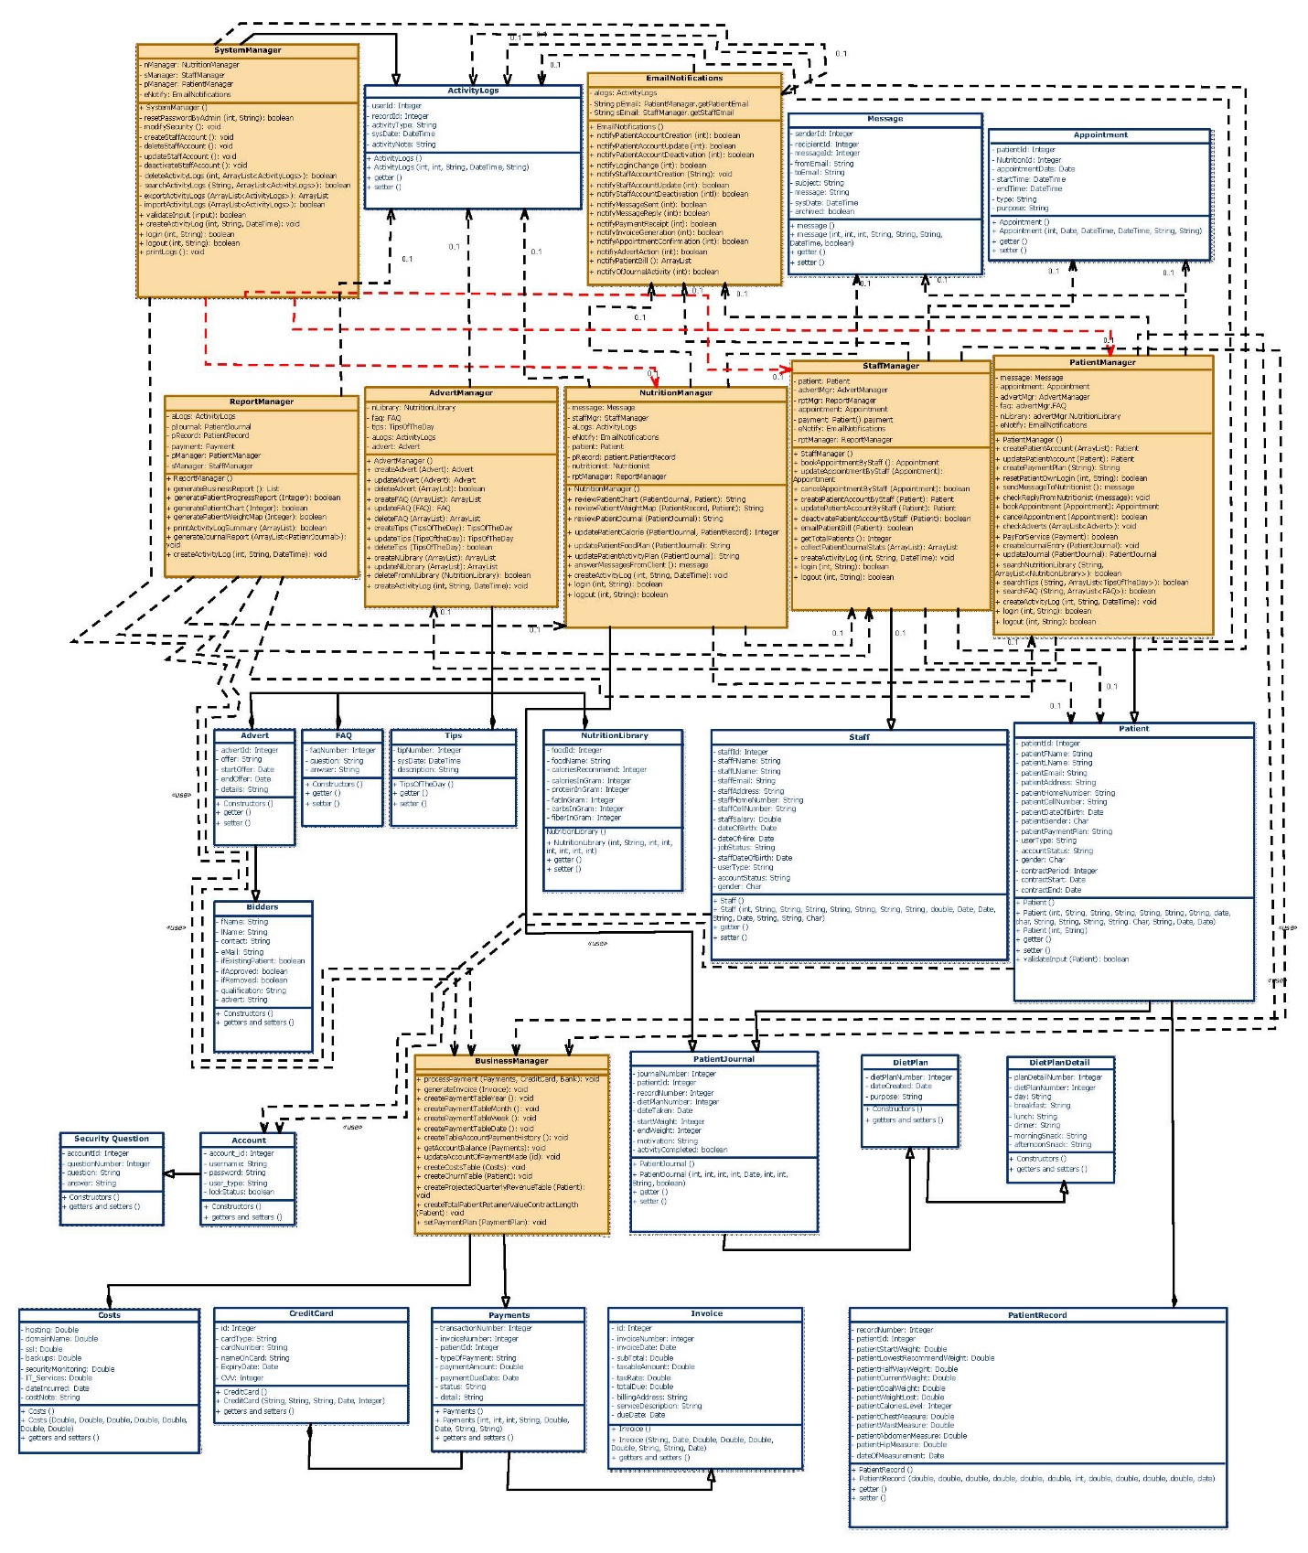For the bigger version, please see Appendix D.

Figure 2: Problem Domain Class Diagram

## STATE MACHINE DIAGRAMS

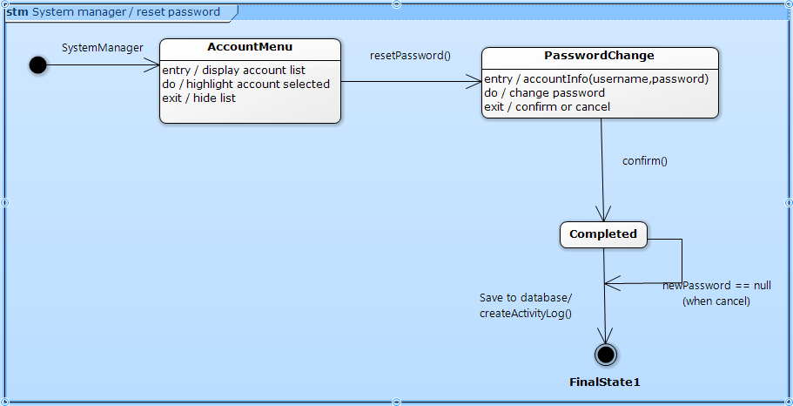Figure 3 System manager - reset password

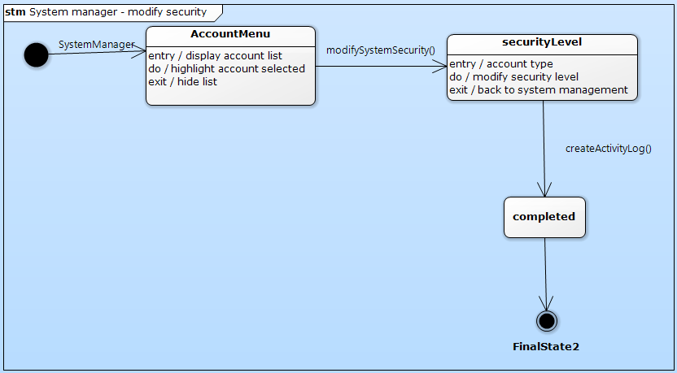Figure 4 System manager - modify security

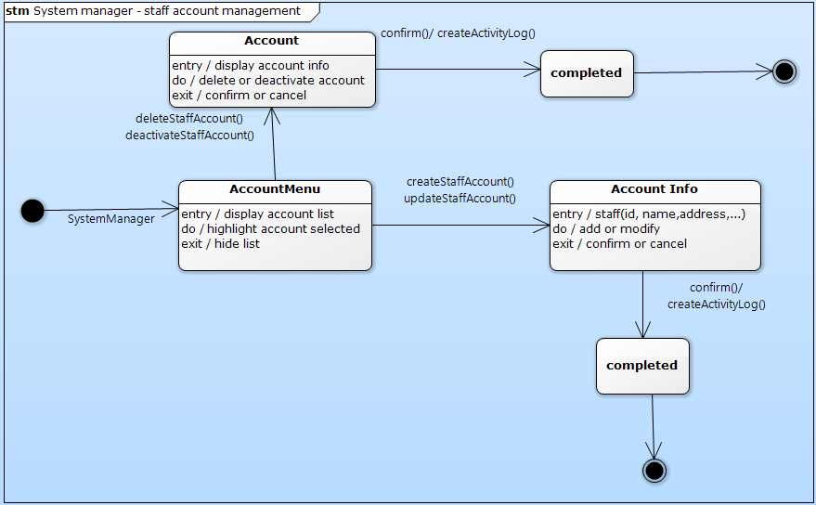Figure 5 System manager - staff account management

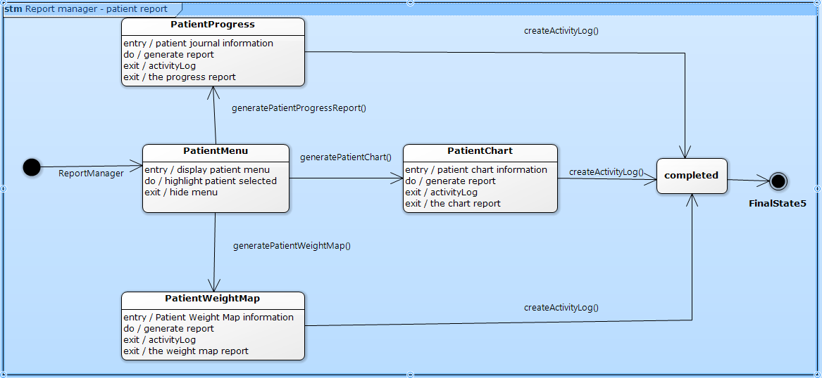

Figure 6 Report manager - patient report

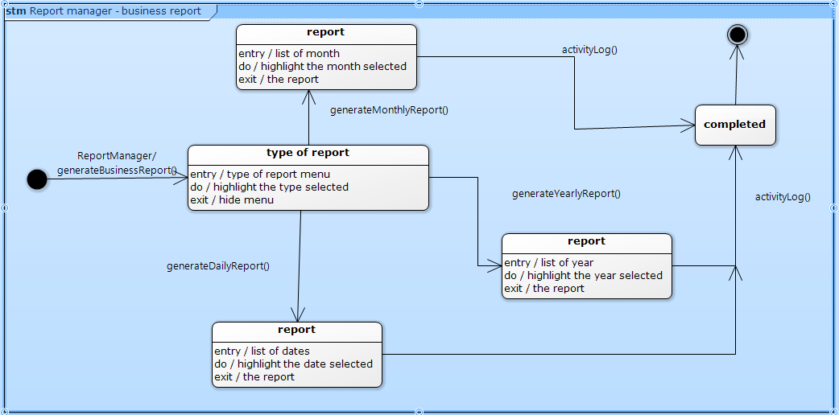Figure 7 Report manager - business report

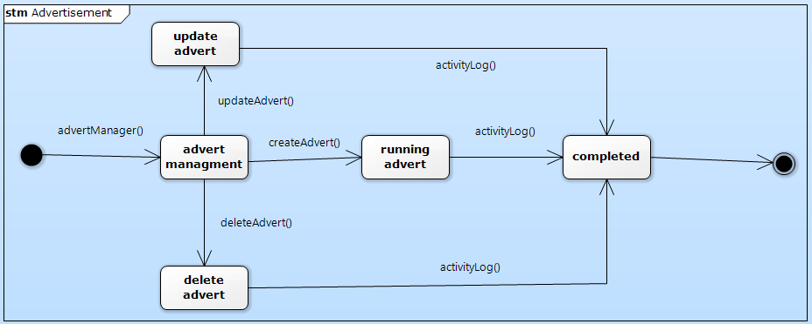Figure 8 Advertisement

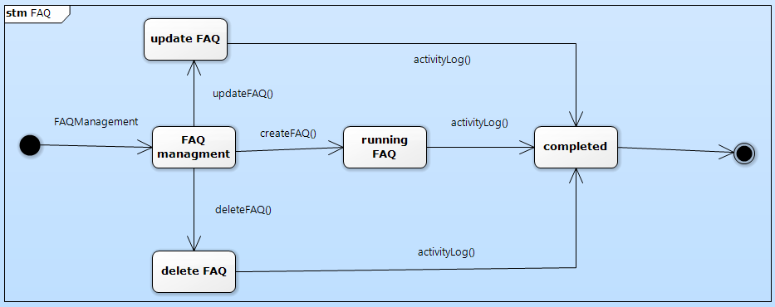

Figure 9 FAQ

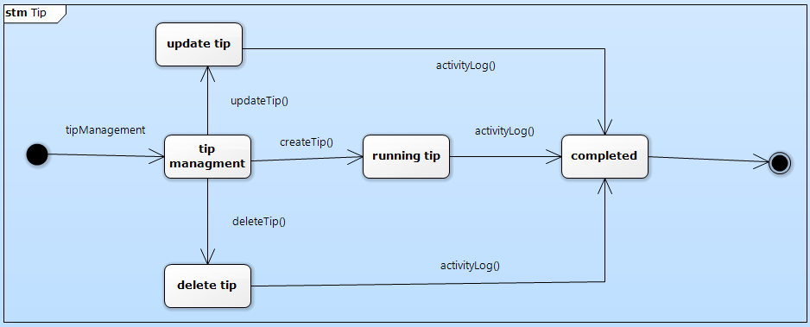

Figure 10 Tip

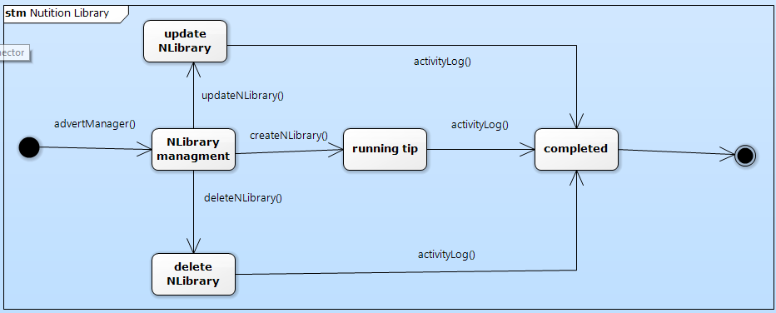

Figure 11 Nutrition library

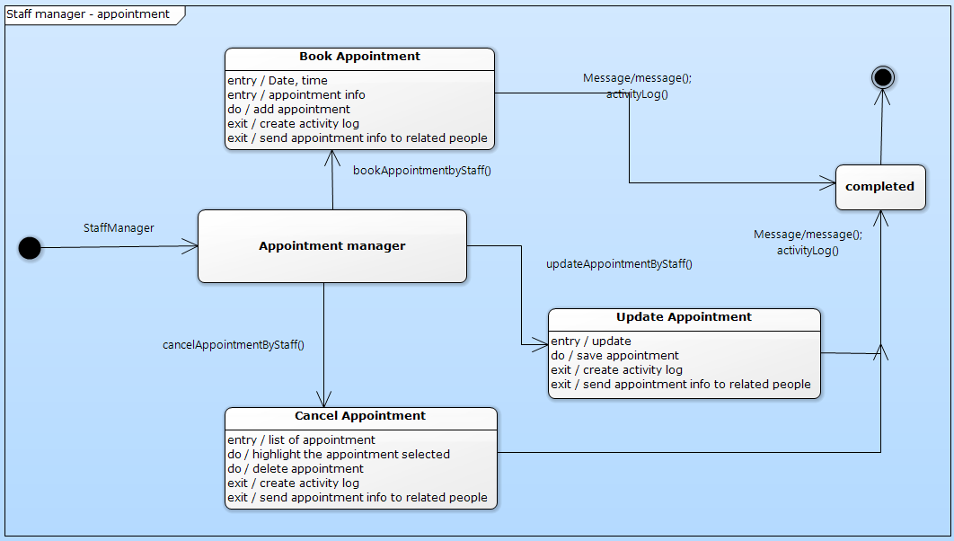

Figure 12 Staff manager – appointment

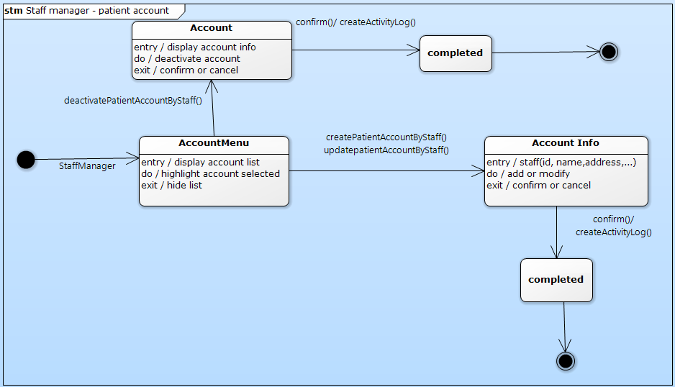

Figure 13 Staff manager - patient account

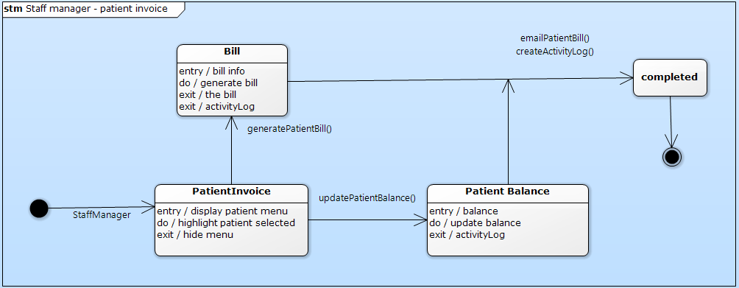

Figure 14 Staff manager patient invoice

## ACTIVITY DIAGRAMS

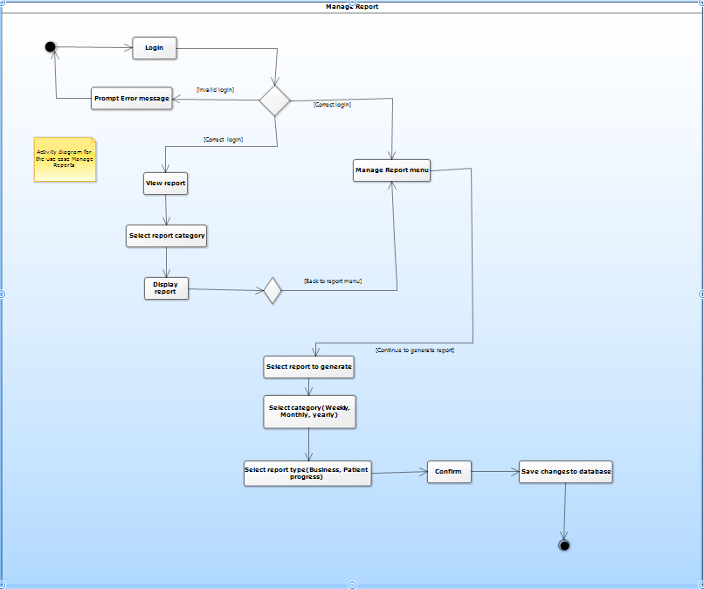

Figure 15 Manage report

# system design

## layered architecture

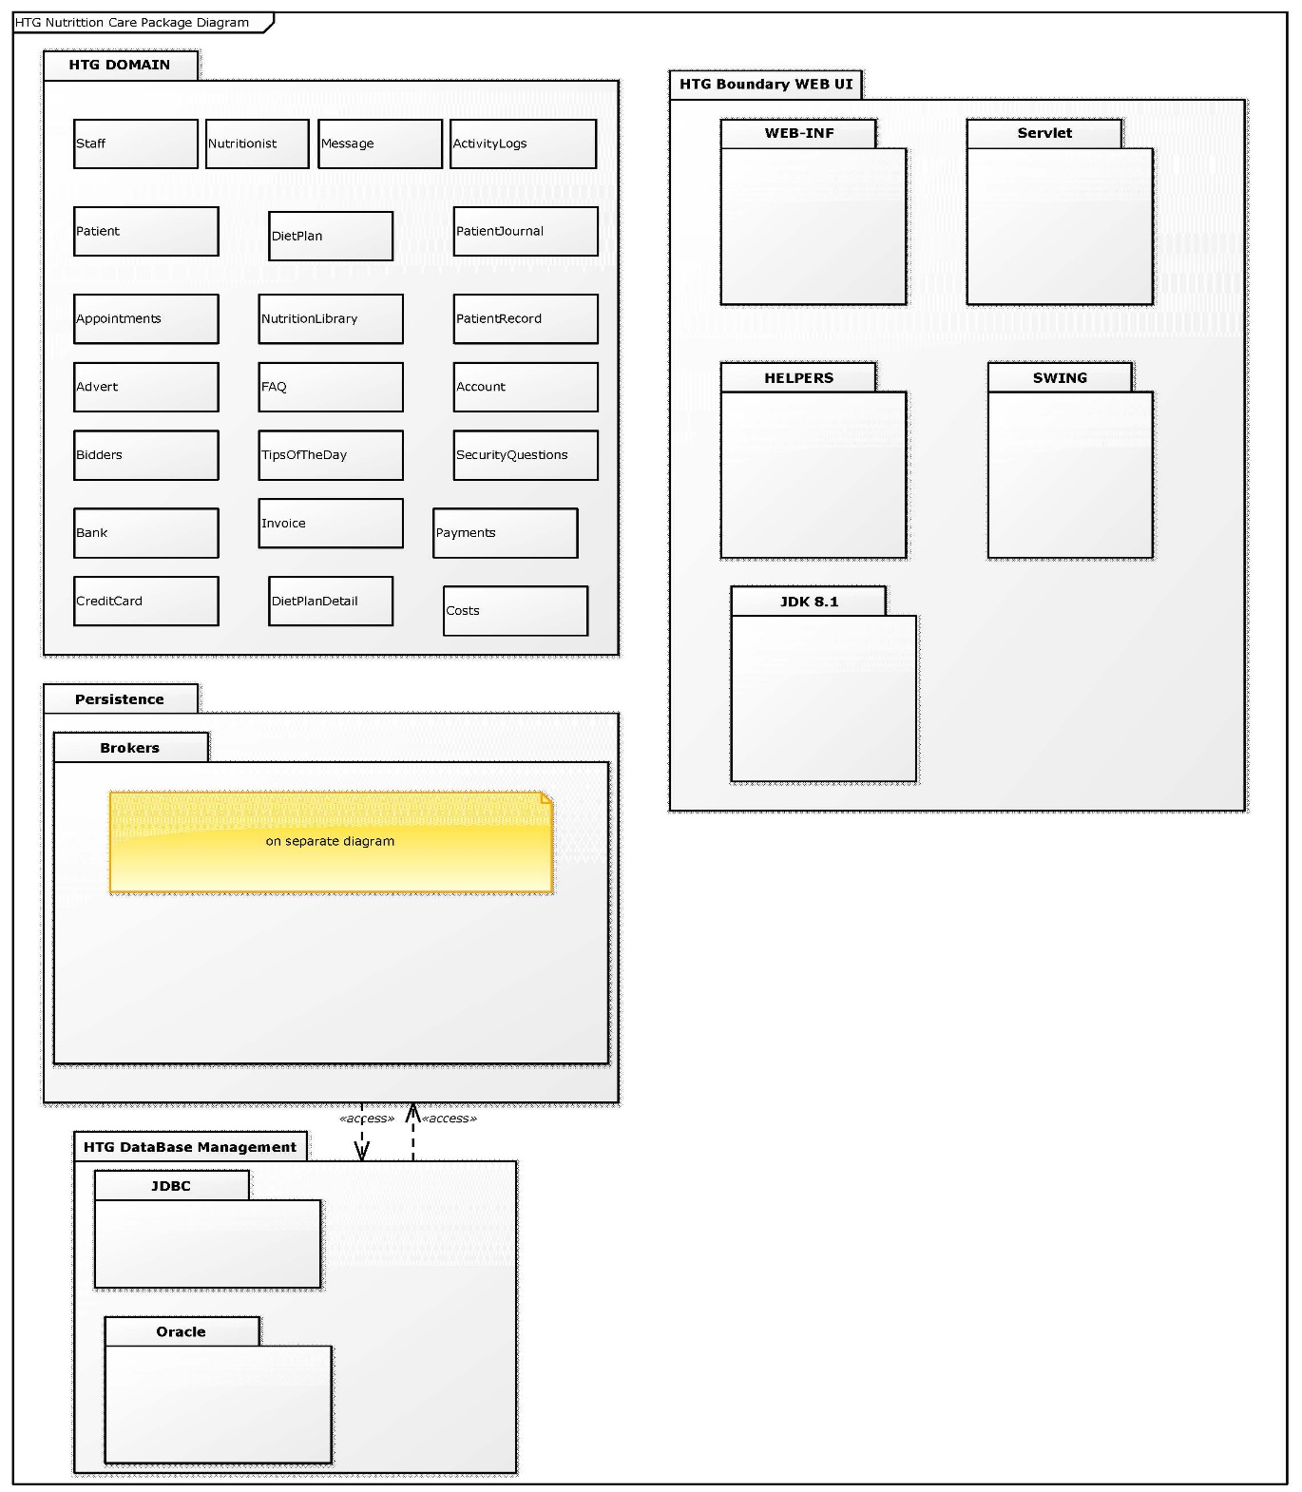

Figure 16 Package Diagram

## hardware architecture

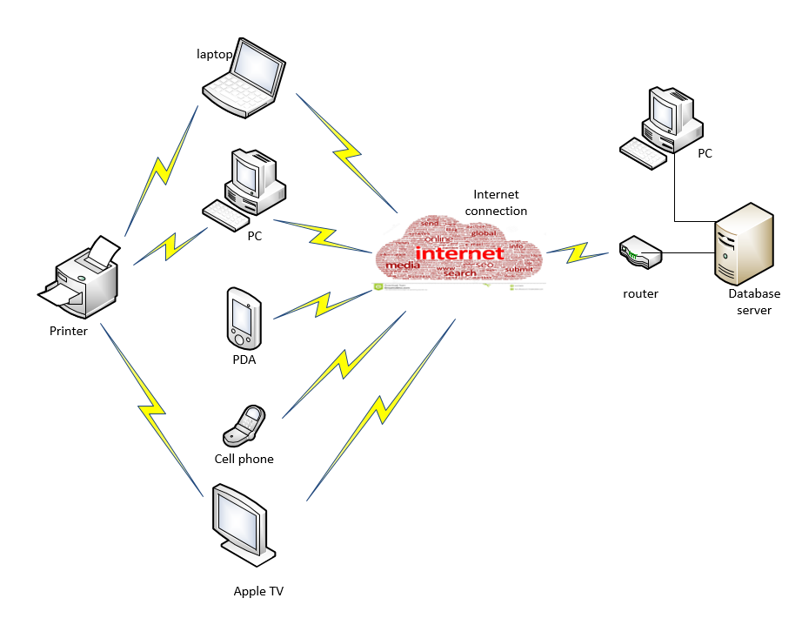

Figure 17 Hardware requirements

The system of Health To Go will be deployed on the web. As a minimum requirement, there must be a personal computer, a database server and internet connection where it can be maintained from. From there, the different internet connected devices can connect.

## hardware platform

1. Required hardware specs to develop and maintain

* Device type: laptop or desktop
* Operating System: Windows 7 (64bit or 32bit) or higher
* RAM: 8.00 GB or higher
* CPU: Core i3 @ 2.10Ghz or higher

1. Required hardware specs for production system

* Device type: laptop
* Operating System: Windows 7 (64bit or 32bit) or higher
* RAM: 8.00 GB or higher
* CPU: Core i3 @ 2.10Ghz or higher

## software platform

1. Required software specs to develop and maintain
   * + - Database development tool: Oracle Database 11g
       - Java Development Kit (JDK) version 8u112
       - Java Runtime Environment (JRE) SE version 8u111
2. Required software specs for production system
   * + - Database Development Tool: Oracle Database 11g
       - Java Development Kit (JDK) version 8u112
       - Java Runtime Environment (JRE) SE version 8u111
       - Netbeans IDE version 8.1

## interaction model

Note: The models presented here are by no means going to be the exact appearance on the application in production. These models merely represent what elements are required for each page of the application.

1. Interface Model Design Standards
2. Header
3. Logo
   1. Apple (in red)
   2. Text: Health To Go with the letter “T” of “To” shaped like a tree
      1. Font-size: h1
      2. Font-family: Calibri
      3. Color: shade of green with gray shadow
   3. Sub-Text: Nutrition Care
      1. Font-size: h3
      2. Font-family: Calibri
      3. Color: shade of green with gray shadow
4. Navigation bar:
   1. Content:
      1. Home
      2. Services
      3. About Us
      4. Contact Us
      5. Nutrition Library
      6. Sign up
      7. Login
      8. Logout
   2. Styles
      1. Font type: Sans Serif
      2. Size: 18px
      3. Color: dirty white
      4. Hover color effect: bright white
      5. Graphics: bootstrap Glyphicons
      6. Background: black
      7. Border corner radius: rounded
   3. Dimension: 30 x 1000 pixels
5. Body
6. Background: transparent
7. Dimension: 500 x 1000 pixels
8. Titles:
   * 1. Text:
        1. Font-family: Calibri
        2. Font-size: 46x
        3. Color: black
     2. Background: banner with gradient greenish color and a double light-gray elevated backdrop
9. Pictures: tiled either square or round
10. Text:
    * 1. Font-family: Calibri
      2. Font-size: h2
      3. Color: black
11. Captions:
    * 1. Font-family: Sans Serif
      2. Font-size: 12px
      3. Color:
         1. Regular: black
         2. Anchor tags: blue
12. Buttons: orange-yellow
13. Footer
14. Content:
    1. Copyright
    2. Contact information
    3. Home link
    4. mailto link
    5. design
15. Type: line box
16. Background color: black with grayish shadow
17. Styles:
    1. Font-family: Sans Serif
    2. Font-size: 15px
    3. Color: dirty white
    4. Anchor tags: blue, no underline
    5. Hover effect: font-size increase by 0.2em with shades of yellow color
18. Modal popups
    1. Header: gradient yellow
    2. Body:
       1. Graphics: bootstrap glyphicons
       2. Text:
          1. Input:
             1. Font-family: Calibri
             2. Font-size: 13px
          2. Placeholder:
             1. Font-family: Sans Serif
             2. Font-size: 12px
          3. Color: black
       3. Buttons:
          1. Background: red
          2. Font:
             1. Family: Calibri
             2. Size: 13px
             3. Color: white
    3. Footer:
       1. Graphics: bootstrap glyphicons
       2. Text:
          1. Anchor tag color: shade of green or blue
          2. Regular: dark gray
19. Design models



Figure 18: HTG home screen



Figure 19: Services page



Figure 20: About page

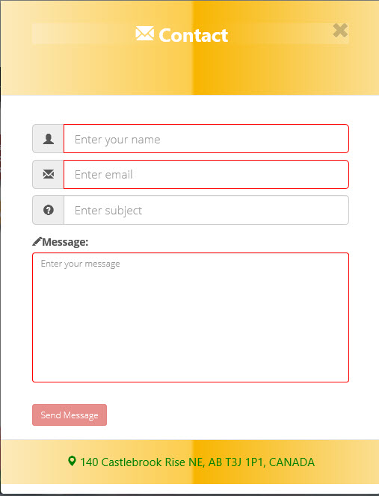

Figure 21: Contact us popup link on navigation bar

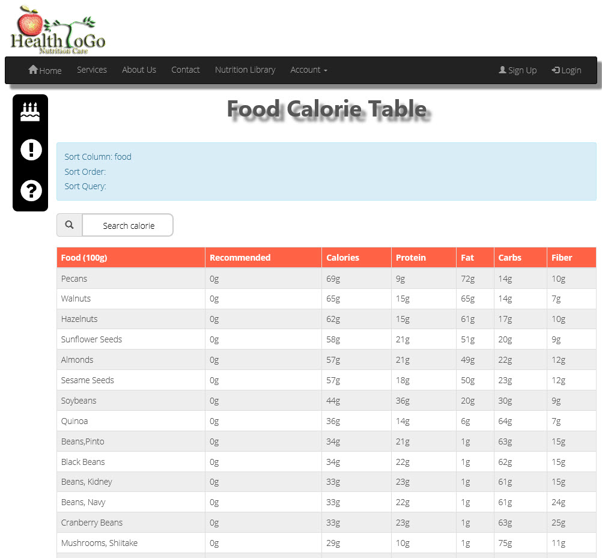

Figure 22: Food calorie table

This calorie table is part of the nutrition library which is a link on the main navigation bar.

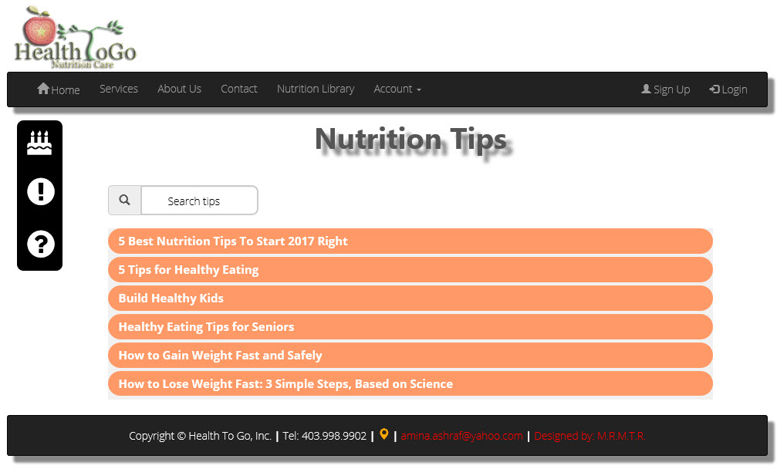Figure 23: Nutition tips table

This nutrition tips table is part of the nutrition library, which is a link on the main navigation bar.



Figure 24: Nutrition tip

This nutrition tip is one of the tips under the table of Figure 23.

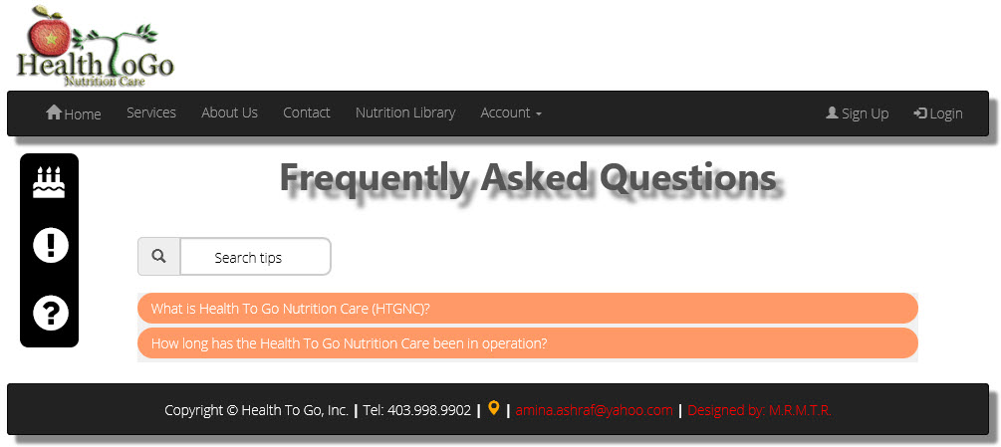

Figure 25: Frequently asked questions

This FAQ table is also part of the nutrition library, which is a link on the main navigation bar.

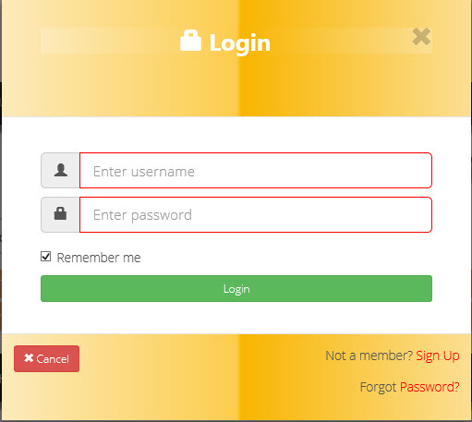

Figure 26: Login

This login is the official login for all users of the application. By the red lines around the input boxes, this login observes front-end validation, not just back-end validation. This popup also has sign up and forgot password features. The remember me checkbox is not implemented.

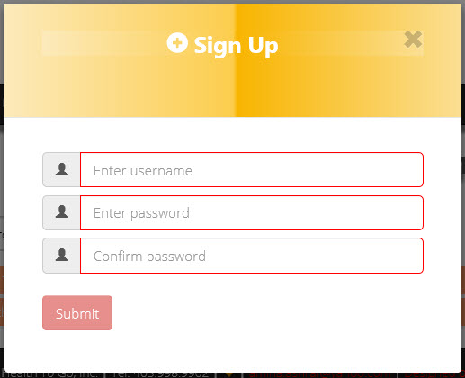

Figure 27: Sign up (part 1)

When the sign up link is clicked, it opens up this popup for initially creating the user’s username and password. Once the data passed validation, it pulls up a second sign up page.

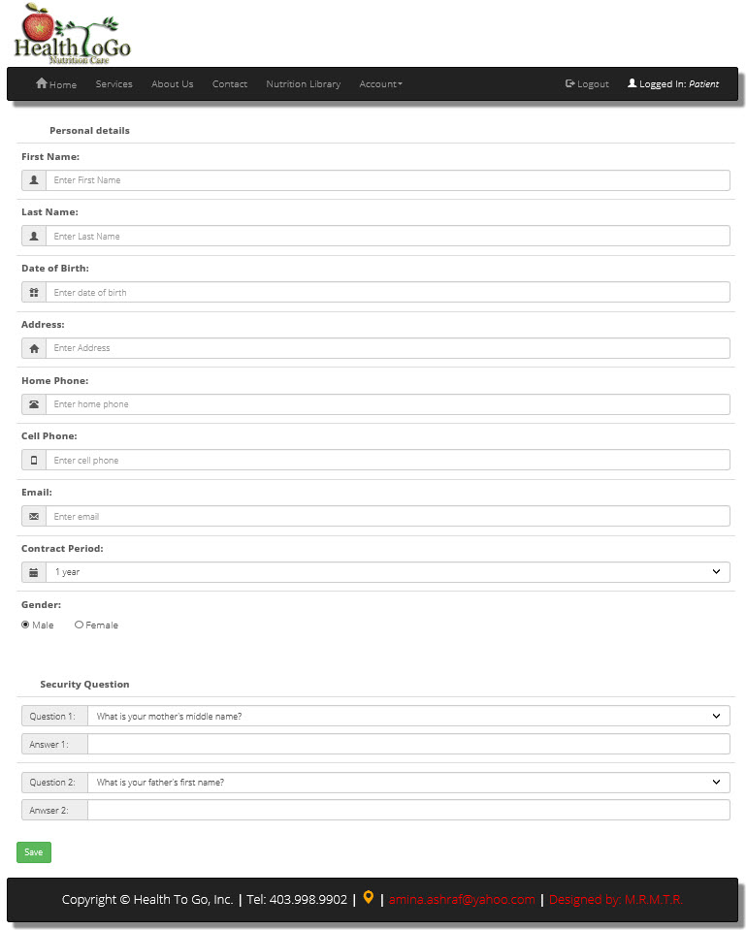

Figure 28: Sign up (part 2)

This sign up part 2 is the page that comes out after part one of the sign up gets validated. Here, the user will have to enter more details of herself/himself for his/her own profile in the system.

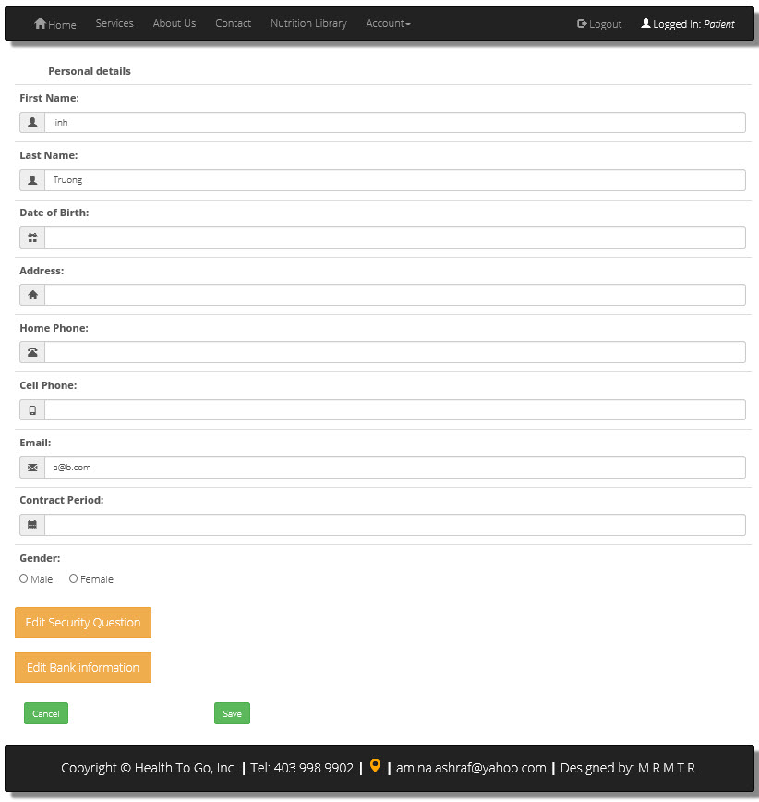

Figure 29: Edit account

An existing account can be edited. This is a link under Account on the navigation bar after the has successfully logged.

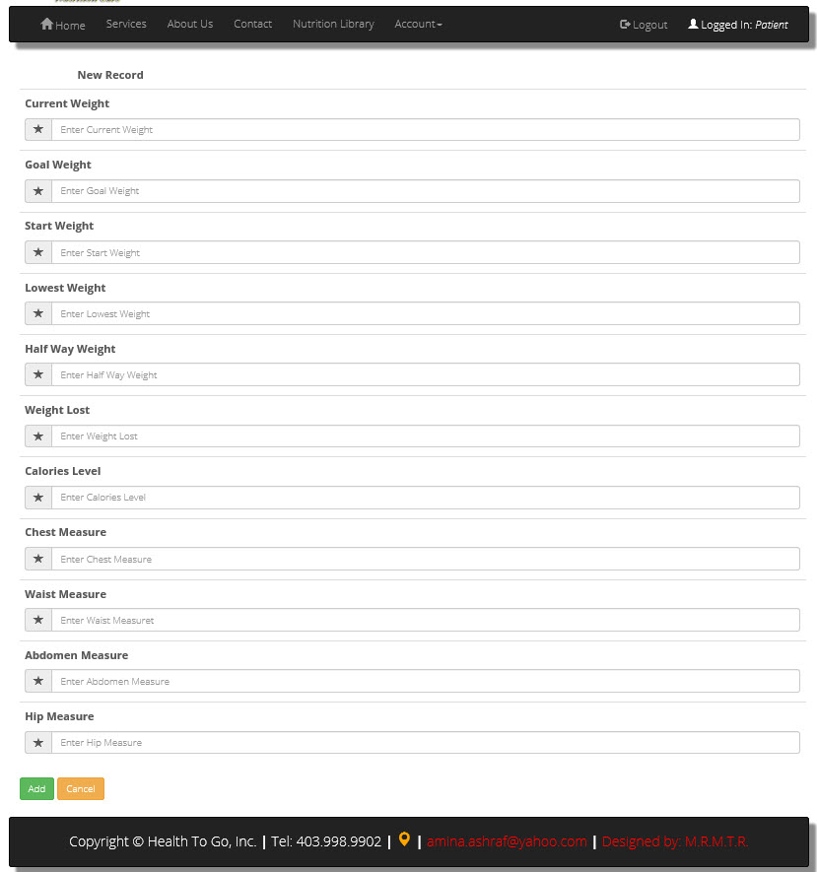

Figure 30: Add patient record (part 2)

Important in the consultation between the nutritionist and patient is the record of the client’s statistics. This form grabs the initial weight and measurements of the patient and saves it in the database.

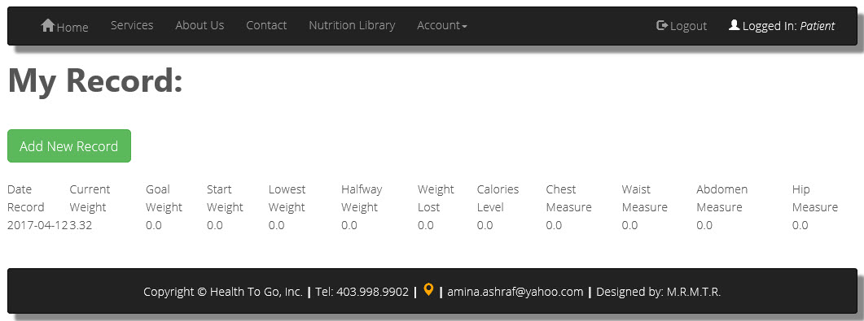

Figure 31: Patient Record (part 2)

Once a record is saved, it gets listed in a table summary above. The labeled ‘Add New Record’ pulls up the previous in Figure 30 for entering a new set of weight and measurements for the patient as the consultancy progresses. As new records get saved, the stack up in the table summary above.

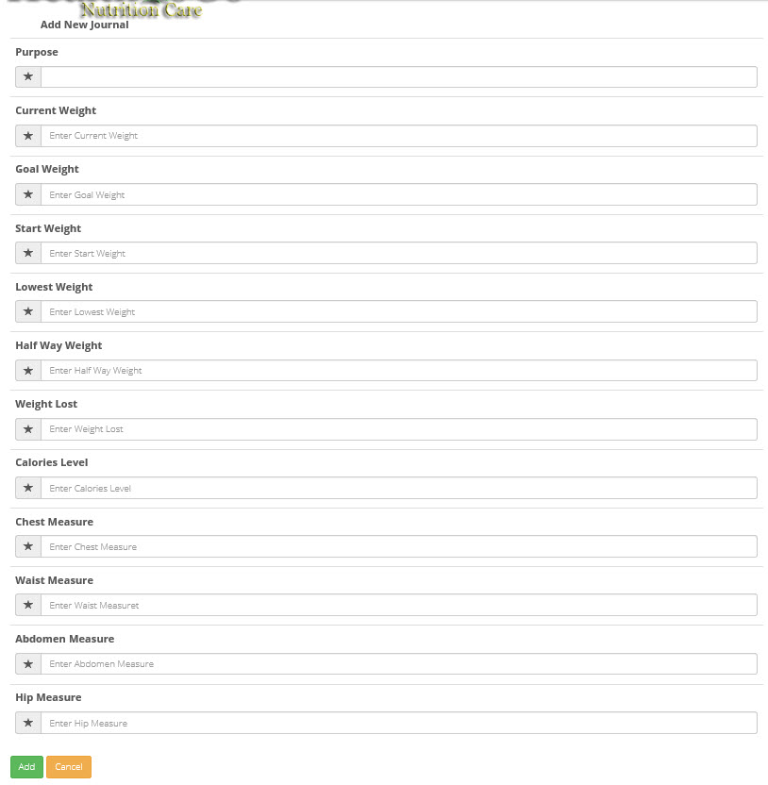

Figure 32: Add new journal (part 1)

The core of the consultation system is the creation by the patient of patient journals. The patient submits a journal for each round of consultations. This data form part of the assessments made by the nutritionist.

Figure 33: Journals table (part 2)

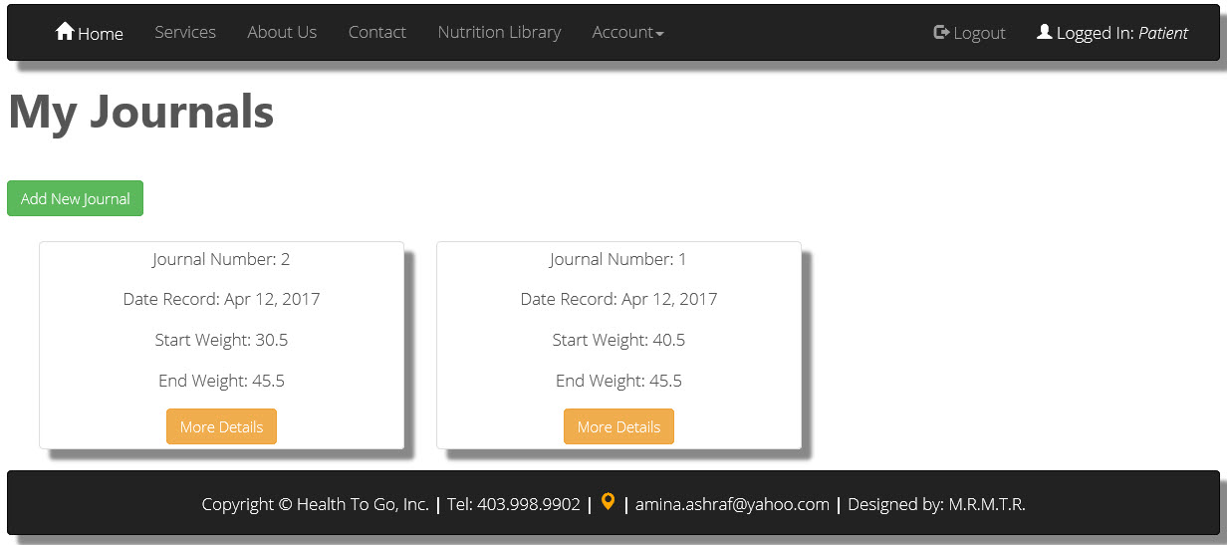Once a journal is saved, it gets posted on this ‘My Journals’ page. The green button labeled ‘Add New Journal’ opens up the form in Figure 32 for adding a new journal.

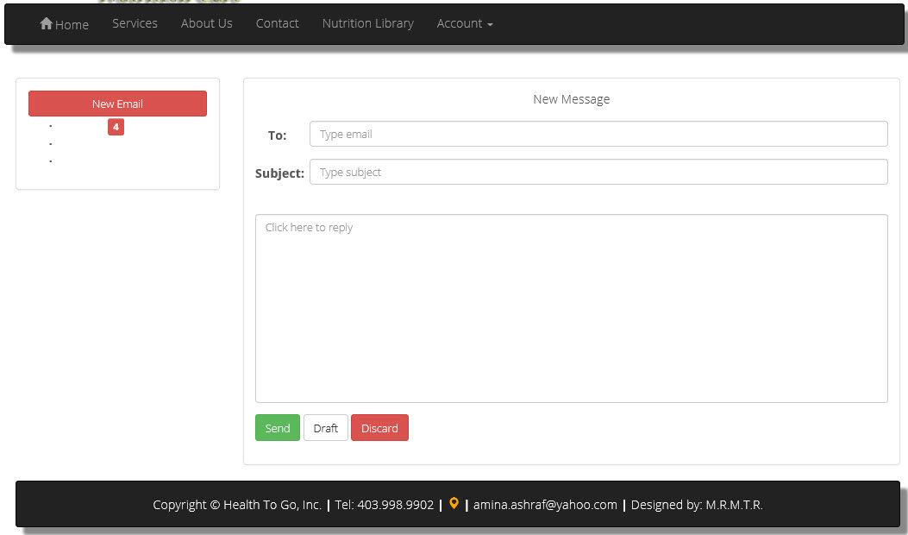

Figure 34: Send messages to nutritionist

At any time during the existence of the nutritionist-patient contract, the patient can send messages to nutritionist through the system using this form. This form has not been fully implemented.



Figure 35: Payment plans

The consultancy has different options. On this page, the prospective client can select his/her desired plan with an option to make an advanced payment. The buttons are links to Paypal.

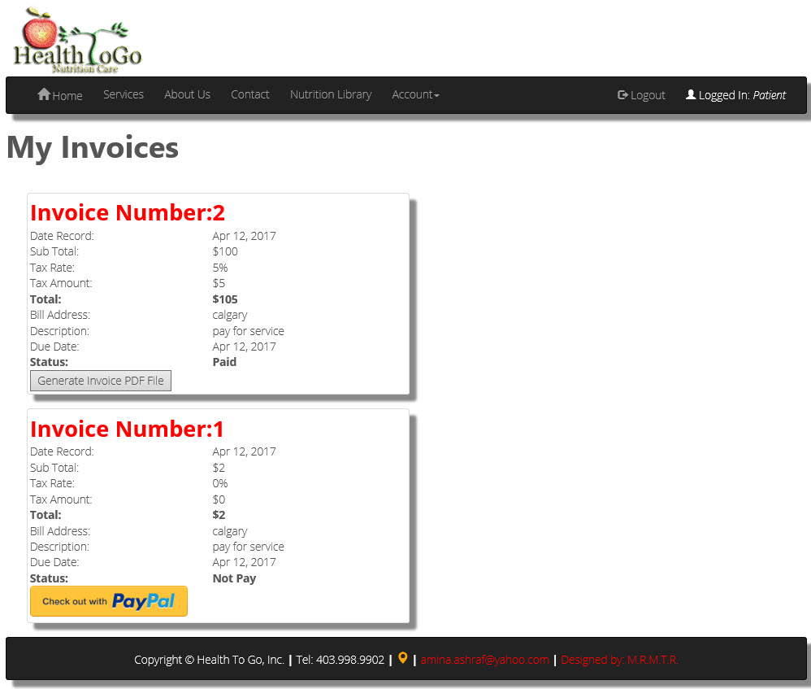

Figure 36: My invoice and payment

Through the system, patient will be able to pay for his/her recurring dues through Paypal. The yellow button at the bottom, takes his/her through this process. Once the payment is done, the patient should be able to printout a copy of his/her invoice. The regular-looking button in the above section creates a PDF version of the invoice and opens it on another tab.

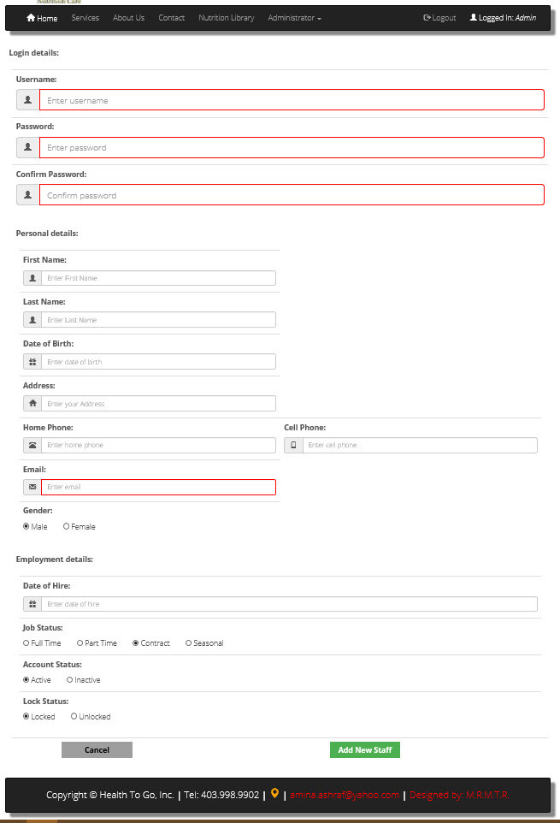

Figure 37: Create staff account by admin

An admin’s work is vital in a system. Through the above form, an admin can create any staff position for the business.

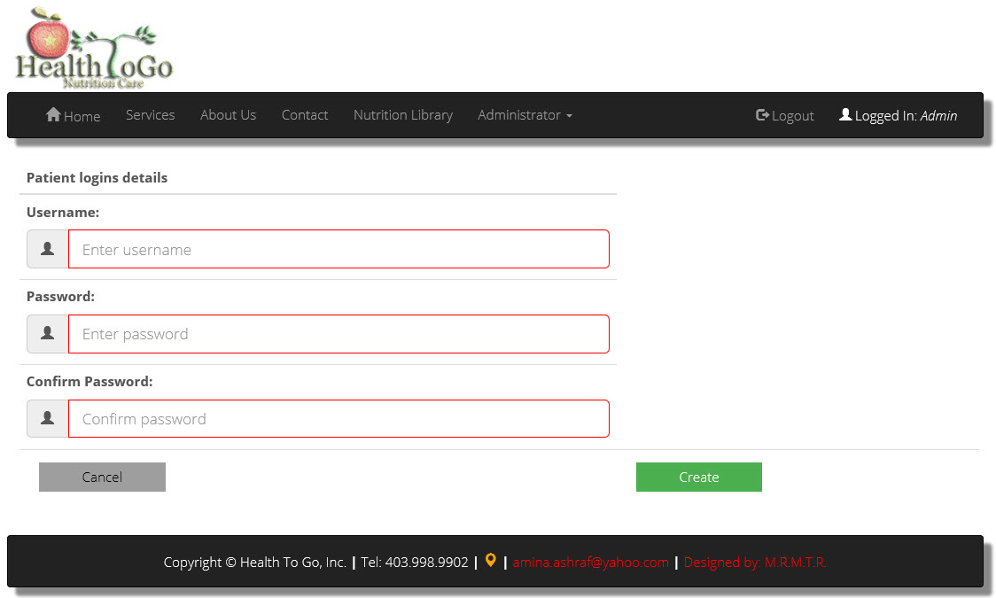

Figure 38: Create patient account by admin

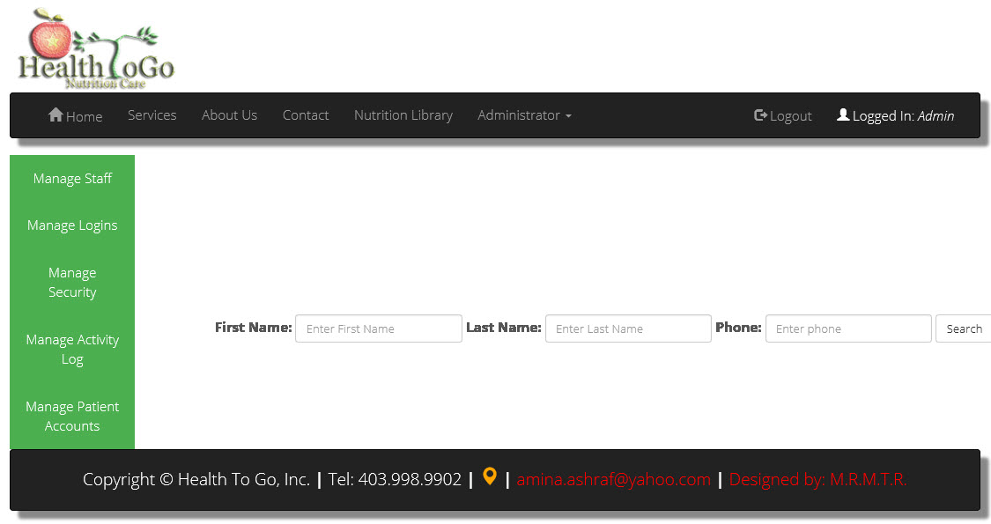With this initial form, an admin can be able to initiate the creation of a patient account as well.

Figure 39: Reset login by admin

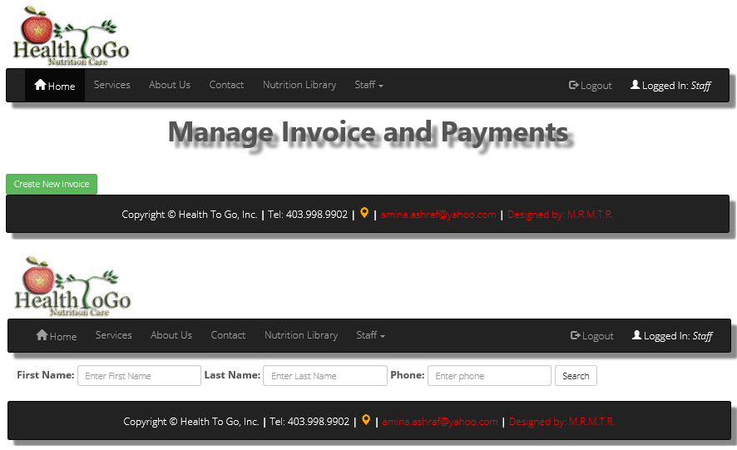

Figure 40: Manage Invoice and Payments by staff

The is able to do maintenance with any patient invoice and payments. By clicking on the button in the top section of the above figure, it calls in an account search functionality, which is the bottom section. When search is done, the page that appears is similar to that in Figure 36, which shows a particular customer’s invoice and payments page.

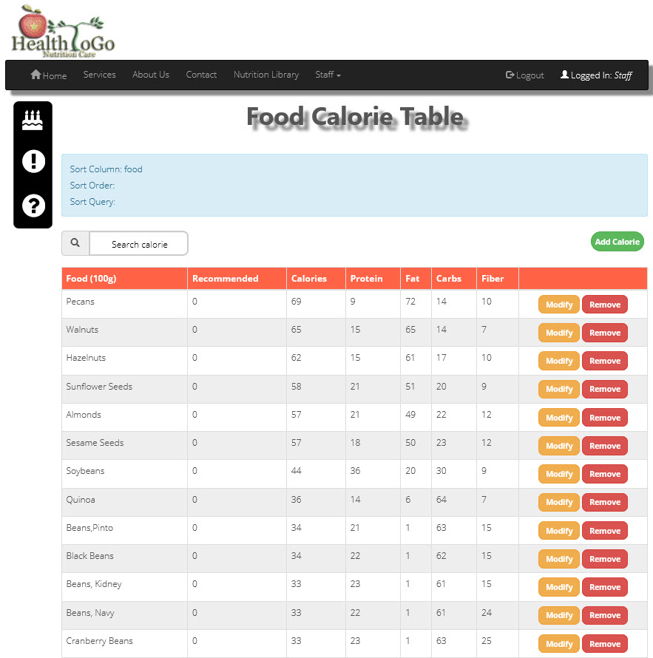

Figure 41: Manage calorie table

The staff manages the nutrition library. Once logged in the staff has access to the above screen. This screen lets the staff to manage the calorie table. It lets the staff calorie, modify and remove calorie from the table.

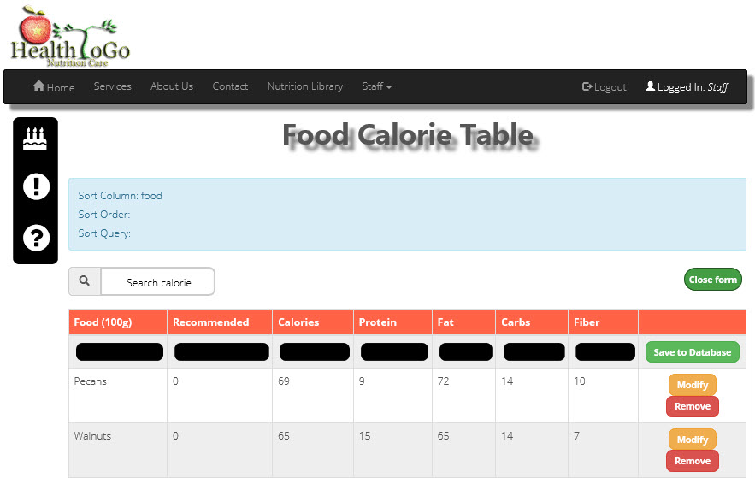

Figure 42: Add calorie

To add a calorie to the food calorie table, there is a button labeled ‘Add calorie’ located on the middle-right hand section of the above-screen that you can press to transform the form into a data-entry screen like above. On click of that button, it changes the button to ‘Close form’, shows a row of blank fields ready for data entry, and a button on the right to save the data into the database.

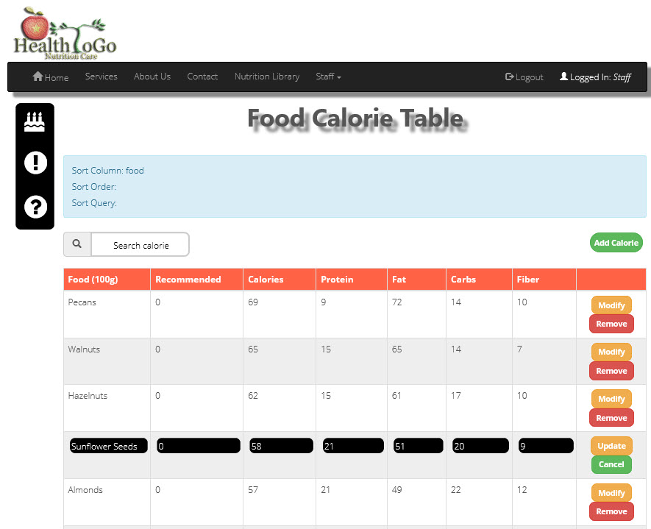

Figure 43: Modify calorie

The buttons on the right-hand said, lets you either modify the row’s calorie or remove it from the table. The blackened rows above signify that the data contained in each row can be changed. When this feature is active, the button on the changes too into ‘Update’ and ‘cancel’ from ‘modify’ and ‘remove’.



Figure 44: Manage nutrition tips

The staff can also manage the nutrition tips table. With this screen, the staff should be able to add tips to the tips table in Figure 25 using the green button near the top right-hand side. Just below the red bar on the right, there are two black shade encircled symbols. These two let the staff edit or remove the tip that is open.

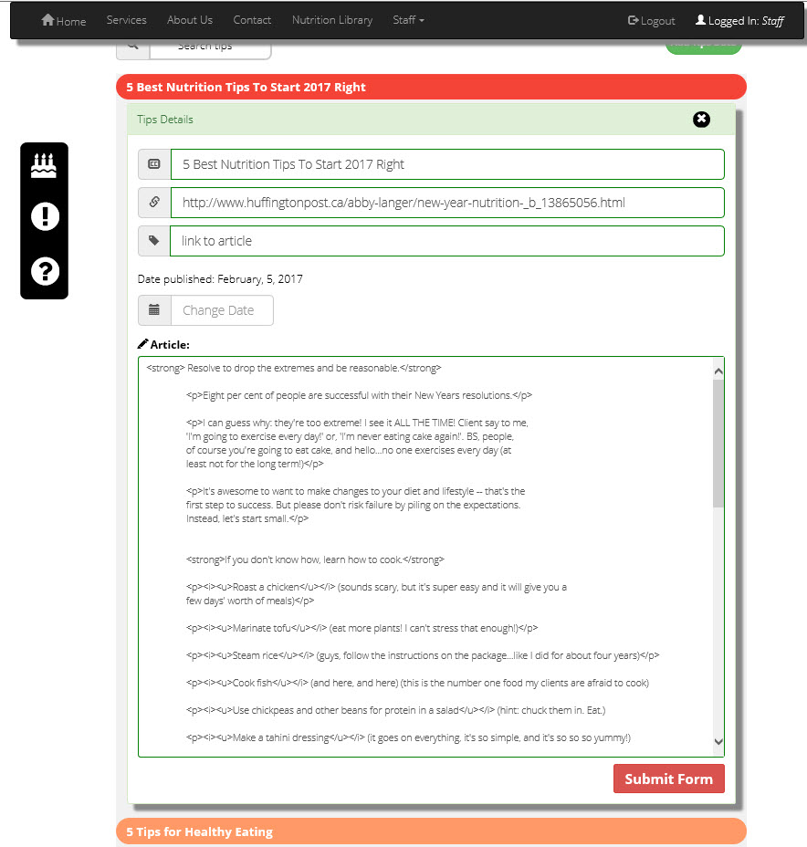

Figure 45: Edit tips

With the click of the edit button, which is the first button below the red bar on the right-hand side in Figure 44, the screen transforms into this. With this screen, the staff should be able to edit the opened tip properly, and then, submit the changes using the red ‘Submit Form’ button at the bottom right of the screen.

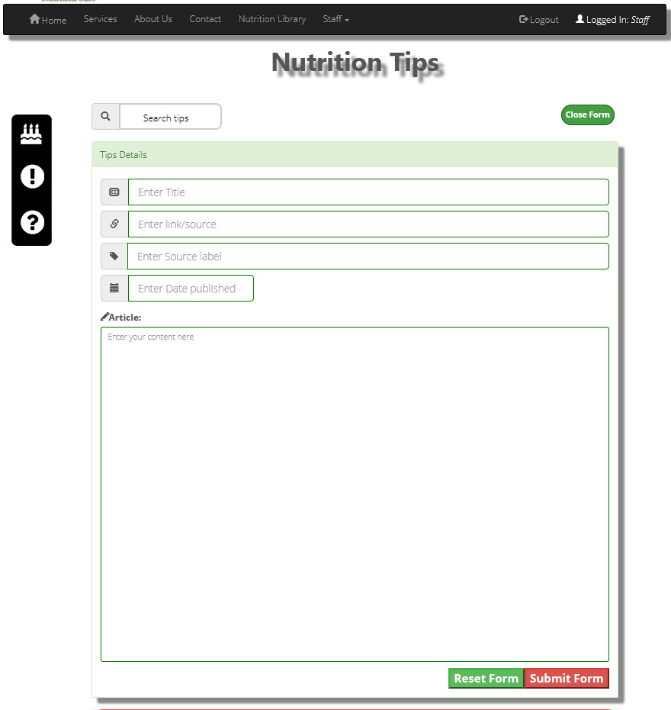

Figure 46: Add nutrition tips

When adding a nutrition tip, the staff can click on the ‘Add tips data’ shown in Figure 44 and a blank fillable form opens on top of the tips table for accepting the new tips data. Using the above screen, you can close the form using the close button at the tom, reset the form using the reset button at the bottom, or submit the newly created form to save it into the database.

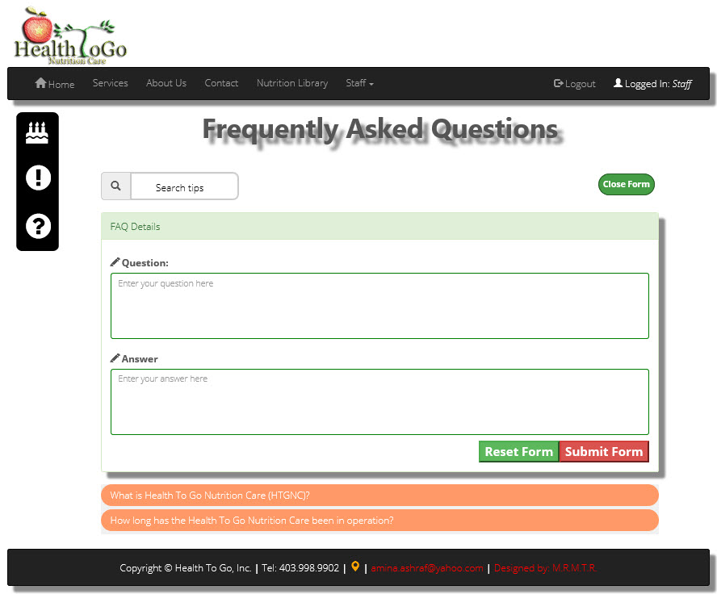

Figure 47: Add FAQ

To add FAQ in Figure 25, you have to log in as staff and click on the manage FAQ link under the staff menu. The above screen lets you add a set of question and answer to the FAQ table.

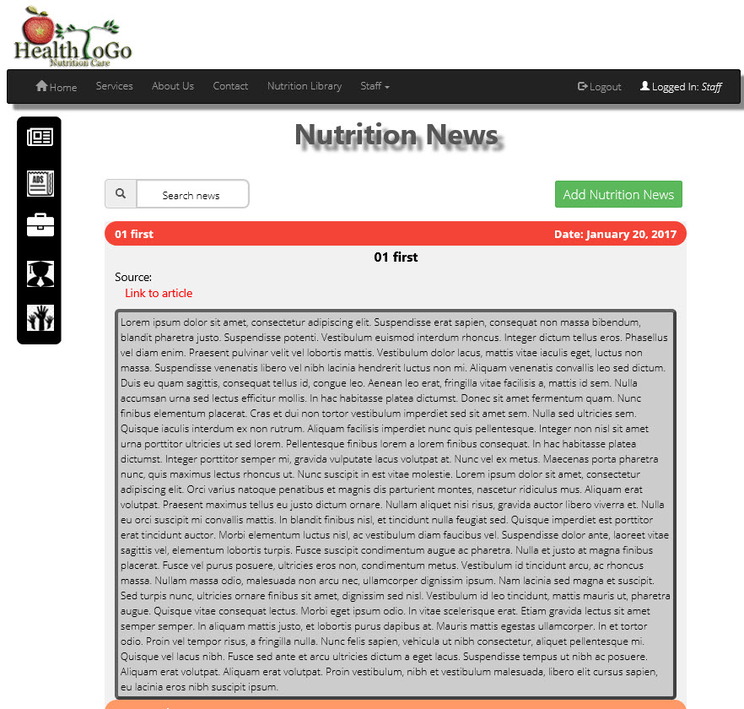

Figure 48: Manage news

This system has a news section. Similar to the functionalities in the mange nutrition library table screens, you can click on the add, edit or remove buttons to manage the news section. However, one must be logged in as staff first.

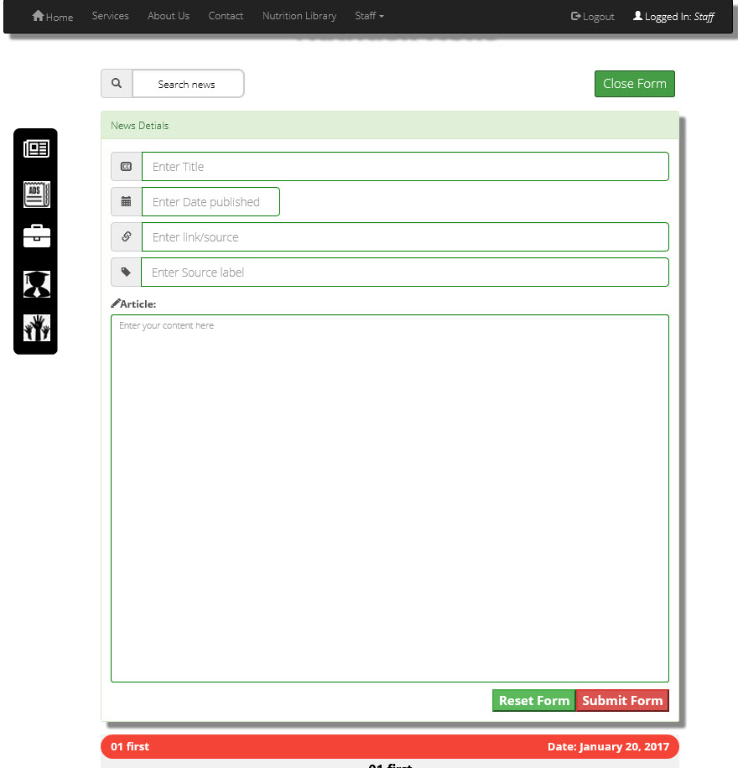

Figure 49: Add news

When add a news to the news table in Figure 48, this is the form for it. This form opens on click of the ‘Add news’ button.

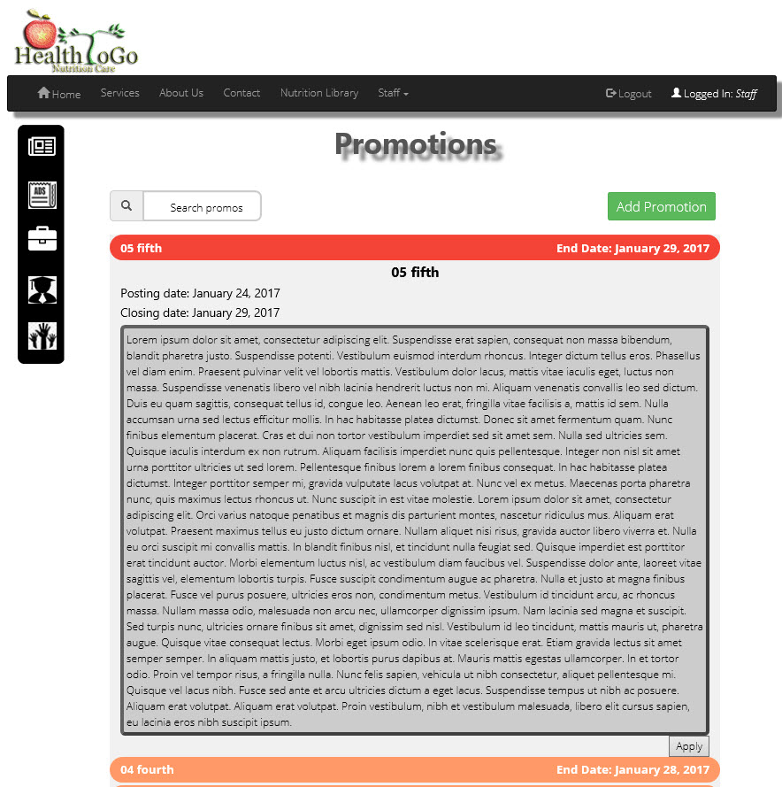

Figure 50: Manage promotions

This system has a promos or promotions section. The above screen is a sample with partially implemented functionalities. You can use the Add promotion button to create a new promotion with the posting and closing dates included. The closing date expires the promotion.

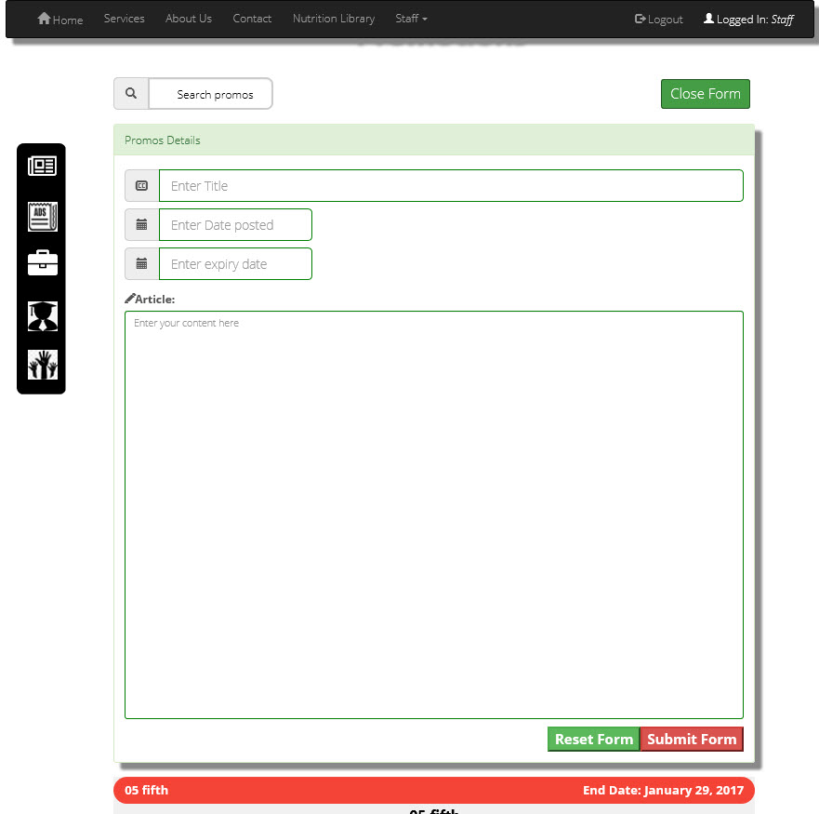

Figure 51: Add promotion

To add a new promotion, the section has its own form that opens on top of the table like the above screen for receiving inputs on a new promotion. The buttons are similar to the other similar functionalities of the system.

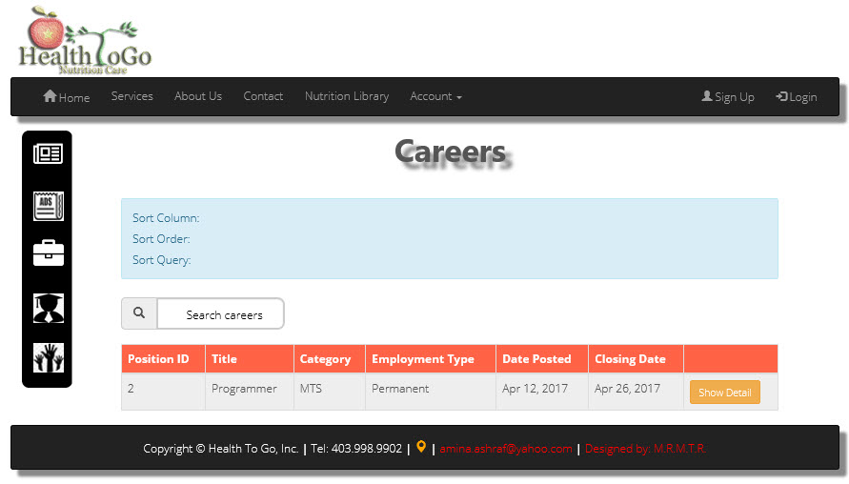

Figure 52: Career section

The system has a careers section that opens through a link on the home page. This section is good for job seekers. On click of the ‘Show Detail’ button, it opens the career position into a form for accepting new applications.

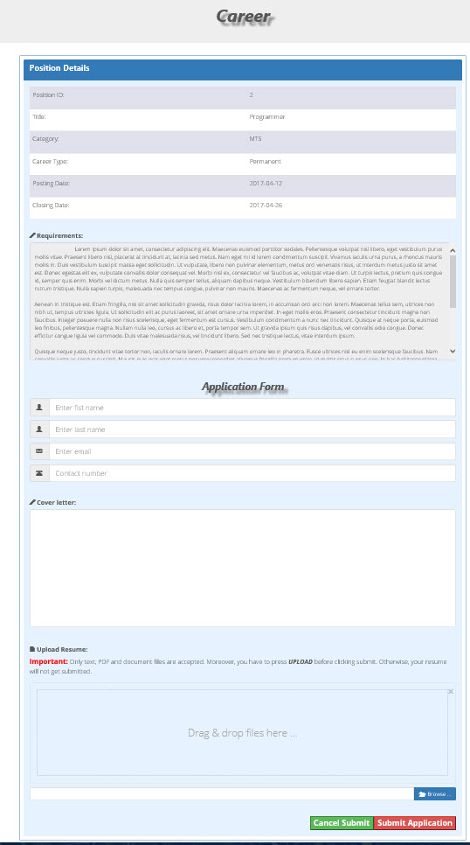

Figure 53: Career applications

A click of the ‘Show Detail’ button in Figure 52, opens into this screen above where any aspiring applicant can enter his/her information and attach a resume for submission.

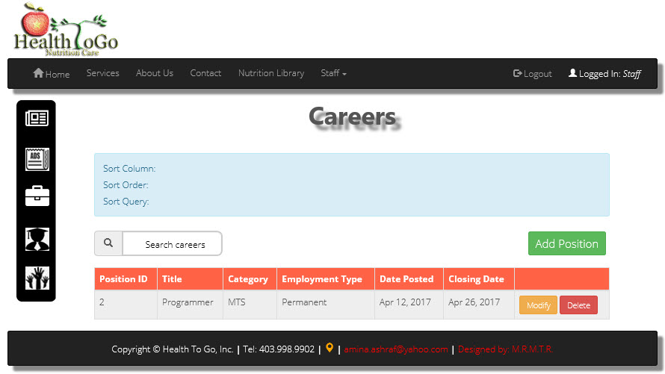

Figure 54: Manage careers

This system has a manage careers section with add modify and remove buttons that can change the entries in the table in Figure 52.

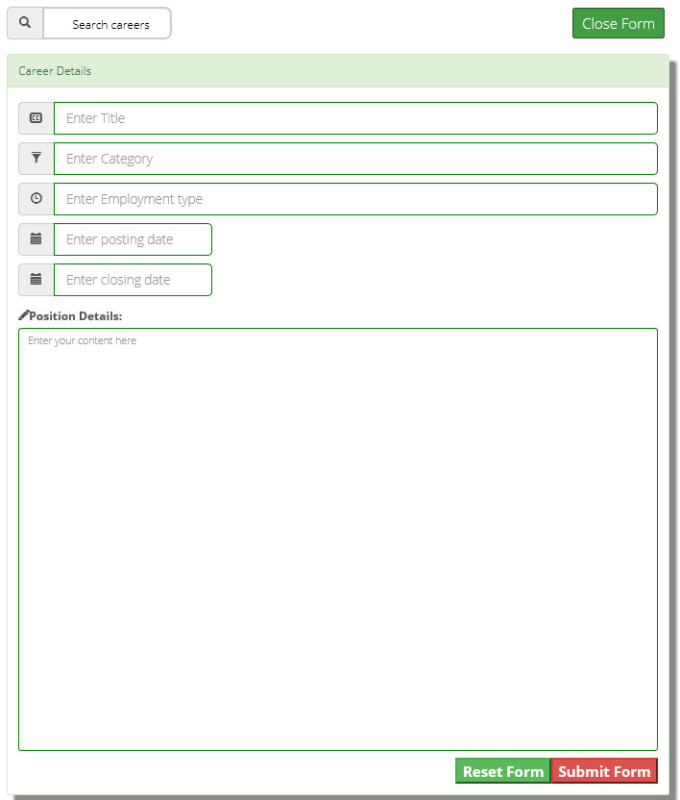

Figure 55: Add career

Clicking the ‘Add Position’ button in Figure 54 opens into this screen with similar functionalities Figure 51.

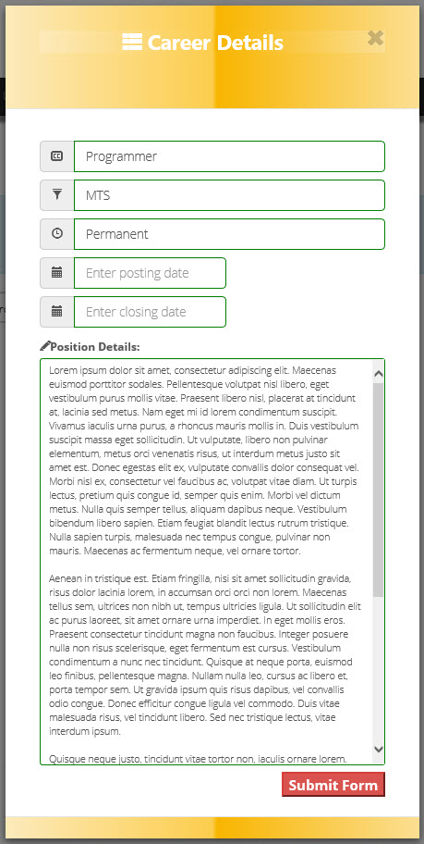

Figure 56: Edit career

Clicking the ‘Modify’ button in Figure 54 opens into this screen where you can edit the particular posted career position and its details.

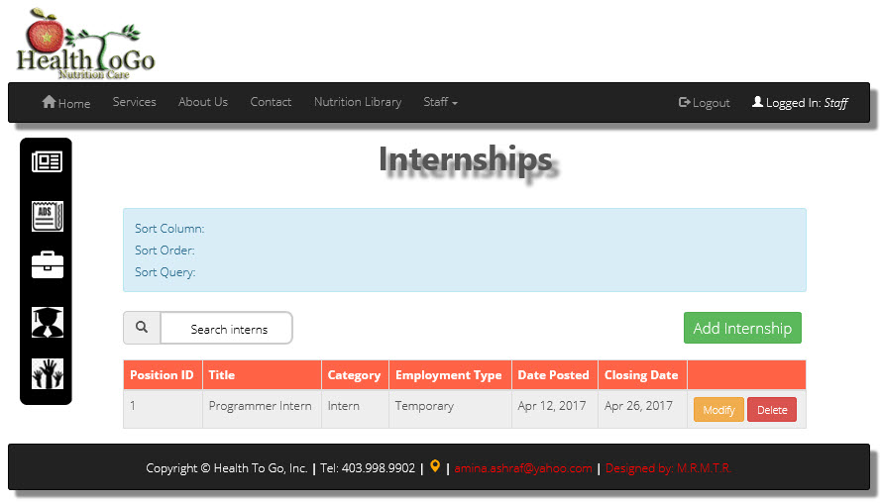

Figure 57: Manage Internship

This system has an internship screen that is accessible through a link under the Quick Links section on the home page that lets anyone looking for an internship to apply. The screen looks similar to Figure 52. In managing this screen, we have the above screen that has similar functionalities to Figure 54.

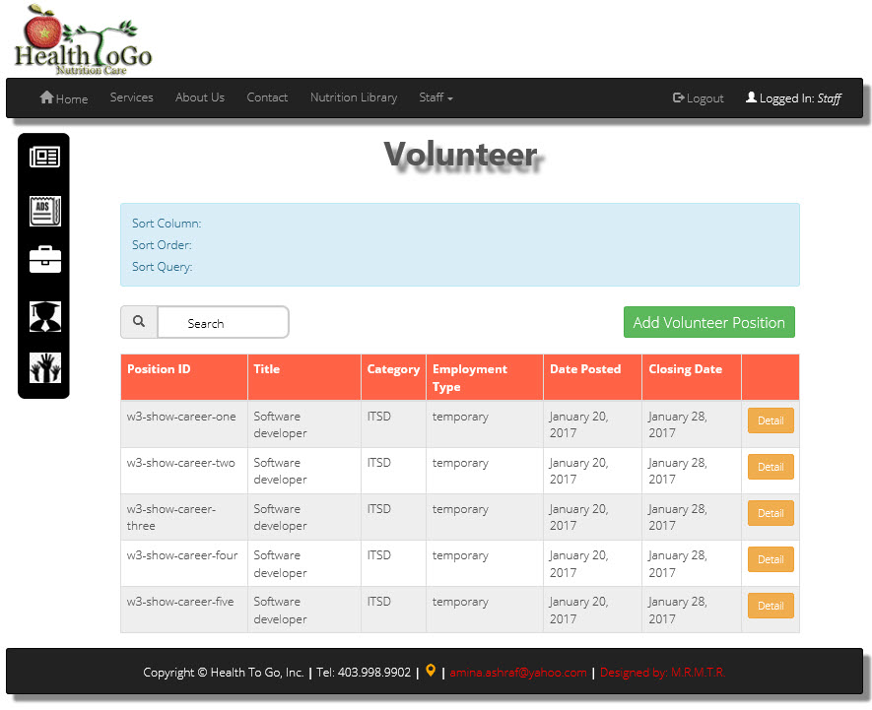

Figure 58: Manage volunteers

This system has a volunteers’ screen that is accessible through a link under the Quick Links section on the home page that lets anyone looking for an advocacy to apply. The screen looks similar to Figure 52. In managing this screen, we have the above screen that has similar functionalities to Figure 54.

## persistence model

To view a bigger picture of the ERD, please refer to Appending E.

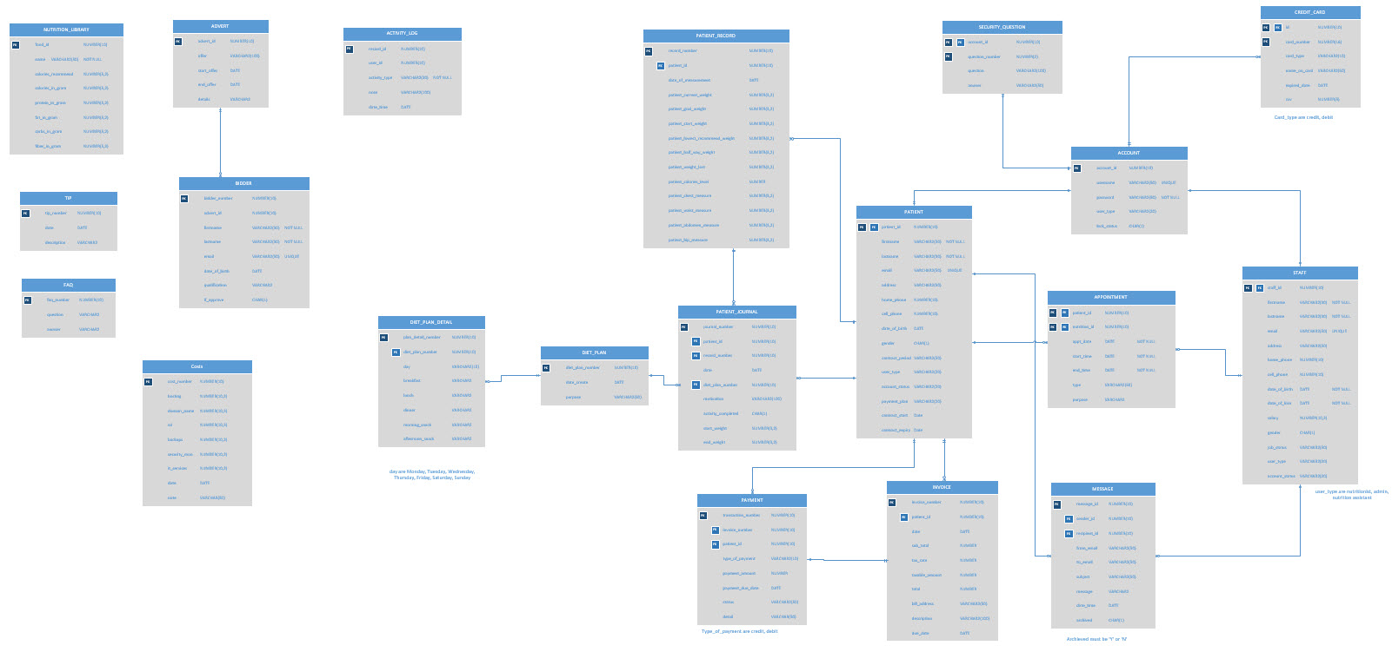

Figure 59 ERD Diagram

DATABASE TABLES

Table Name: ACCOUNT

|  |  |  |  |  |
| --- | --- | --- | --- | --- |
| **Field Name** | **Data Type** | **Data Description** | **Key** | **Expect Data Size** |
| account_id | NUMBER(10) | account’s unique ID | PK | 8 bytes |
| username | VARCHAR2(50) | account’s username | UNIQUE | 50 bytes |
| password | VARCHAR2(50) | account’s password | NOT NULL | 50 bytes |
| user_type | VARCHAR2(20) | type of account |  | 20 bytes |
| lock_status | CHAR(1) | lock status of account |  | 2 bytes |

Table Name: PATIENT

|  |  |  |  |  |
| --- | --- | --- | --- | --- |
| **Field Name** | **Data Type** | **Data Description** | **Key** | **Expect Data Size** |
| patient_id | NUMBER(10) | patient’s unique id | PK, FK | 8 bytes |
| firstname | VARCHAR2(30) | firstname | NOT NULL | 30 bytes |
| lastname | VARCHAR2(30) | lastname | NOT NULL | 30 bytes |
| email | VARCHAR2(50) | email | UNIQUE | 50 bytes |
| address | VARCHAR2(50) | address |  | 50 bytes |
| home_phone | NUMBER(10) | home phone |  | 8 bytes |
| cell_phone | NUMBER(10) | cell phone |  | 8 bytes |
| date_of_birth | DATE | date of birth |  | 10 bytes |
| gender | CHAR(1) | gender |  | 2 bytes |
| user_type | VARCHAR2(20) | type of patient |  | 20 bytes |
| account_status | VARCHAR2(20) | status of account |  | 20 bytes |
| payment_plan | VARCHAR(30) | payment plan |  | 30 bytes |
| Contract_period | NUMBER(10) | Term of contract |  | 10 bytes |
| contract_start | DATE | Start of contract |  | 10 bytes |
| contract_expiry | DATE | End of contract |  | 10 bytes |

Table Name: CREDIT_CARD

|  |  |  |  |  |
| --- | --- | --- | --- | --- |
| **Field Name** | **Data Type** | **Data Description** | **Key** | **Expect Data Size** |
| id | NUMBER(10) | account id | PK, FK | 8 bytes |
| card_number | NUMBER(16) | card number | PK | 8 bytes |
| card_type | VARCHAR2(10) | card type | NOT NULL, CHECK | 10 bytes |
| name_on_card | VARCHAR2(50) | card’s name | NOT NULL | 50 bytes |
| expired_date | Date | expired date | NOT NULL | 10 bytes |
| cvv | NUMBER(5) | cvv | NOT NULL | 8 bytes |

Table Name: STAFF

|  |  |  |  |  |
| --- | --- | --- | --- | --- |
| **Field Name** | **Data Type** | **Data Description** | **Key** | **Expect Data Size** |
| staff_id | NUMBER(10) | patient’s unique id | PK, FK | 8 bytes |
| firstname | VARCHAR2(30) | firstname | NOT NULL | 30 bytes |
| lastname | VARCHAR2(30) | lastname | NOT NULL | 30 bytes |
| email | VARCHAR2(50) | email | UNIQUE | 50 bytes |
| address | VARCHAR2(50) | address |  | 50 bytes |
| home_phone | NUMBER(10) | home phone |  | 8 bytes |
| cell_phone | NUMBER(10) | cell phone |  | 8 bytes |
| date_of_birth | DATE | date of birth |  | 10 bytes |
| date_of_hire | DATE | date of hire |  | 10 bytes |
| salary | NUMBER(10,2) | salary |  | 8 bytes |
| gender | CHAR(1) | gender |  | 2 bytes |
| job_status | VARCHAR2(50) | job status |  | 50 bytes |
| user_type | VARCHAR2(20) | type of patient |  | 20 bytes |
| account_status | VARCHAR2(20) | account status |  | 20 bytes |

Table Name: SECURITY_QUESTION

|  |  |  |  |  |
| --- | --- | --- | --- | --- |
| **Field Name** | **Data Type** | **Data Description** | **Key** | **Expect Data Size** |
| account_id | NUMBER(10) | account id | FK | 8 bytes |
| question_number | NUMBER(10) | question number | PK | 8 bytes |
| question | VARCHAR2(100) | question |  | 100 bytes |
| anwser | VARCHAR2(50) | answer for the question |  | 50 bytes |

Table Name: APPOINTMENT

|  |  |  |  |  |
| --- | --- | --- | --- | --- |
| **Field Name** | **Data Type** | **Data Description** | **Key** | **Expect Data Size** |
| patient_id | NUMBER(10) | patient id | PK, FK | 8 bytes |
| nutrition_id | NUMBER(10) | nutrition id | PK, FK | 8 bytes |
| app_date | DATE | Date of appointment |  | 10 bytes |
| start_time | DATE | start time of appointment | NOT NULL | 10 bytes |
| end_time | DATE | expect end time of appoint | NOL NULL | 10 bytes |
| type | VARCHAR2(50) | type of appoint |  | 50 bytes |
| purpose | VARCHAR2 | purpose |  | 255 bytes |

Table Name: MESSAGE

|  |  |  |  |  |
| --- | --- | --- | --- | --- |
| **Field Name** | **Data Type** | **Data Description** | **Key** | **Expect Data Size** |
| message_id | NUMBER(10) | message id | PK | 8 bytes |
| sender_id | NUMBER(10) | sender | FK1, FK2 | 8 bytes |
| recipient_id | NUMBER(10) | receiver | FK1, FK2 | 8 bytes |
| from_email | VARCHAR2(50) | from email | NOL NULL | 50 bytes |
| to_email | VARCHAR2(50) | to email | NOT NULL | 50 bytes |
| subject | VARCHAR2(50) | subject |  | 50 bytes |
| message | VARCHAR2 | message content |  | 255 bytes |
| date_time | DATE | date sent |  | 10 bytes |
| achieved | CHAR(1) | achieved or not? | CHECK | 2 bytes |

Table Name: INVOICE

|  |  |  |  |  |
| --- | --- | --- | --- | --- |
| **Field Name** | **Data Type** | **Data Description** | **Key** | **Expect Data Size** |
| invoice_number | NUMBER(10) | invoive number | PK | 8 bytes |
| patient_id | NUMBER(10) | patient id | FK | 8 bytes |
| date | DATE | date of invoice |  | 10 bytes |
| sub_total | NUMBER | sub total |  | 8 bytes |
| tax_rate | NUMBER | tax rate |  | 8 bytes |
| taxable_amount | NUMBER | taxable amount |  | 8 bytes |
| total | NUMBER | total amount |  | 8 bytes |
| bill_address | VARCHAR2(50) | bill address |  | 50 bytes |
| description | VARCHAR2(100) | description |  | 100 bytes |
| due_date | DATE | due date |  | 10 bytes |

Table Name: PAYMENT

|  |  |  |  |  |
| --- | --- | --- | --- | --- |
| **Field Name** | **Data Type** | **Data Description** | **Key** | **Expect Data Size** |
| transaction_number | NUMBER(10) | transaction number | PK | 8 bytes |
| invoice_number | NUMBER(10) | invoice number | FK | 8 bytes |
| patient_id | NUMBER(10) | patient id | FK | 8 bytes |
| type_of_payment | VARCHAR2(20) | type of payment | CHECK | 20 bytes |
| payment_amount | NUMBER | amount |  | 8 bytes |
| payment_due_date | DATE | due date |  | 10 bytes |
| Status | VARCHAR2(50) | status |  | 50 bytes |
| detail | VARCHAR2(50) | Notes on payment |  | 50 bytes |

Table Name: PATIENT_JOURNAL

|  |  |  |  |  |
| --- | --- | --- | --- | --- |
| **Field Name** | **Data Type** | **Data Description** | **Key** | **Expect Data Size** |
| journal_number | NUMBER(10) | journal number | PK | 8 bytes |
| patient_id | NUMBER(10) | patient id | FK | 8 bytes |
| record_number | NUMBER(10) | record number | FK | 8 bytes |
| date | DATE | date recored |  | 10 bytes |
| diet_plan_number | NUMBER(10) | diet plan | FK | 8 bytes |
| motivation | VARCHAR2(100) | motivation |  | 100 bytes |
| activity_completed | CHAR(1) | completed or not? |  | 2 bytes |
| start_weight | NUMBER(3,2) | start weight |  | 8 bytes |
| end_weight | NUMBER(3,2) | end weight |  | 8 bytes |

Table Name: PATIENT_RECORD

|  |  |  |  |  |
| --- | --- | --- | --- | --- |
| **Field Name** | **Data Type** | **Data Description** | **Key** | **Expect Data Size** |
| record_number | NUMBER(10) | record number | PK | 8 bytes |
| patient_id | NUMBER(10) | patient id | FK | 8 bytes |
| date_of_measurement | DATE | date |  | 10 bytes |
| patient_current_weight | NUMBER(3,2) | current weight |  | 8 bytes |
| patient_goal_weight | NUMBER(3,2) | goal weight |  | 8 bytes |
| patient_start_weight | NUMBER(3,2) | start weight |  | 8 bytes |
| patient_lowest_recommend_weight | NUMBER(3,2) | recommend weight |  | 8 bytes |
| patient_half_way_weight | NUMBER(3,2) | half way weight |  | 8 bytes |
| patient_weight_lost | NUMBER(3,2) | weight lost |  | 8 bytes |
| patient_calories_level | NUMBER | calories level |  | 8 bytes |
| patient_chest_measure | NUMBER(3,2) | chest measurement |  | 8 bytes |
| patient_waist_measure | NUMBER(3,2) | waist measurement |  | 8 bytes |
| patient_abdomen_measure | NUMBER(3,2) | abdomen measurement |  | 8 bytes |
| patient_hip_measure | NUMBER(3,2) | hip measurement |  | 8 bytes |

Table Name: DIET_PLAN

|  |  |  |  |  |
| --- | --- | --- | --- | --- |
| **Field Name** | **Data Type** | **Data Description** | **Key** | **Expect Data Size** |
| diet_plan_number | NUMBER(10) | diet plan number | PK | 8 bytes |
| date_create | DATE | date created |  | 10 bytes |
| purpose | VARCHAR2(50) | purpose |  | 50 bytes |

Table Name: DIET_PLAN_DETAIL

|  |  |  |  |  |
| --- | --- | --- | --- | --- |
| **Field Name** | **Data Type** | **Data Description** | **Key** | **Expect Data Size** |
| plan_detail_number | NUMBER(10) | plan number | PK | 8 bytes |
| diet_plan_number | NUMBER(10) | diet plan number | FK | 8 bytes |
| day | VARCHAR2 | what day in week | CHECK | 255 bytes |
| breakfast | VARCHAR2 | breakfast |  | 255 bytes |
| lunch | VARCHAR2 | lunch |  | 255 bytes |
| dinner | VARCHAR2 | dinner |  | 255 bytes |
| morning_snack | VARCHAR2 | after breakfast snack |  | 255 bytes |
| afternoon_snack | VARCHAR2 | after lunch snack |  | 255 bytes |

Table Name: ACTIVITY_LOG

|  |  |  |  |  |
| --- | --- | --- | --- | --- |
| **Field Name** | **Data Type** | **Data Description** | **Key** | **Expect Data Size** |
| record_id | NUMBER(10) | record id | PK | 8 bytes |
| user_id | NUMBER(10) | user id | FK | 8 bytes |
| activity_type | VARCHAR2(30) | type of activity | not null | 30 bytes |
| note | VARCHAR2(100) | note |  | 100 bytes |
| date_time | DATE | date | not null | 10 bytes |

Table Name: ADVERT

|  |  |  |  |  |
| --- | --- | --- | --- | --- |
| **Field Name** | **Data Type** | **Data Description** | **Key** | **Expect Data Size** |
| advert_id | NUMBER(10) | advert id | PK | 8 bytes |
| offer | VARCHAR2(100) | advert’s title |  | 100 bytes |
| start_offer | DATE | start time |  | 10 bytes |
| end_offer | DATE | end time |  | 10 bytes |
| details | VARCHAR2 | advert’s content |  | 255 bytes |

Table Name: BIDDER

|  |  |  |  |  |
| --- | --- | --- | --- | --- |
| **Field Name** | **Data Type** | **Data Description** | **Key** | **Expect Data Size** |
| bidder_number | NUMBER(10) | bidder id | PK | 8 bytes |
| advert_id | NUMBER(10) | advert id | FK | 8 bytes |
| firstname | VARCHAR2(30) | firstname |  | 30 bytes |
| lastname | VARCHAR2(30) | lastname |  | 30 bytes |
| email | VARCHAR2(50) | email |  | 50 bytes |
| date_of_birth | DATE | date of birth |  | 10 bytes |
| qualification | VARCHAR2(20) | qualification required |  | 20 bytes |
| if_approve | CHAR(1) | if approve or not |  | 2 bytes |

Table Name: NUTRITION_LIBRARY

|  |  |  |  |  |
| --- | --- | --- | --- | --- |
| **Field Name** | **Data Type** | **Data Description** | **Key** | **Expect Data Size** |
| food_id | NUMBER(10) | food id | PK | 8 bytes |
| name | VARCHAR2(50) | food’s name | NOT NULL | 50 bytes |
| calories_recommend | NUMBER(5,2) | calories recommend |  | 8 bytes |
| calories_in_gram | NUMBER(5,2) | calories in gram |  | 8 bytes |
| protein_in_gram | NUMBER(5,2) | protein in gram |  | 8 bytes |
| fat_in_gram | NUMBER(5,2) | fat in gram |  | 8 bytes |
| carbs_in_gram | NUMBER(5,2) | carbs in gram |  | 8 bytes |
| fiber_in_gram | NUMBER(5,2) | fiber in gram |  | 8 bytes |

Table Name: TIP

|  |  |  |  |  |
| --- | --- | --- | --- | --- |
| **Field Name** | **Data Type** | **Data Description** | **Key** | **Expect Data Size** |
| tip_number | NUMBER(10) | tip number | PK | 8 bytes |
| date | DATE | date created tip |  | 10 bytes |
| description | VARCHAR2 | description |  | 255 bytes |

Table Name: FAQ

|  |  |  |  |  |
| --- | --- | --- | --- | --- |
| **Field Name** | **Data Type** | **Data Description** | **Key** | **Expect Data Size** |
| faq_number | NUMBER(10) | faq number | PK | 8 bytes |
| question | VARCHAR2 | question |  | 255 bytes |
| anwser | VARCHAR2 | anwser |  | 255 bytes |

Table Name: Costs

|  |  |  |  |  |
| --- | --- | --- | --- | --- |
| **Field Name** | **Data Type** | **Data Description** | **Key** | **Expect Data Size** |
| Cost_number | NUMBER(10) | Cost control number | PK | 8 bytes |
| hosting | NUMBER(10,2) | Hosting cost |  | 13 bytes |
| domain_main | NUMBER(10,2) | Domain name cost |  | 13 bytes |
| ssl | NUMBER(10,2) | ssl cost |  | 13 bytes |
| backups | NUMBER(10,2) | Backup cost |  | 13 bytes |
| security_mon | NUMBER(10,2) | Security monitor |  | 13 bytes |
| it_services | NUMBER(10,2) | it services |  | 13 bytes |

## class diagrams

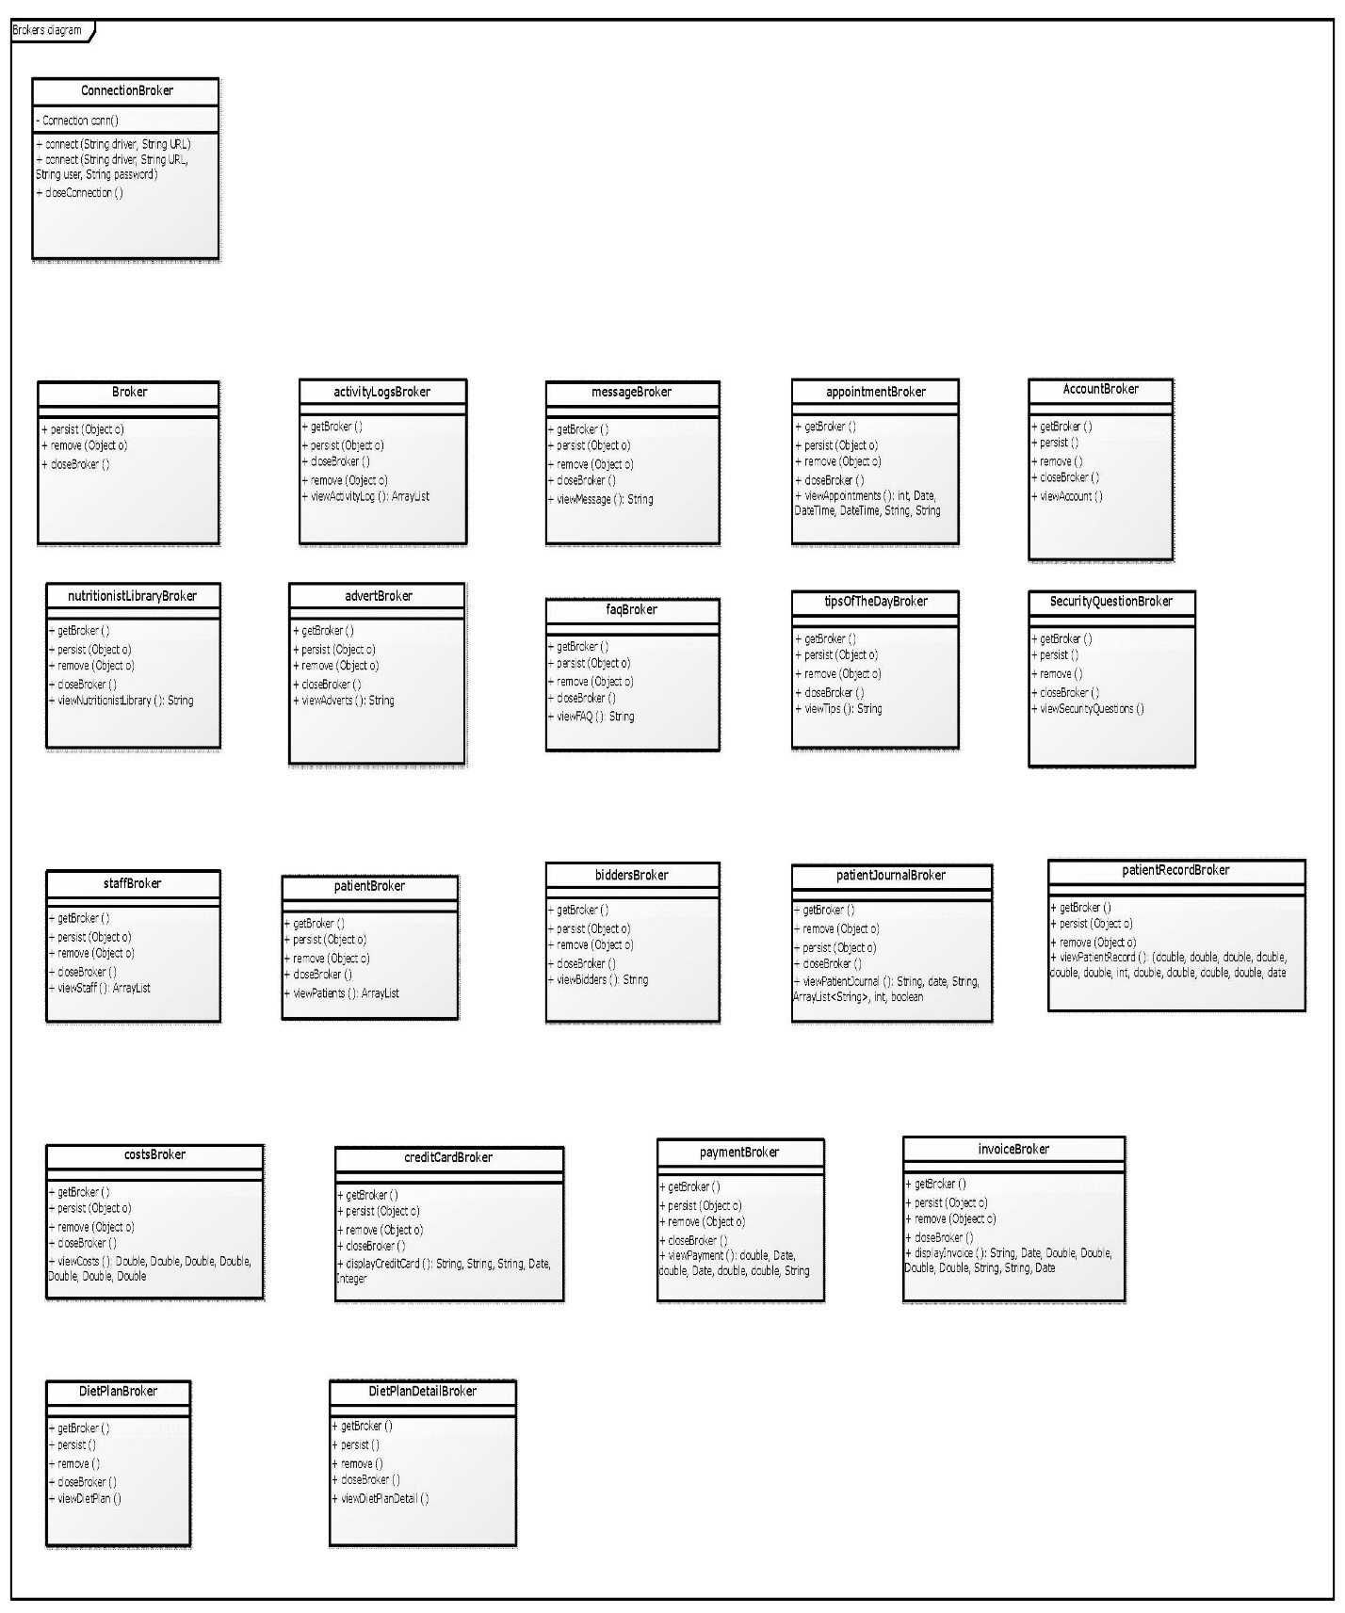

Figure 60 Brokers Diagram

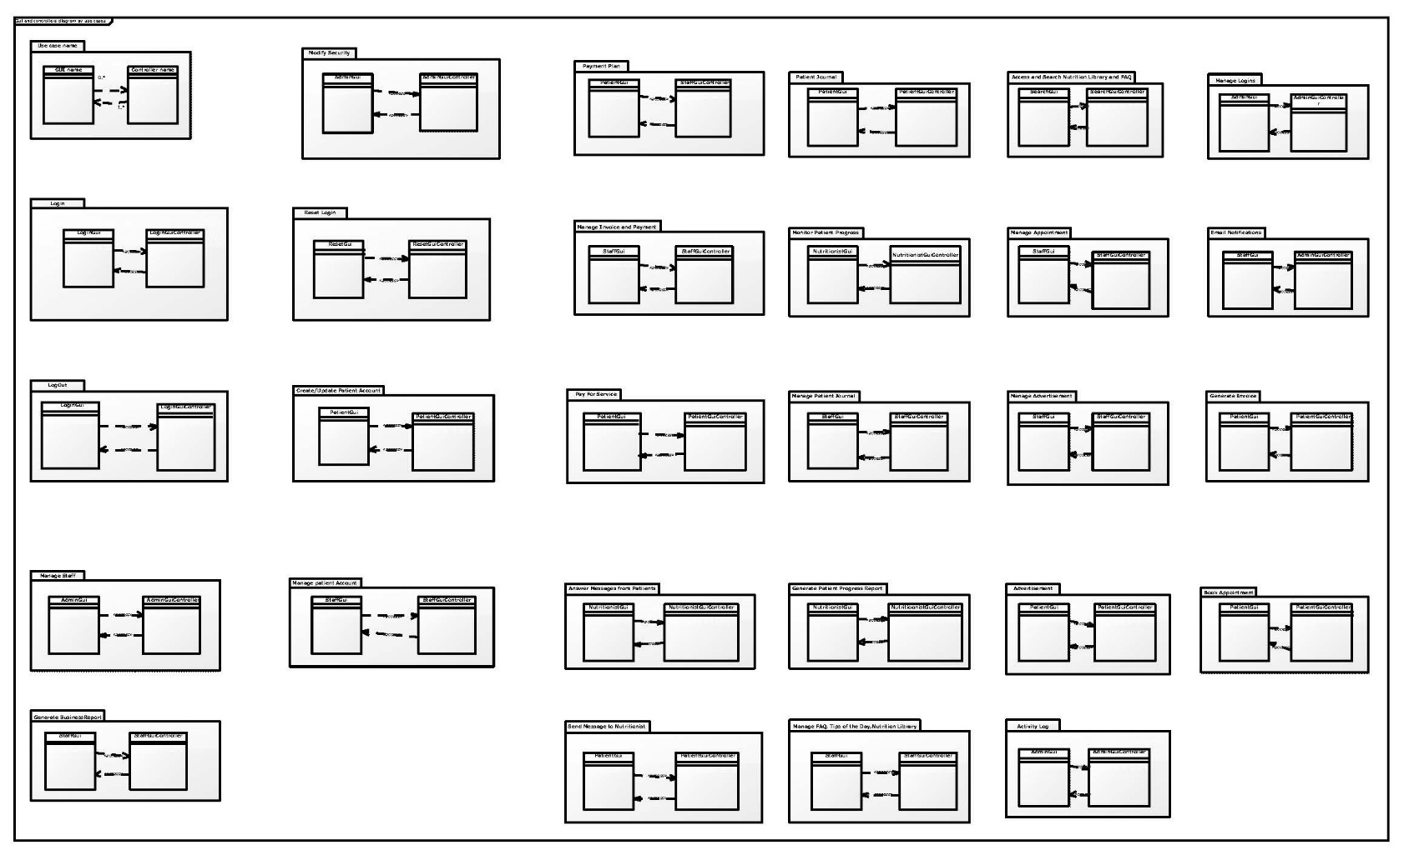

Figure 61 Gui and Controllers

A larger version of this pic is available on Appendix F.

## INTERACTION SEQUENCE DIAGRAMS

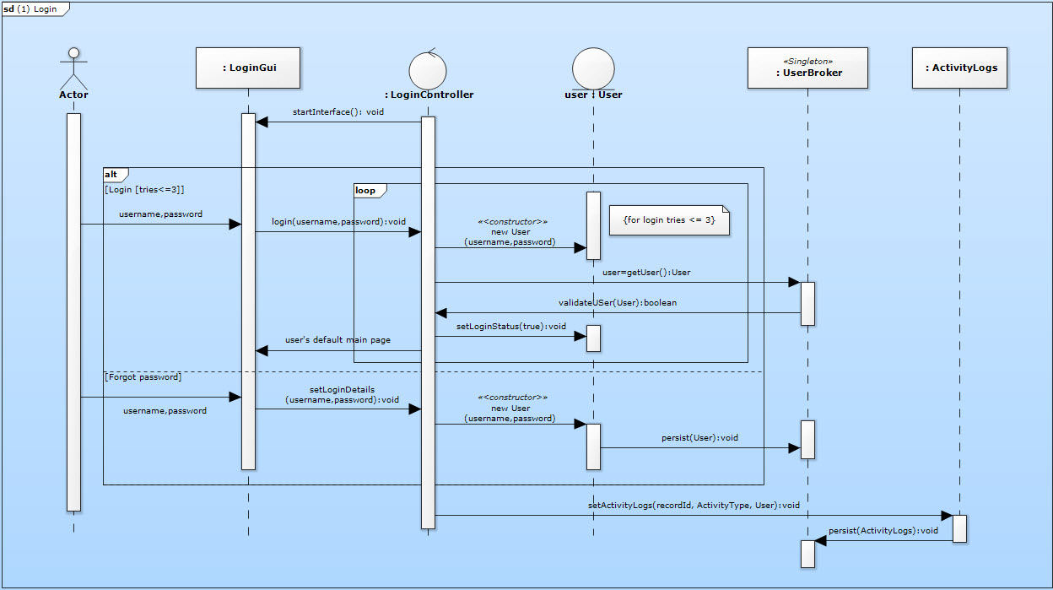

Figure 62 Login

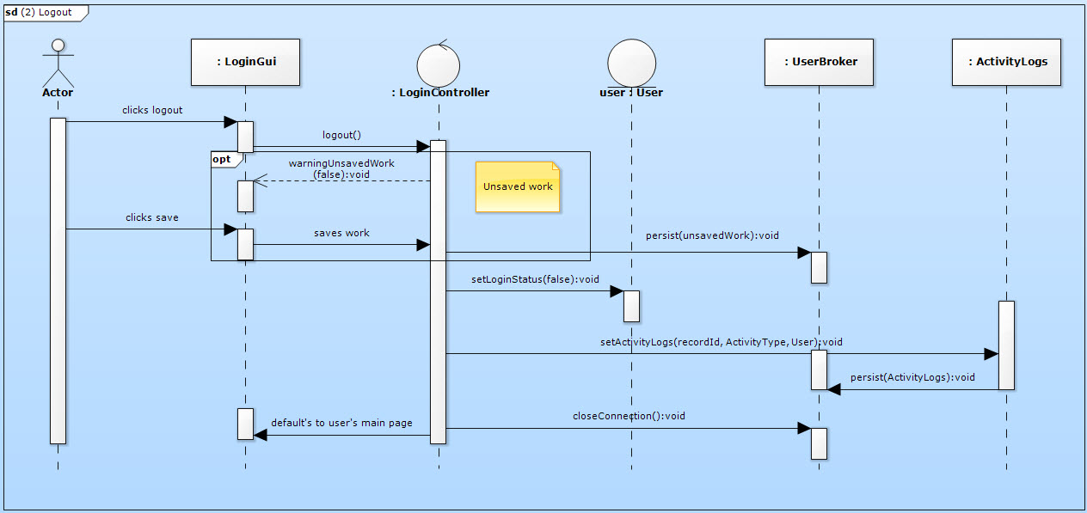

Figure 63 Logout

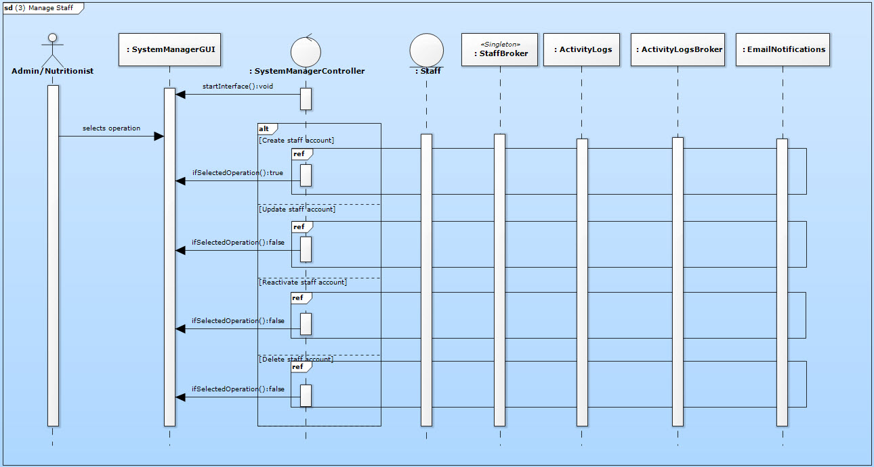

Figure 64 Manage Staff

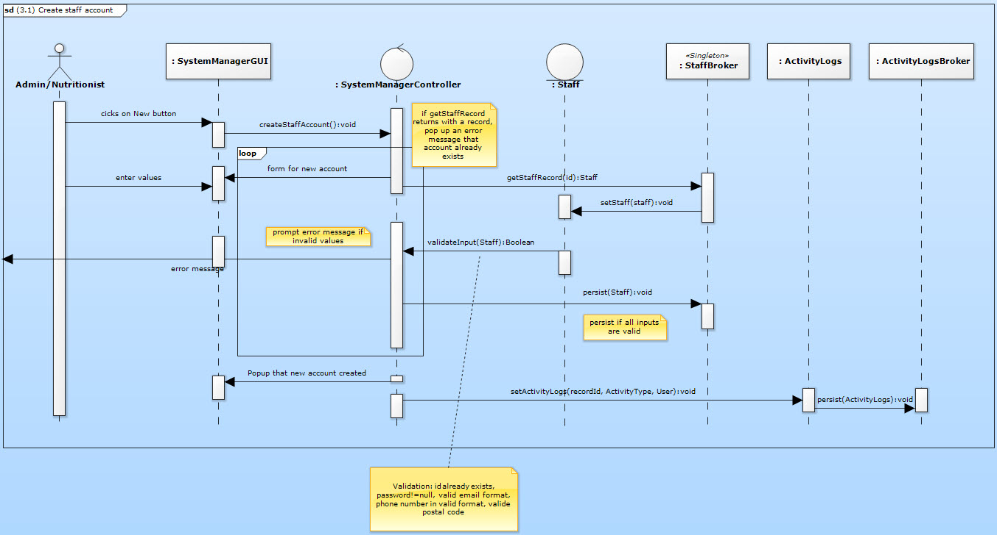

Figure 65 Create Staff Account

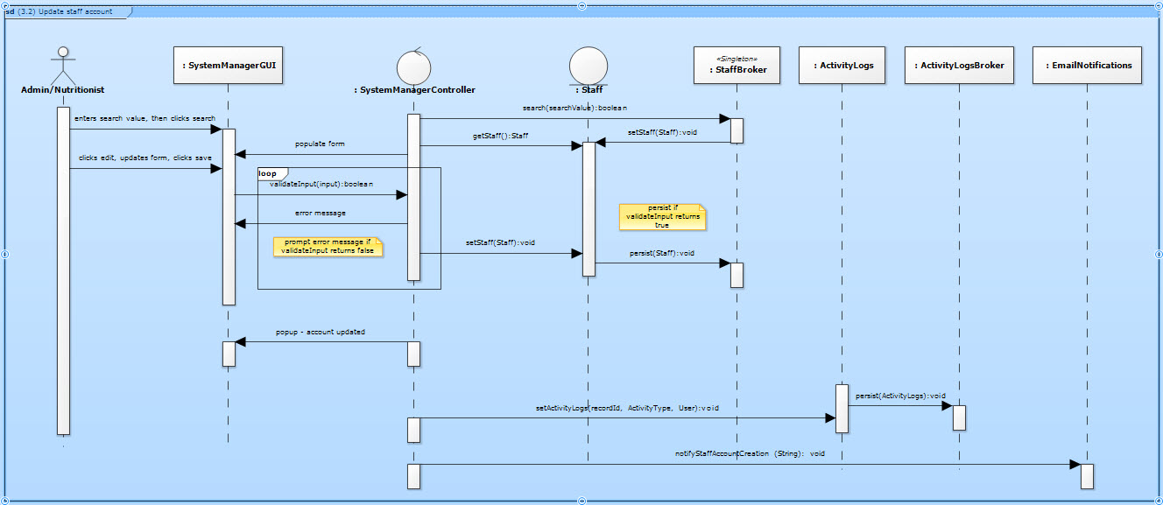

Figure 66 Update Staff Account

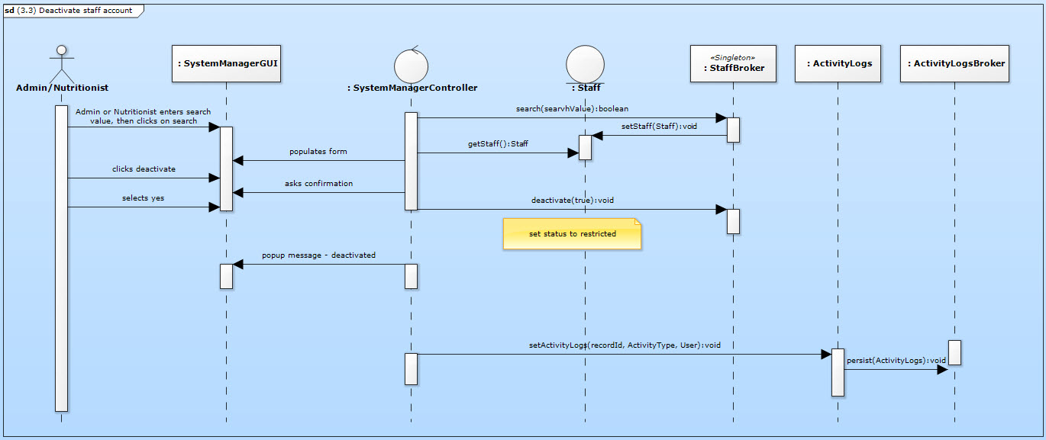

Figure 67 Deactivate Staff Account

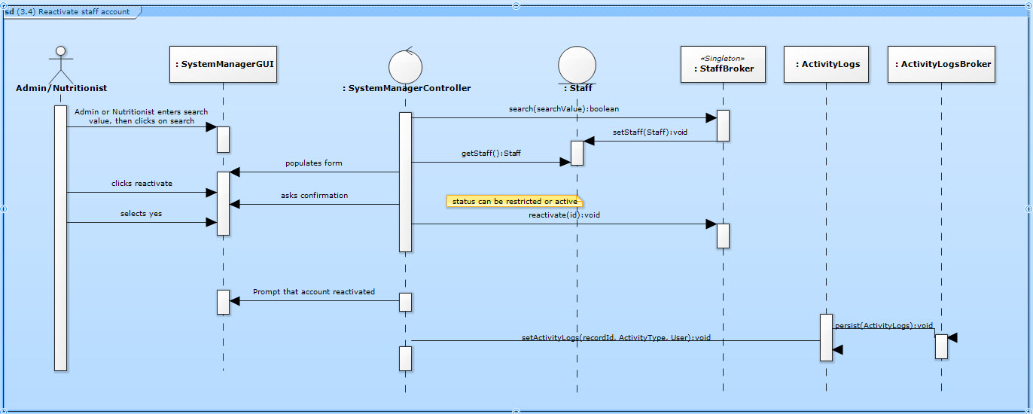

Figure 68 Reactivate Staff Account

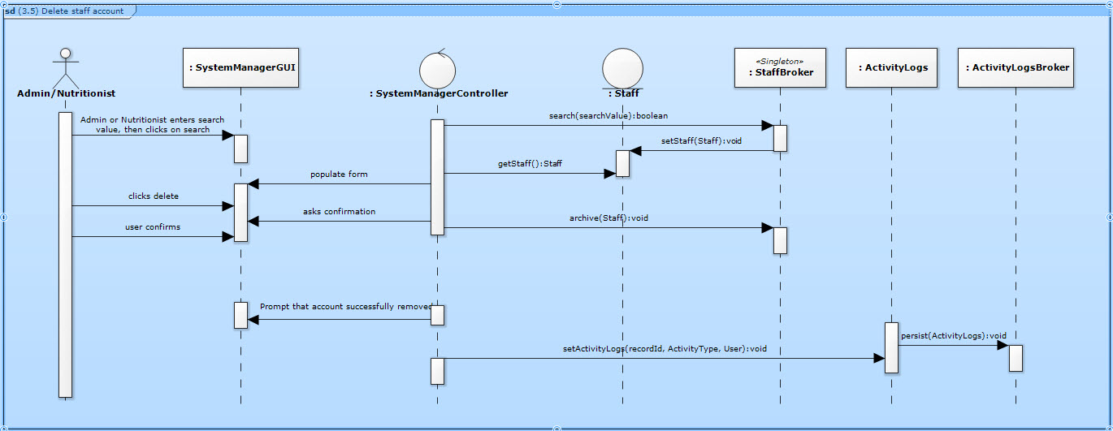

Figure 69 Delete Staff Account

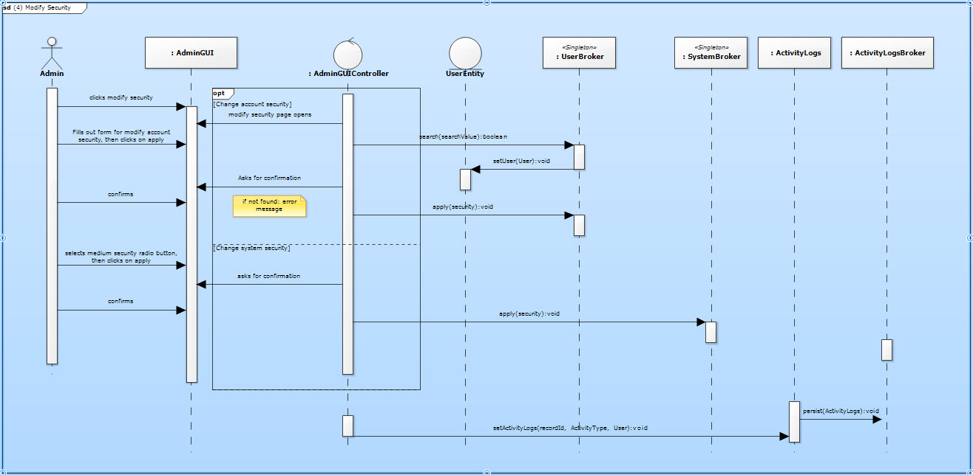

Figure 70 Modify Security

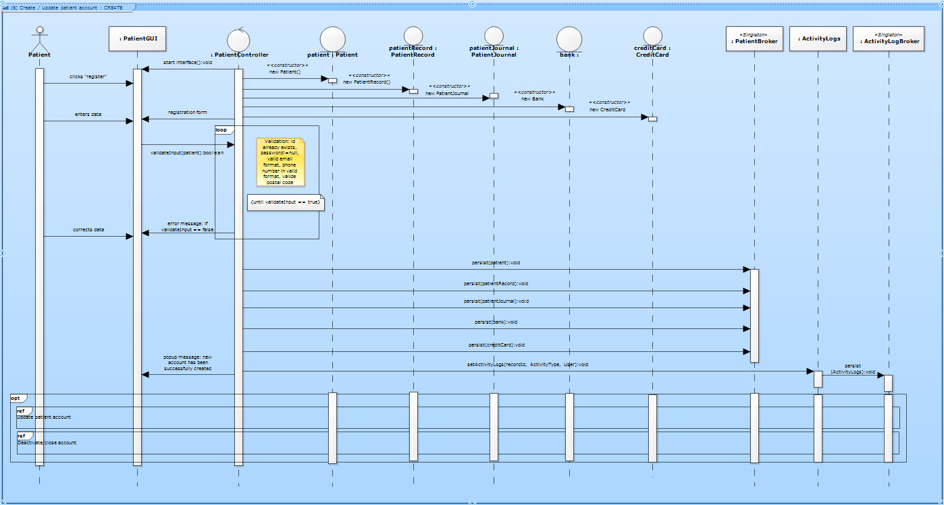

Figure 71 Create and manage patient account

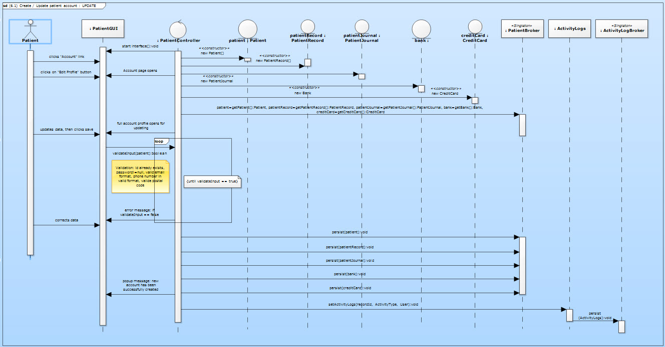

Figure 72 Create and manage patient account – UPDATE

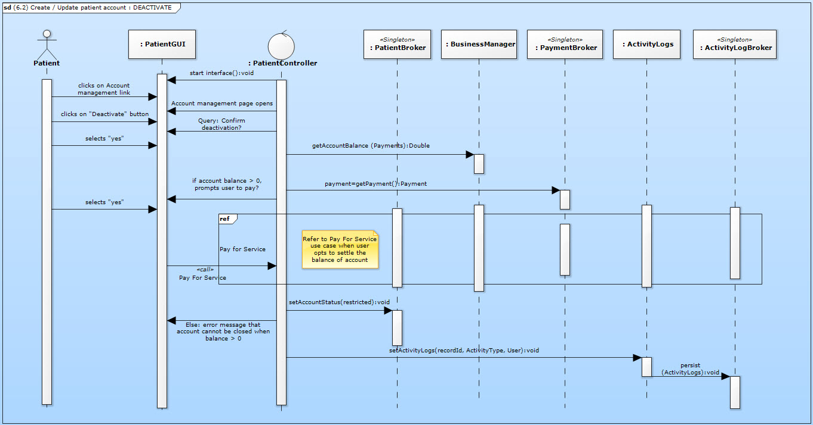

Figure 73 Create and manage patient account – DEACTIVATE

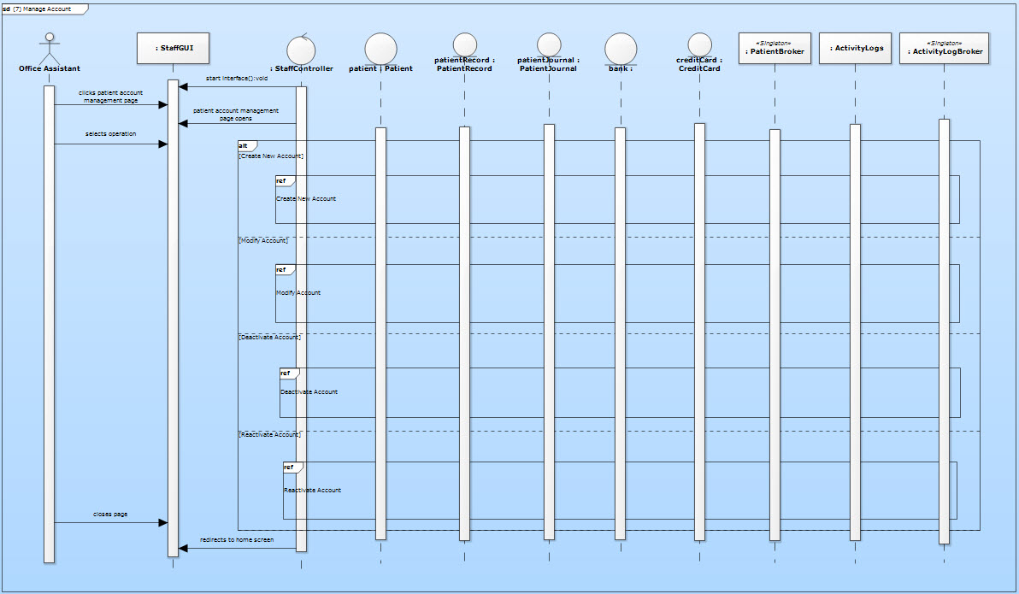

Figure 74 Manage Patient Account

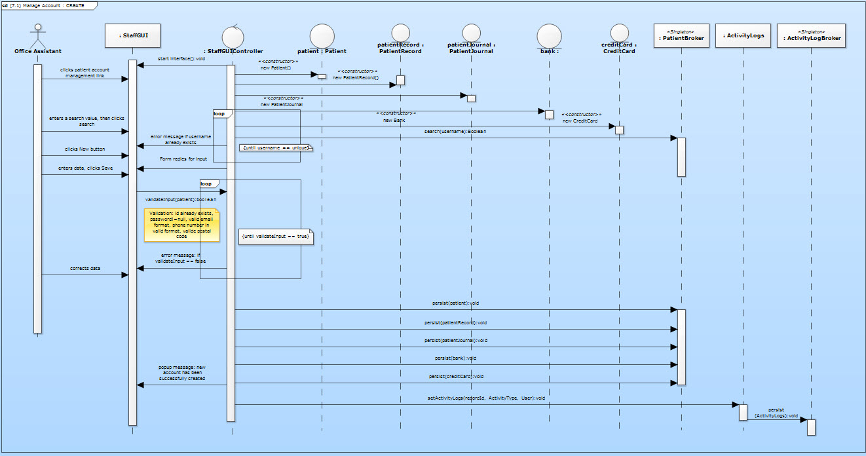

Figure 75 Manage patient account – CREATE

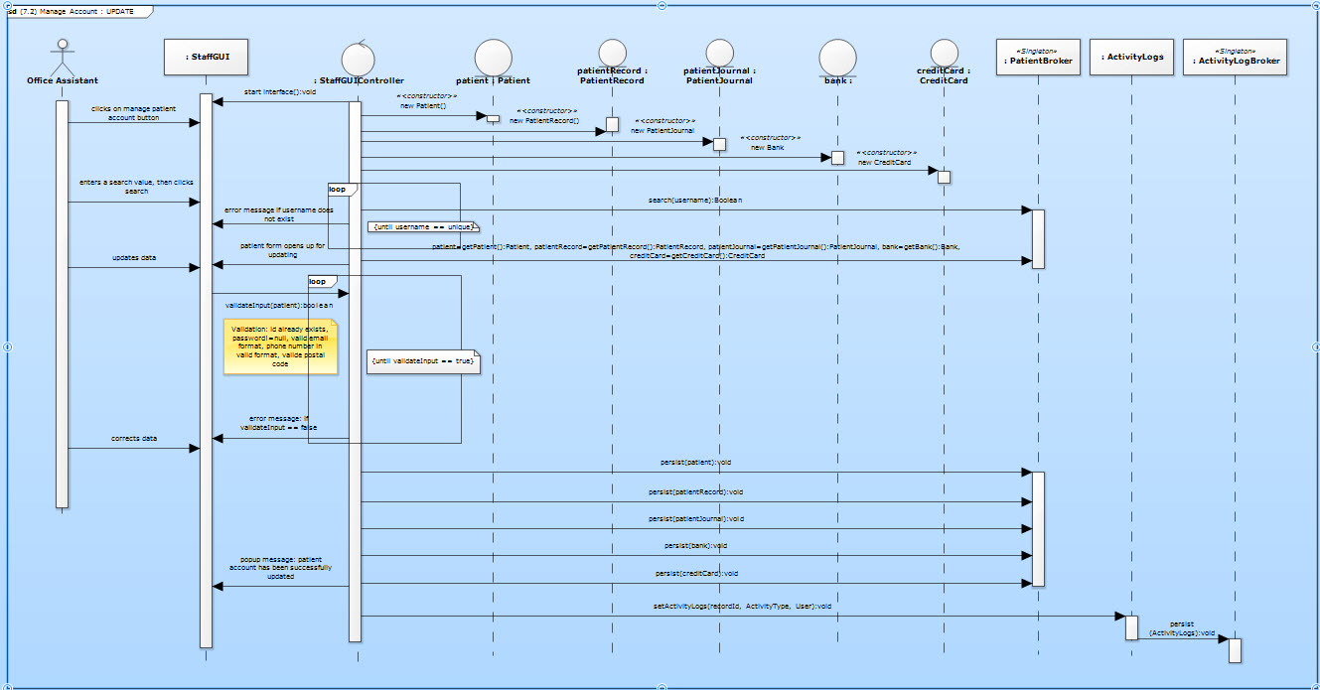

Figure 76 Manage patient account – UPDATE

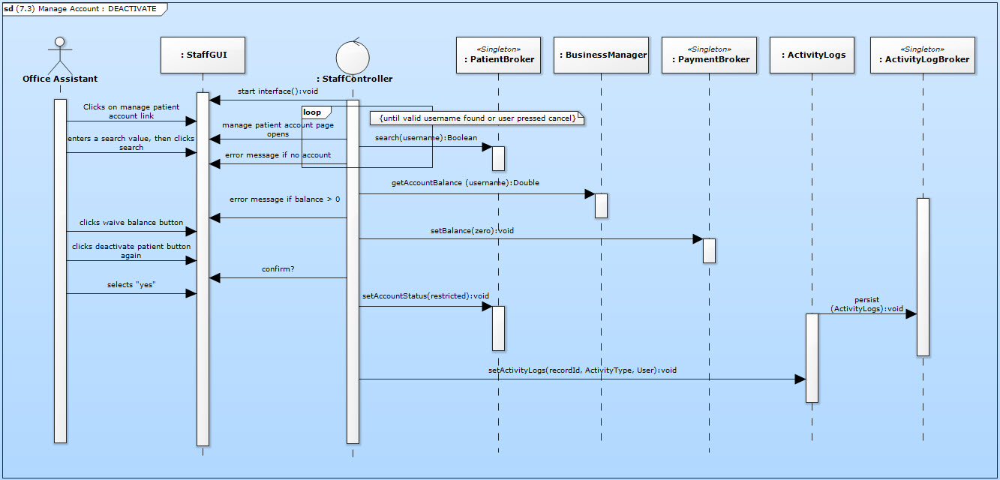

Figure 77 Manage patient account – DEACTIVATE

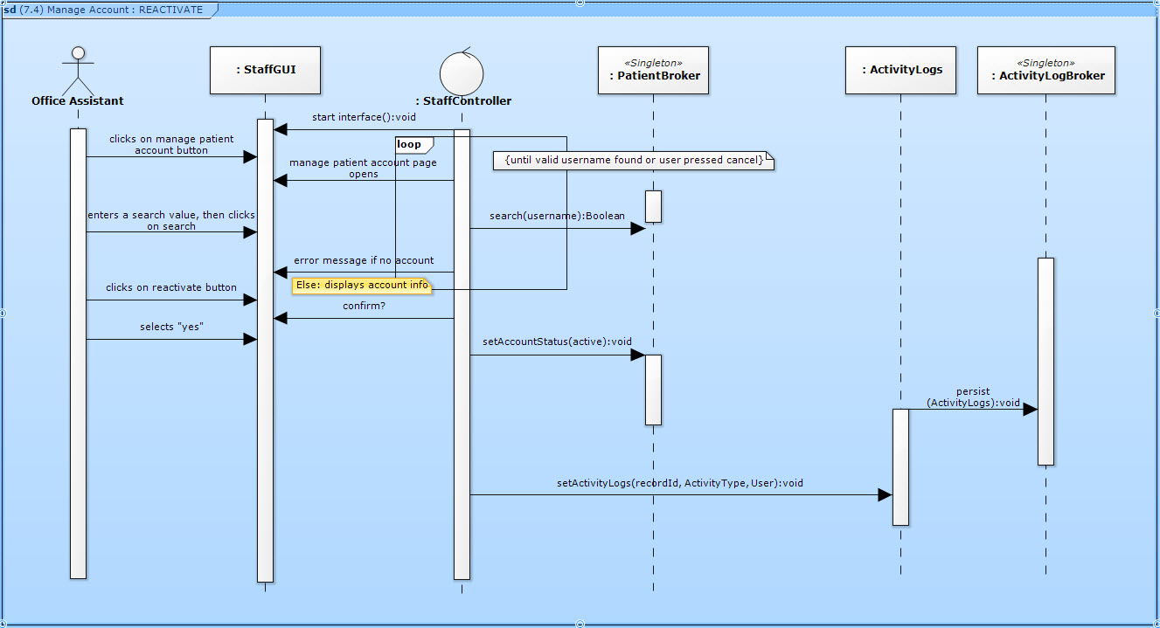

Figure 78 Manage patient account – REACTIVATE

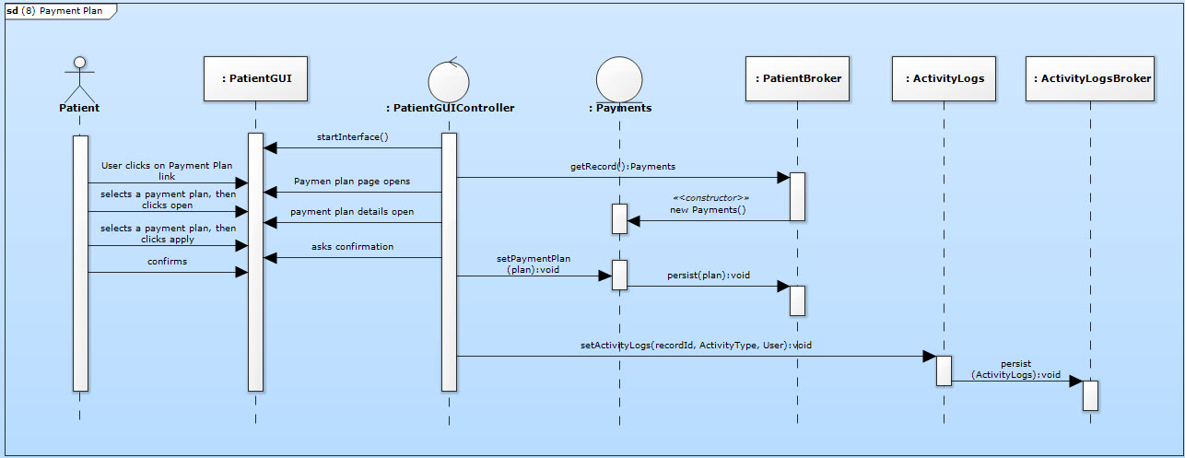

Figure 79 Payment Plan

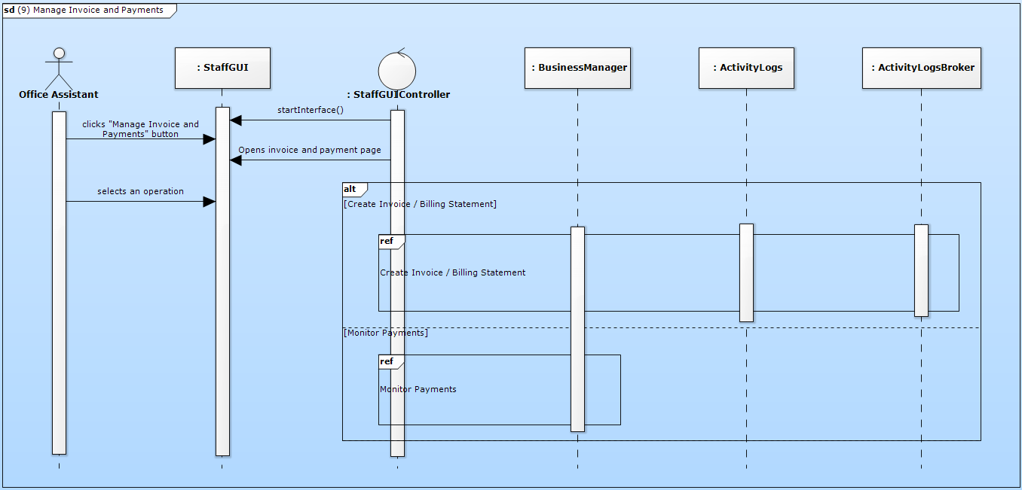

Figure 80 Manage invoice and payments

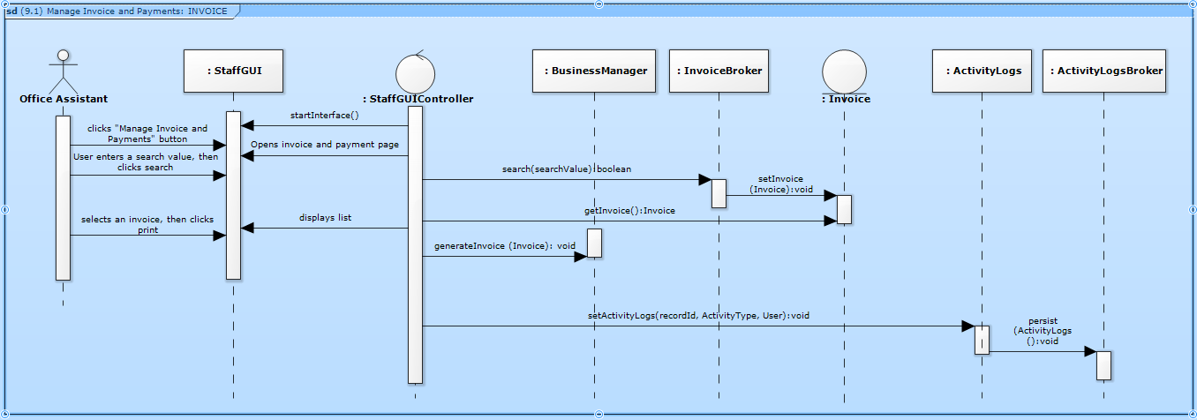Figure 81 Manage invoice and payments – INVOICE

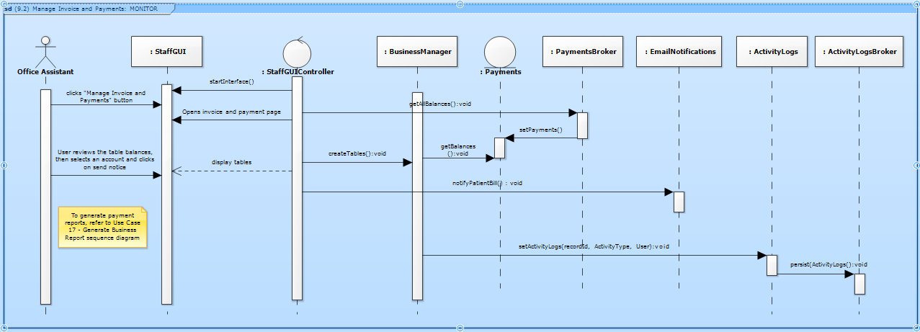Figure 82 Manage invoice and payments – MONITOR

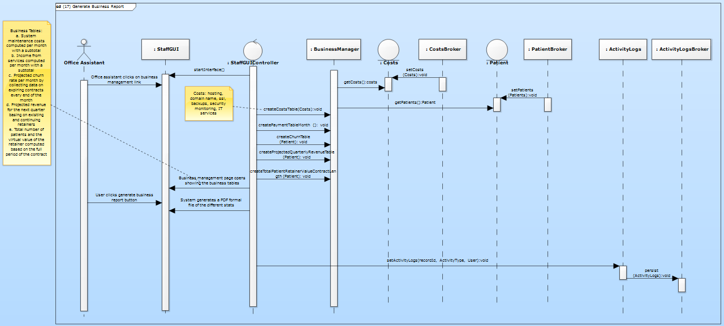Figure 83 Generate business report

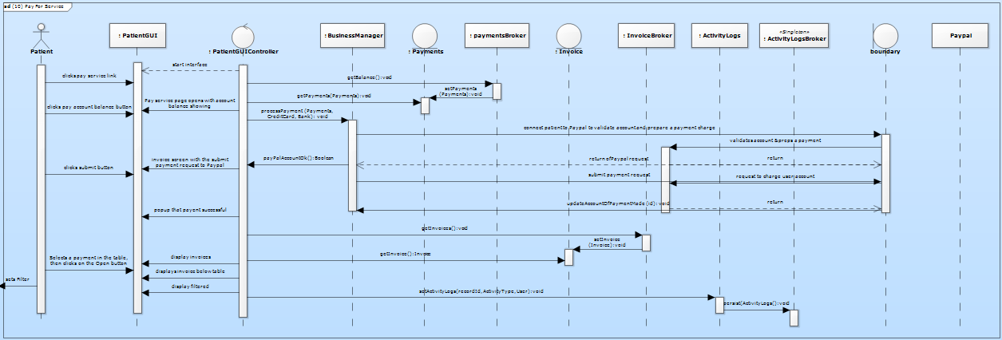

Figure 84 Pay for service

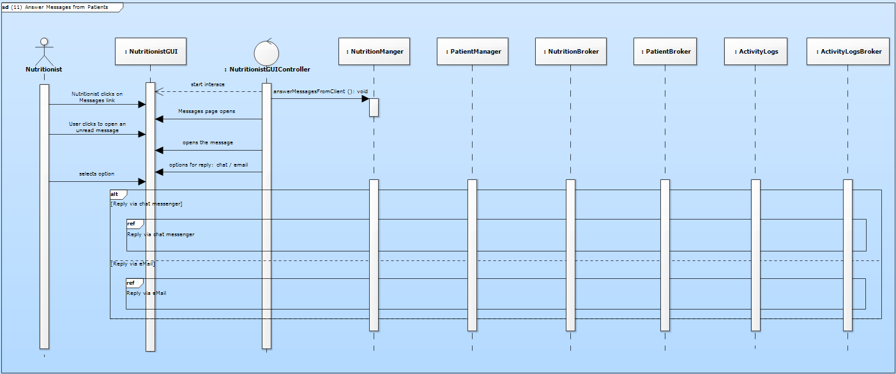Figure 85 Answer messages from patients

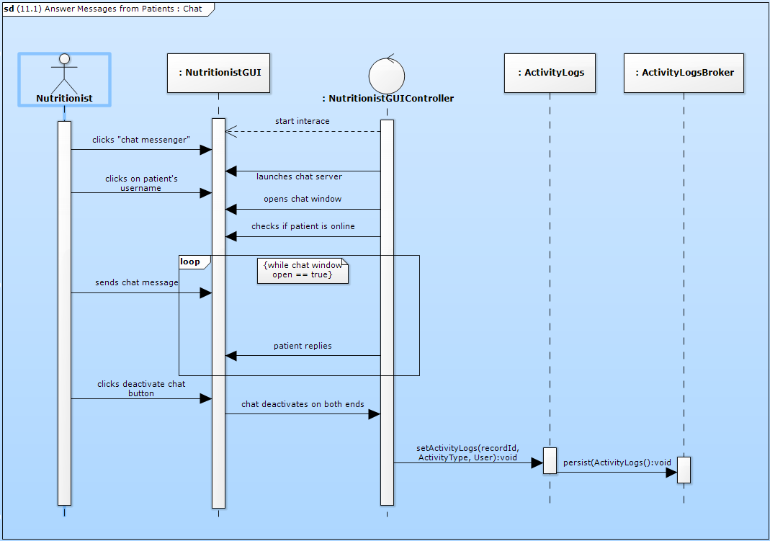Figure 86 Answer messages from patients – CHAT

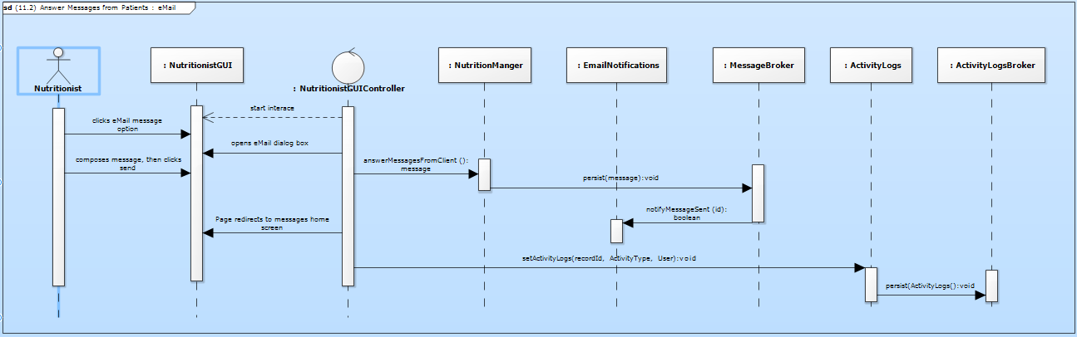

Figure 87 Answer messages from patients – EMAIL

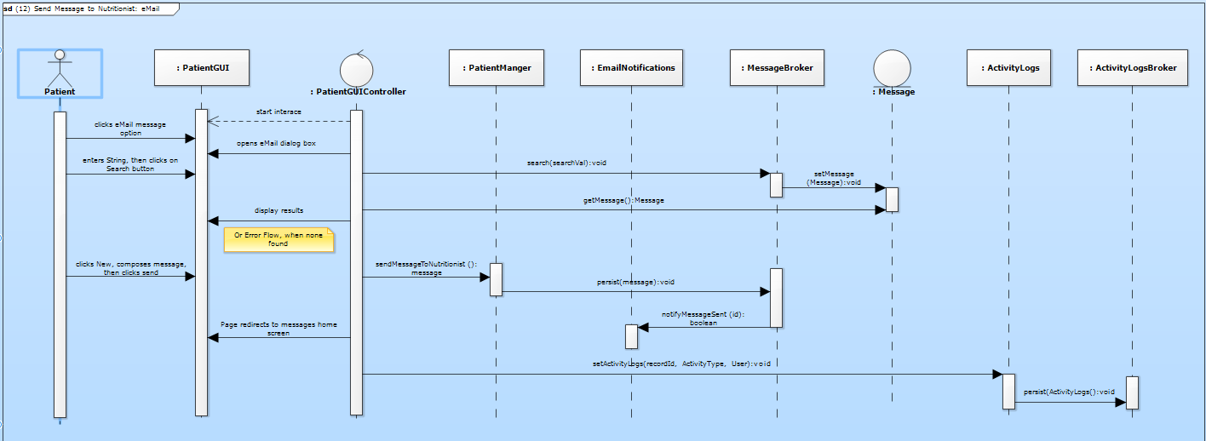Figure 88 Send message to nutritionist – EMAIL

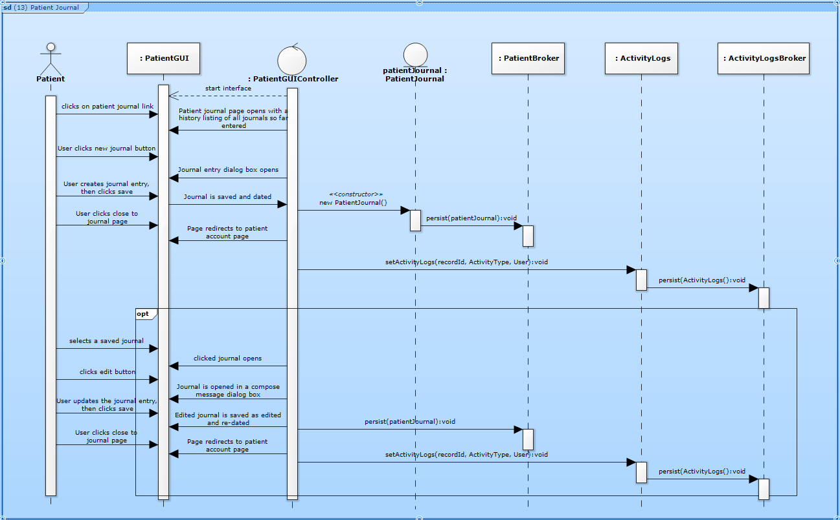Figure 89 Patient journal

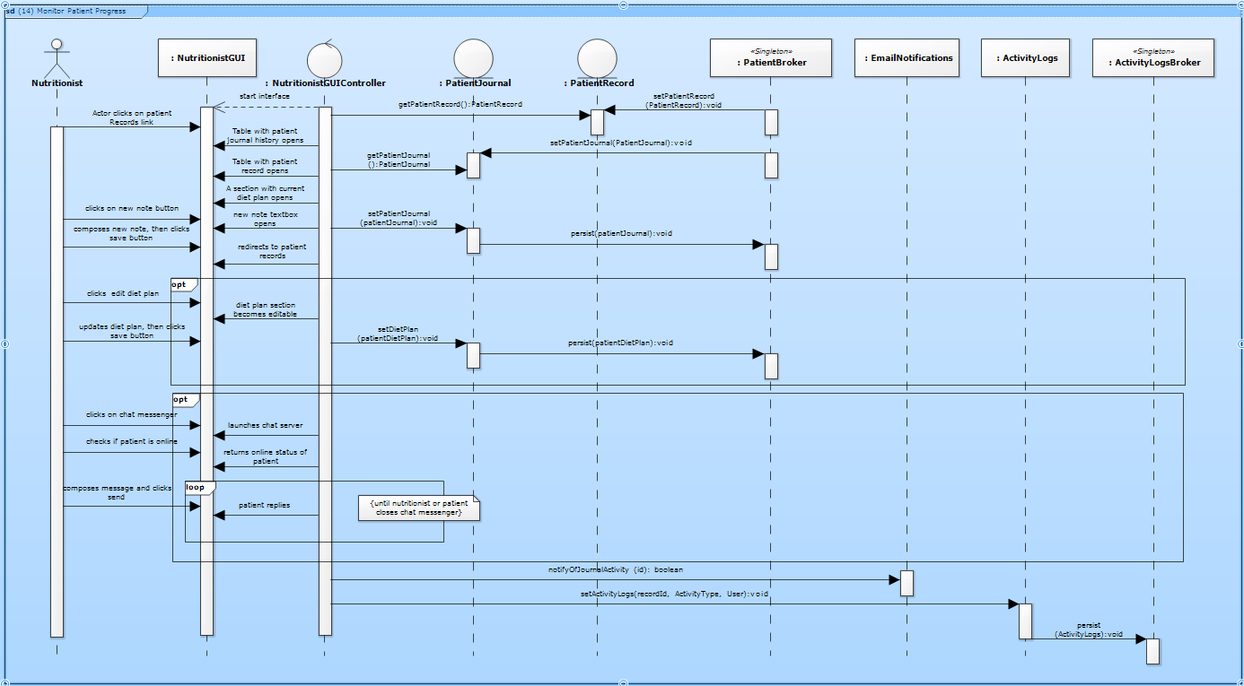Figure 90 Monitor patient progress

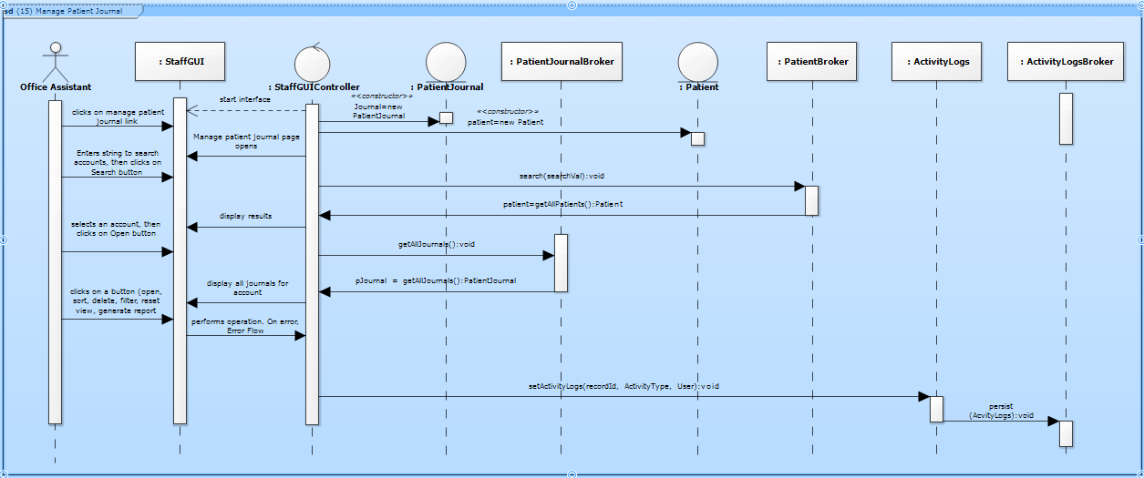Figure 91 Manage patient journal

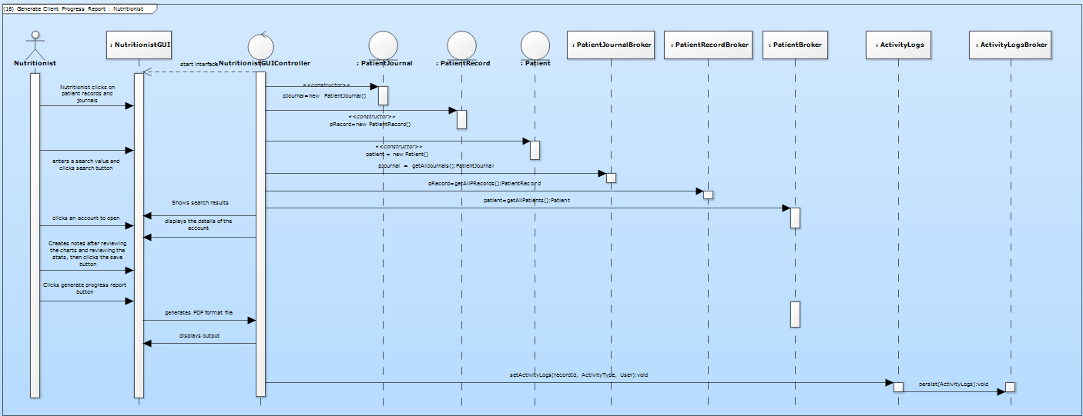

Figure 92 Generate patient progress report – NUTRITIONIST

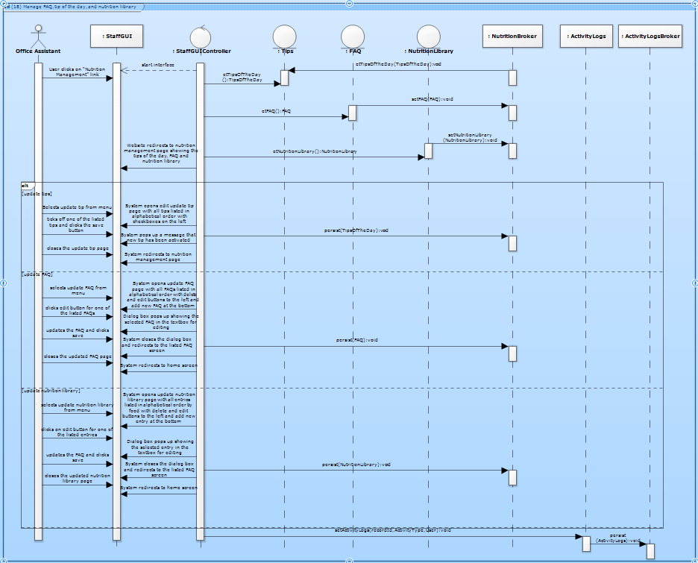Figure 93 Manage FAQ, Tips of the day, Nutrition library

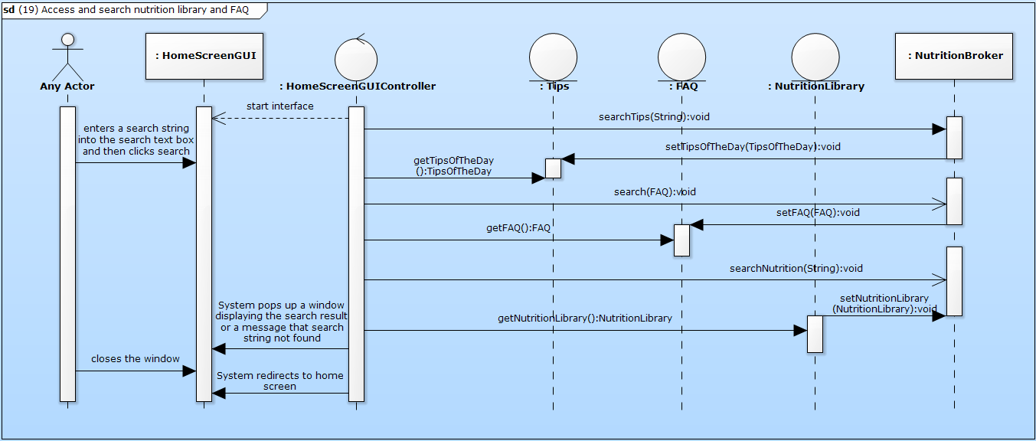Figure 94 Access and search nutrition library

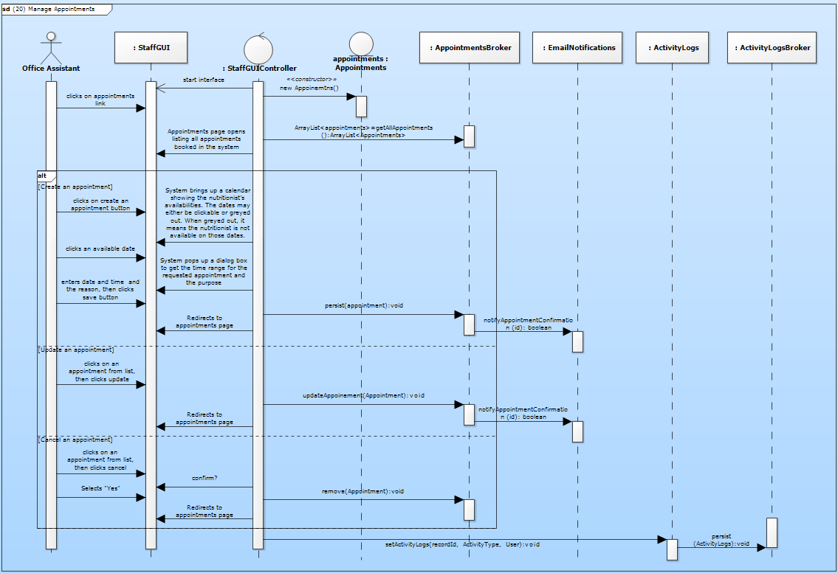Figure 95 Manage appointments

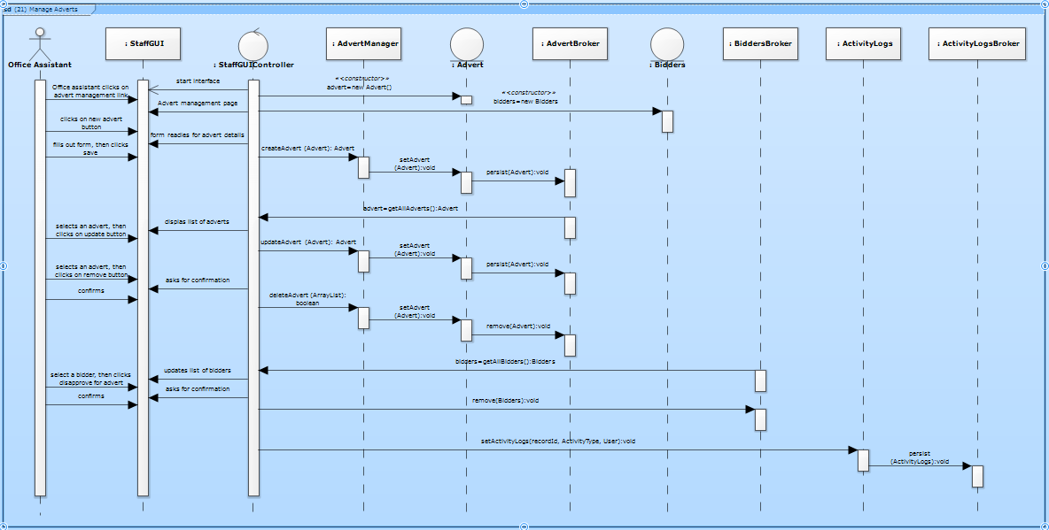Figure 96 Manage adverts

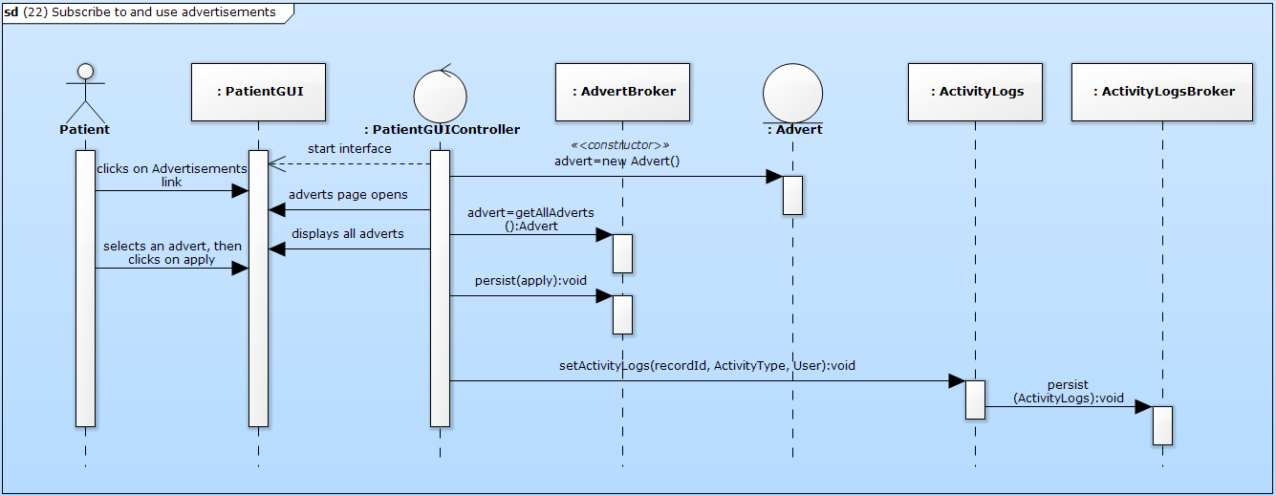Figure 97 Subscribe and use adverts

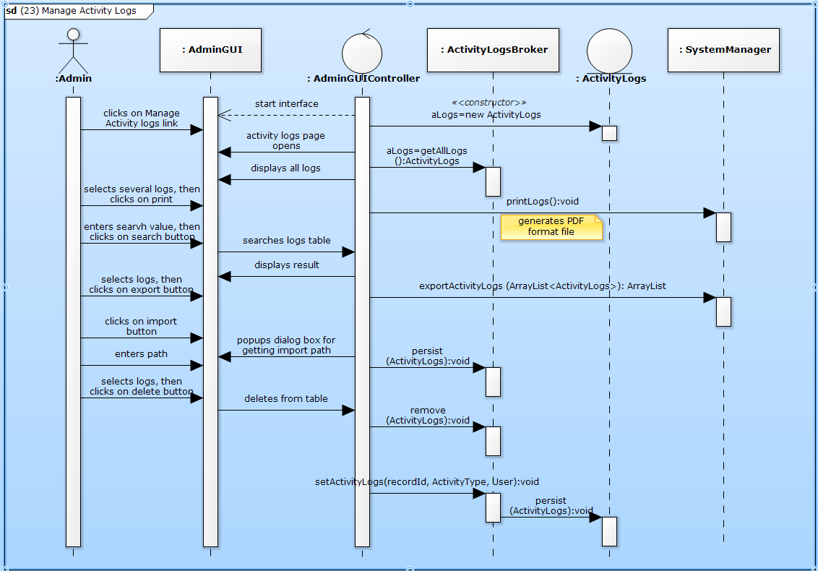Figure 98 Manage activity logs

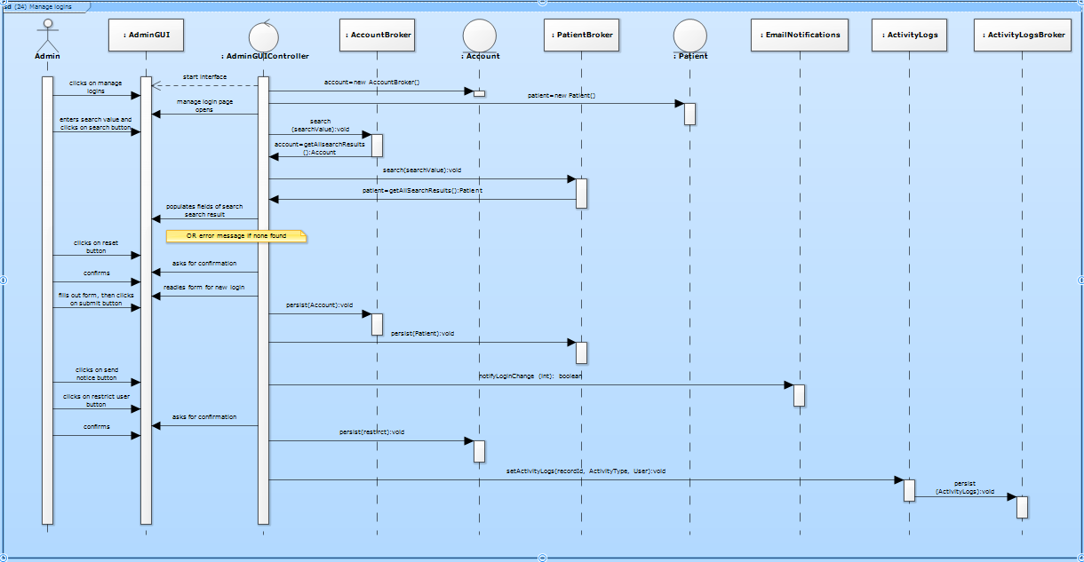Figure 99 Manage logins

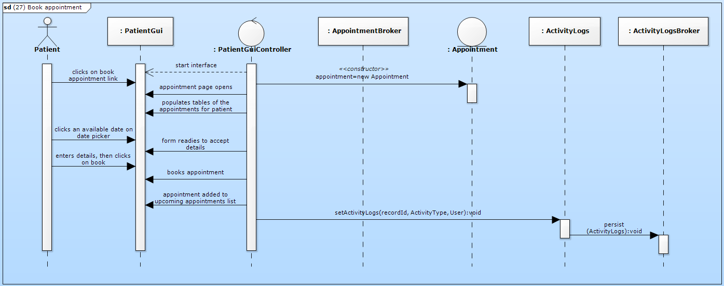Figure 100 Book appointment

## DATA DICTIONARY

Please check out included CD.

# Testing

Please refer to the attached acceptance test plan document for the entire system.

# SYSTEM DEPLOYMENT

## DATA CONVERSION

There are several ways the data can be transferred in and out of the system. First of all, since this is the first version of the HTG Nutrition care system, the client was using a paper based tracking system using forms and excel spread sheets to keep track of her clients’ personal information and records. The system is designed and implemented so that those existing data can be entered into the system through the various forms and saved in the backend database. For example, a client’s personal information can entered by creating a patient record through the patient page and a form will pop up so that the patient information can be filled and saved in the database. Another way that data can be entered into the system is using the admin privilege, data can be entered directly to the system through MySQL command line and executing the scripts to save the data into different tables. This data can then be retrieve and modified through the system.

## CHANGEOVER STRATEGY

Due to the fact that this system is the first version and there was no previous version to be replaced by this new one, there is no changeover strategy at this point. However, if this system is to be replaced by another newer version, then there must be a changeover strategy put in place in order to allow smooth and secure transition between this system and the newer one.

# SYSTEM ADMINISTRATION AND MAINTENANCE

Please see the attached User’s manual.

## SYSTEM MAINTENANCE

The following sections of the system are identified to require reqular updating and maintenance:

* + - 1. News section
      2. Tips section
      3. FAQ section
      4. Promos section
      5. Career section
      6. Internship section
      7. Volunteer section
      8. Invoice and payment section
      9. Activity logs

It is recommended to hire and train a staff versed in web development that can perform the management of the system and particularly pay special attention to the components enumerated above.

# DEFICIENCY LIST

## REQUIREMENTS NOT MET

The following requirements of the client have not been met due to time constraint and network restrictions, among other factors:

1. A functionality for enabling the nutritionist to answer messages from patients
2. A functionality for enabling patients to send messages to nutritionist
3. A functionality for monitoring patient progress
4. A functionality for managing patient journal
5. A functionality for managing activity logs in the system
6. Email notifications for patient and system events
7. A functionality for generating patient progress report
8. A functionality for generating the business report

## NON-FUNCTIONING COMPONENTS

The system components that are non-functional at the moment are as follows:

1. Reset login
2. Sending message to nutritionist by patient
3. Patient journal
4. Advert subscription
5. Manage activity logs
6. Except for managing activity logs and modify security, the admin functions are supposedly functional. However, due to some updating issues we ran into conflicts and been unable to properly fix the linking problems in time.
7. Answer messages from patient
8. Monitor patient progress
9. Manage patient journals
10. Generate patient progress report
11. Generate business report
12. Manage appointments
13. Manage email notifications
14. Manage subscriptions

# Project Management

## Schedule

The milestones for the team are listed as follows:

* + Requirements document - October 3, 2016
  + Requirements analysis document – October 31, 2016
  + Final design document – December 12, 2016
  + Team charter – January 10, 2017
  + Client design review – January 25, 2017
  + Technical design review – March 6, 2017
  + Acceptance test plan – March 27, 2017
  + Beta installation – March 27, 2017
  + Nutrition consultancy system completion – April 3, 2017
  + Final presentation – April 20, 2017

## gantt chart

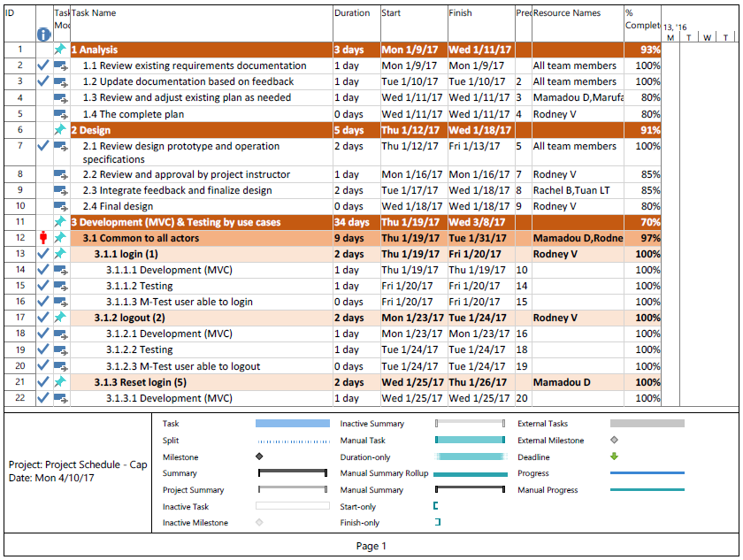

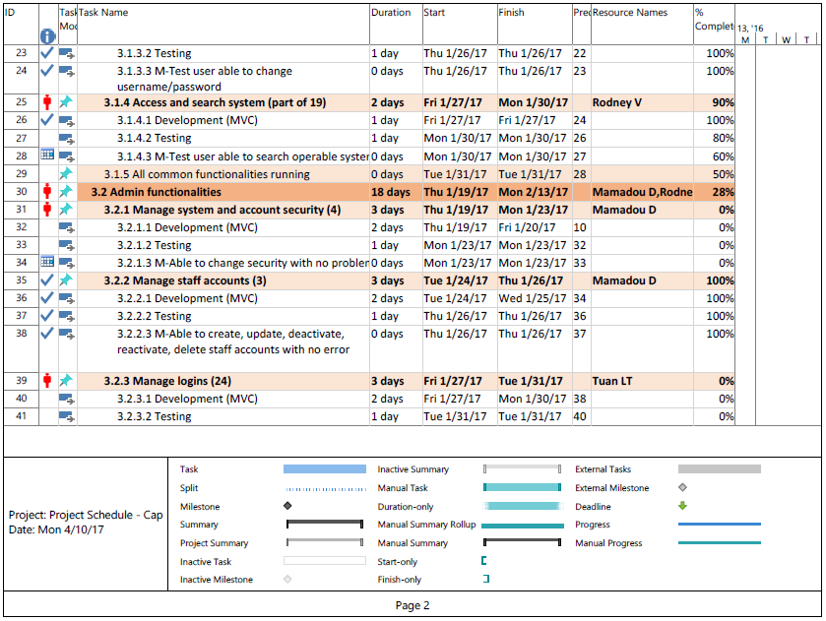

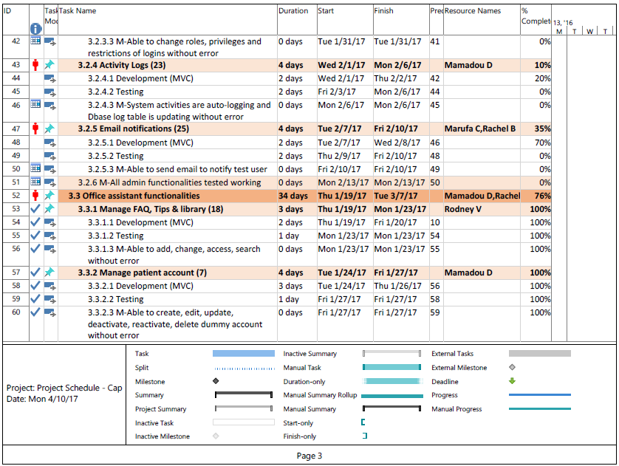

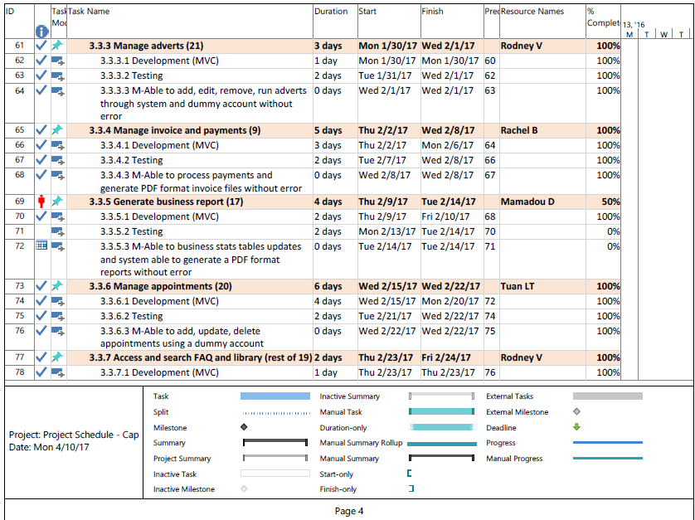

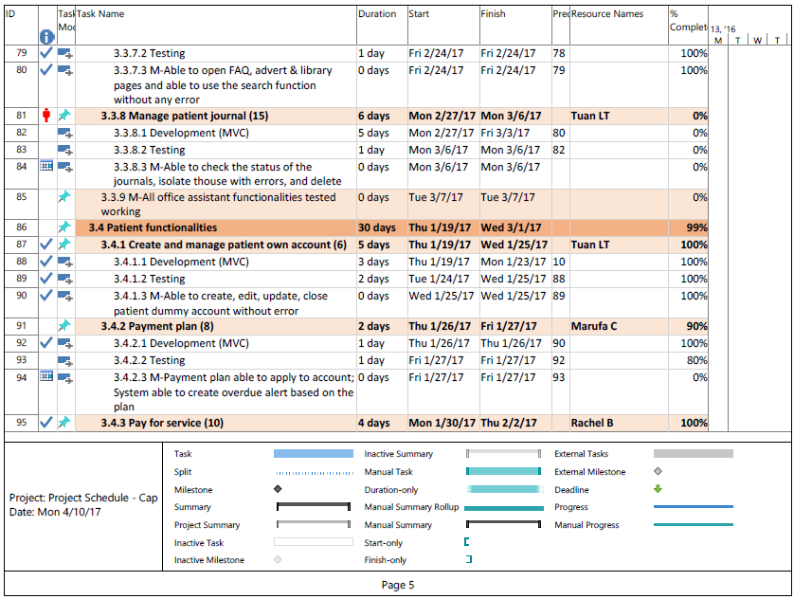

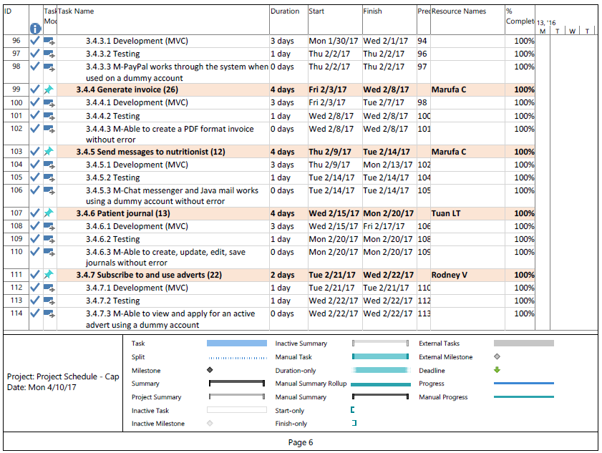

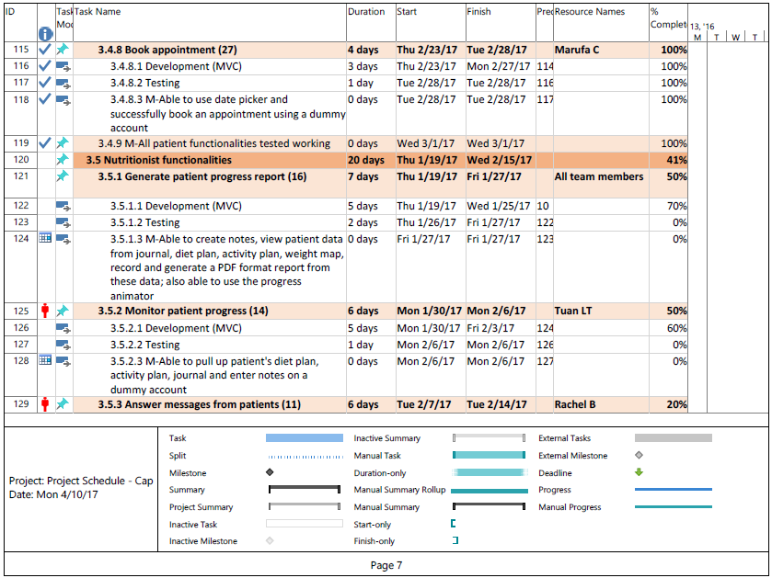

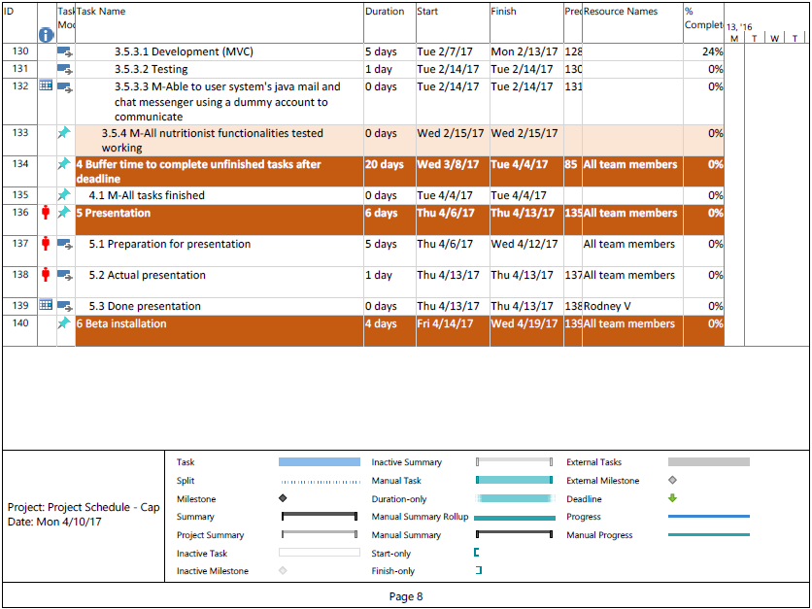

## Team Configuration

Basing on each core member's preference, the work assignments have been divided as follows:

|  |  |
| --- | --- |
| * + **Marufa Chowdhury**     - Server-side implementation, core-Java     - Front-End Development, all aspects | [marufa.chowdhury@sait.edu.ca](mailto:marufa.chowdhury@sait.edu.ca)  (403) 863-6862 |
| * + **Tuan Truong**     - Server-side implementation, all aspects     - Front-End Development, all aspects | [tuan.truong@sait.edu.ca](mailto:tuan.truong@sait.edu.ca)  (587) 889-6534 |
| * + **Rachel Bautista**     - Server-side implementation, core-Java     - Front-End Development, all aspects | [rachel.bautista@sait.edu.ca](mailto:rachel.bautista@sait.edu.ca)  (403) 975-9976 |
| * + **Mamadou Diallo**     - Server-side implementation, core-Java     - Front-End Development, all aspects | [mamadou.diallo@sait.edu.ca](mailto:mamadou.diallo@sait.edu.ca)  (403) 561-7039 |
| * + **Rodney Vencio**     - Server-side implementation, all aspects     - Front-End Development, all aspects | [rodney.vencio@sait.edu.ca](mailto:rodney.vencio@sait.edu.ca)  (403) 399-5382 |

## Project Standards and PROCEDURES

For standards, the team has it in two parts – standard tools and coding standards. The standard tools are the software and application programs that we will use in completing the project. The coding standards are the formats or templates that we will implement in our coding to make sure that all parts are homogenous and that there is unity.

1. Standard tools:

* Microsoft Office Word 2013-2016:
  + for documentation of the entire project
* Micorosoft Office Project 2013-2016:
  + For the team’s GANTT chart
* Software Ideas Modeler (SIM) ver. 10.42
  + For all diagram requirements
* WYSIWYG Web Builder 11
  + For all mockups and supplement to the front-end website design
* Eclipse Jave EE IDE Version: Neon
  + For all Java core development (MVC controller)
  + Javadoc generation
* Netbeans IDE version 8.1
  + For all web components (MVC View)
* MySQL Community Server 5.7 and Oracle 11g Express Edition
  + For all database components (MVC Model)
* GIT
  + As the central code repository via web to help the group manage the different aspects of the coding process

1. Coding Standards:
2. Variable names must be in camel-case format starting with the lowercase first letter, like below.

Example:

wage, firstName

1. Constant names or final variables must all be uppercased with the underscore character as separator, like below

     Example:

OVER_TIME, OVER_TIME_HOURS_LIMIT

1. Method names must be verbs and in camel-case format as well starting with lowercase first letter, like below:

    Example:

addEmployee(), deleteEmployee()

1. Comments and Javadoc statements should be encased, like below:

Example:

// This is a comment

/**

* This is a Javadoc

* comment

*/

1. Param and return statements should follow the following form:

/**

* User defined constructor that creates an employee object

* with user specified values for class level variables.

*

* @param name employee's given name

* @param age employee's age

* @param hours weekly hours work by employee

* @param wage hourly wage paid to employee

* @return true if the employee is not null

*/

   public Boolean Employee(String name, int age, double hours, double wage)

   {

      setName(name);

      setAge(age);

      setHours(hours);

      setWage(wage);

return true;

   }

1. Variables in declarations should be left aligned and a tab separating the variable types and their objects, like below:

Example:

TextFile  file;

int         idNumber;

double    price, tax;

1. Proper indentation inside the method should be observed with the curly braces below the method name, like below:

Example:

void main(void)

{

        int employeeID;

}

//NOT

void main(void) {

… }

//NOT

void main(void)

{

    int employeeID;

}

1. To increase readability:
2. Operators should be surrounded by a space character
3. Java reserved words should be followed by a white space
4. Commas should be followed by a white space
5. Colons should be surrounded by a whitespace

Example:

while (true)    //NOT: while(true)

{

 …

}

doSomething(a, b, c, d);  // NOT: doSomething(a,b,c,d);

for (i = 0; i < 10; i++)    // NOT: for(i=0;i<10;i++)

1. Names representing packages should be in all lower case.

Example:

mypackage, package myemployee;

1. Variables should be initialized where they are declared
2. Each classes should have Author’s name, version, date, file name, class description

Example:

/**

* @author bob

*

* @version 1.0

*

* Date: September 1, 2015

*

* File name: employee.java

*

* Class description: This class represents an Employee and their

* associated attributes.

*

* /

1. Database constraints must follow the following format:

Tablename_columnname_type (pk, fk, ck, etc.)

Example:

EMPLOYEE_firstname_pk

1. Database table names must all be in uppercase, like below:

Example:

EMPLOYEE

1. Database variable names that may need a whitespace will use an underscore “_”, like below:

Example:

EMPLOYEE_firstname

# Glossary

1. ***Interviewing:*** This is probably the most widely used fact-finding technique; it is also the one that requires the most skill and sensitivity. A systems analysis interview is a structured meeting between the analyst and an interviewee who is usually a member of staff of the organization being investigated. The interview may be one of a series of interviews that range across different areas of the interviewee’s work or that probe in progressively greater depth about the tasks undertaken by the interviewee. [1]
2. ***Document Sampling*:** A fact-finding technique by collecting blank and completed documents during the course of interviews and observation sessions. These will be used to determine the information that is used by people in their work and the inputs to and outputs from processes which they carry out, either manually or using an existing computer system. [2]
3. ***Brute force attack*:** A brute force attack is a trial-and-error method used to obtain information such as a user password or personal identification number (PIN). In a brute force attack, automated software is used to generate a large number of consecutive guesses as to the value of the desired data. Brute force attacks may be used by criminals to crack encrypted data, or by security analysts to test an organization's network security. [3]
4. ***Cross-Site Scripting (XSS)*:** XSS is a security breach that takes advantage of dynamically generated Web pages. In an XSS attack, a Web application is sent with a script that activates when it is read by an unsuspecting user’s browser or by an application that has not protected itself against cross-site scripting. Because dynamic Web sites rely on user input, a malicious user can input malicious script into the page by hiding it within legitimate requests. Common exploitations include search engine boxes, online forums and public-accessed blogs. Once XSS has been launched, the attacker can change user settings, hijack accounts, poison cookies with malicious code, expose SSL connections, access restricted sites and even launch false advertisements. The simplest way to avoid XSS is to add code to a Web application that causes the dynamic input to ignore certain command tags. Scripting tags that take advantage of XSS include <SCRIPT>, <OBJECT>, <APPLET>, <EMBED> and <FORM>. Common languages used for XSS include JavaScript, VBScript, HTML, Perl, C++, ActiveX and Flash. Cross-site scripting also is referred to as malicious tagging and sometimes abbreviated as CSS, though CSS is more commonly used as an abbreviation for cascading style sheets. [4]
5. ***Inclusion vulnerabilities*:** a type of vulnerability that is most commonly found to affect web applications that rely on a scripting run time. This issue is caused when an application builds a path to executable code using an attacker-controlled variable in a way that allows the attacker to control which file is executed at run time. A file include vulnerability is distinct from a generic Directory Traversal Attack, in that directory traversal is a way of gaining unauthorized file system access, and a file inclusion vulnerability subverts how an application loads code for execution. Successful exploitation of a file include vulnerability will result in remote code execution on the web server that runs the affected web application. [5]
6. ***SQL Injection:*** a computer attack in which malicious code is embedded in a poorly-designed application and then passed to the backend database. The malicious data then produces database query results or actions that should never have been executed. [6]
7. **System**: this term has been often mentioned in this report without a good description of what it really constitutes. This system should be consisting of the front end Health To Go business website, the core java control program to run the website and access the database and the back-end MySQL database component.

# INDEX

Access and search nutrition library and FAQ 48

Actors 14

***Admin*** 9

Answer messages from patients 33

Book appointment (Patient) 61

***brute force attack*** 12

Create and Update Patient Account 23

***Cross-Site Scripting (XSS)*** 12

**Document Sampling** 11

Email notification 59

Generate business report 45

Generate Invoice 60

Generate patient progress report 42

***Health To Go*** 8

***inclusion vulnerabilities*** 12

Login 15

Logout 17

Manage Activity Logs 56

Manage Advertisement 52

Manage Appointments 49

Manage FAQ, tip of the day, and nutrition library 46

Manage Invoice and Payment 30

Manage logins 57

Manage Patient Account 25

Manage patient Journals 41

Manage Staff 18

Modify Security 20

Monitor Patient progress 38

**Nutritionist** 9

**Office Assistant** 9

**Patient** 8

Patient Journal 37

Pay for Service 32

Payment Plan 29

Reset Login 21

Security considerations 12

Send Message to Nutritionist 35

***SQL injection*** 12

Subscribe to and use advertisements 55

System Access 11

System data 11

System response times 11

Usability 12

use case diagram 14

# BIBLIOGRAPHY

|  |  |
| --- | --- |
| [1] | S. M. a. R. F. Simon Bennett, OBJECT-ORIENTED SYSTEMS ANALYSIS AND DESIGN USING UML, London: McGraw Hill Education, 2010, p. 143. |
| [2] | S. M. a. R. F. Simon Bennett, OBJECT-ORIENTED SYSTEMS ANALYSIS AND DESIGN USING UML, London: McGraw Hill Education, 2010, p. 146. |
| [3] | Techopedia, "Techopedia - The IT Education Site," Techopedia TM, 1 February 2016. [Online]. Available: https://www.techopedia.com/definition/18091/brute-force-attack. [Accessed 30 October 2016]. |
| [4] | IT Business Edge, "Webopedia," QuinStreet Enterprise, 1 March 2016. [Online]. Available: http://www.webopedia.com/TERM/X/XSS.html. [Accessed 30 October 2016]. |
| [5] | Wikipedia, "Wikipedia," Wikipedia, 30 October 2016. [Online]. Available: https://en.wikipedia.org/wiki/File_inclusion_vulnerability. [Accessed 31 October 2016]. |
| [6] | Technopedia, "Technopedia," Techopedia - The IT Education Site, 1 February 2016. [Online]. Available: https://www.techopedia.com/definition/4126/sql-injection. [Accessed 31 October 2016]. |

# Appendices

## PROGRAM LISTINGS

Soft copies of all codes, fully documented, including fully generated Javadoc files will be made available on google drive. For any request to obtain them, please send an email to the Capstone team at [htg_capstone@yahoo.ca](mailto:htg_capstone@yahoo.ca). All requests will go through a process of evaluation and verification for security purposes. We will not entertain any request unless proper clearance from SAIT through the ITSD department and our client Ms. Amina Ashraf are sufficiently supplied.

For submission purposes, all the soft copies of the source code with documentation and javadoc will be submitted in a USB drive to the course instructors.

## Appendix A: ENROLLMENT CHART

## APPENDIX B: CLIENT CHART

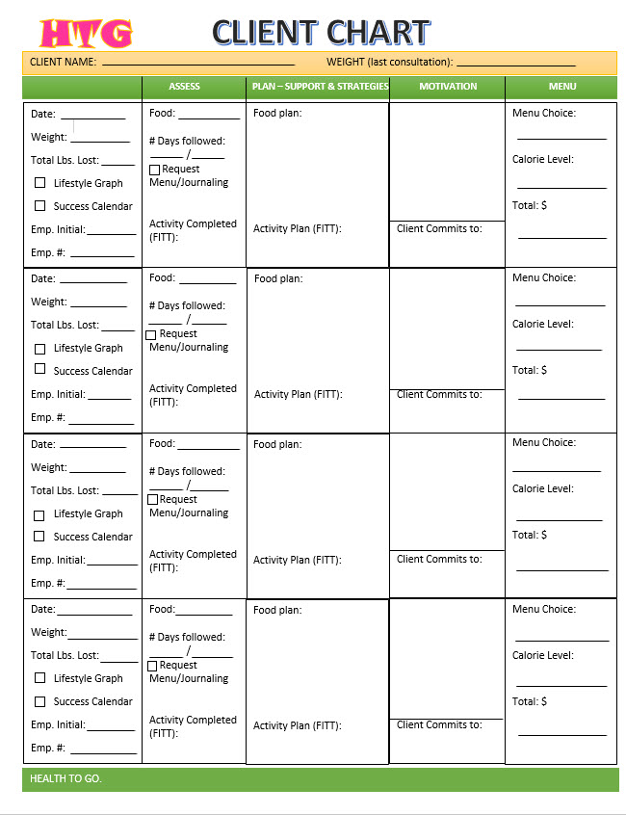

## APPENDIX C: WEIGHT MAP

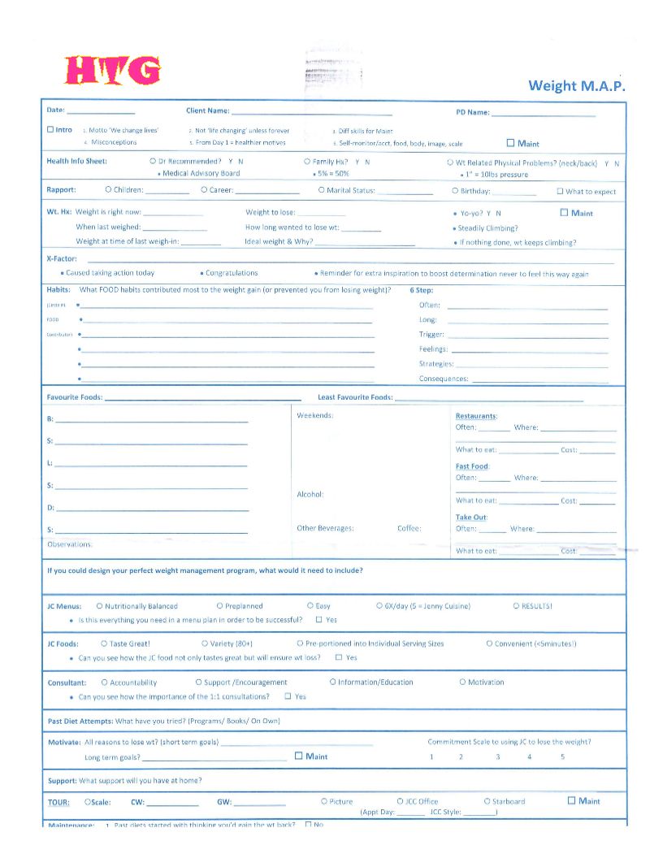

## APPENDIX D: BIGGER VERSION OF CLASS DIAGRAM

Please see the tabloid-sized printout next.

## APPENDIX E: bigger version of persistence model

Please see the attached diagram.

## APPENDIX F: BIGGER VERSION OF GUI AND CONTROLLERS DIAGRAM

Please see the attached diagram.